MODERN

NETWORKING

MASTERS OF SCIENCE (INFORMATION TECHNOLOGY)

PRACTICAL REPORT

ON

MODERN NETWORKING

SUBMITTED BY

SOKHI RINKI JASSI

SEAT NO:

SUBMITTED TO

PROF. SAYALI PARAB

MSc. (INFORMATION TECHNOLOGY) SEM -II

2023 – 2024



DEPARTMENT OF INFORMATION TECHNOLOGY

COSMOPOLITAN'S

VALIA C.L. COLLEGE OF COMMERCE &

VALIA L.C. COLLEGE OF ARTS

(Affiliated to University of Mumbai)

D.N. NAGAR, ANDHERI (WEST), MUMBAI 400 053

VALIA C.L. COLLEGE OF COMMERCE &

VALIA L.C. COLLEGE OF ARTS

(Affiliated to University of Mumbai)

D.N. NAGAR, ANDHERI (WEST), MUMBAI 400 053

DEPARTMENT OF INFORMATION TECHNOLOGY



CERTIFICATE

This is to certify that the Journal of "Cloud Management", is Bonafide work of SOKHI RINKI JASSI bearing Seat No: submitted in partial fulfillment of the requirements for the award of P.G of MASTERS OF SCIENCE IN INFORMATION TECHNOLOGY from University of Mumbai.

Internal Guide External Examiner Co-Ordinator Sign: Sign: Sign:

Date: Date: Date:

Name: Sayali Parab Name: Name:

College Seal:

**INDEX**

|  |  |  |  |  |
| --- | --- | --- | --- | --- |
| **Practical No.** | **Practicals** | **Date** | **Page No.** | **Sign** |
| 1. | Configure IP SLA Tracking and Path  Control Topology | 01/03/24 | 2 |  |
| 2. | Using the AS_PATH Attribute | 07/03/24 | 19 |  |
| 3. | Configuring IBGP and EBGP  Sessions, Local Preference, and MED | 14/03/24 | 30 |  |
| 4. | Secure the Management Plane | 21/03/24 | 52 |  |
| 5. | Configure and Verify Path Control  Using PBR | 28/03/24 | 64 |  |
| 6. | IP Service Level Agreements and  Remote SPAN in a Campus  Environment | 04/04/24 | 79 |  |
| 7. | Inter-VLAN Routing | 12/04/24 | 95 |  |
| 8. | Simulating MPLS environment | 18/04/24 | 97 |  |
| 9. | Simulating VRF | 25/04/24 | 112 |  |

# **Practical 1**

**Aim: Configure IP SLA Tracking and Path Control**

**Topology:** 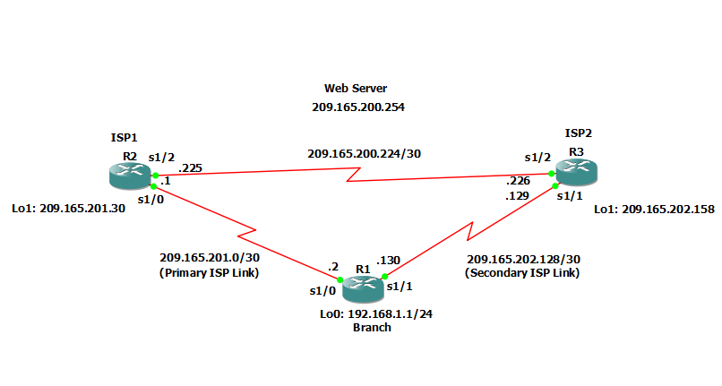

**Objectives:**

* Configure and verify the IP SLA feature.
* Test the IP SLA tracking feature.
* Verify the configuration and operation using show and debug commands.

An IP service level agreement, or IP SLA, is a network measurement technology that uses active traffic monitoring data to analyze the performance of a network in real time. It collects time-based performance data that actively helps monitor and troubleshoot a network.

**Background**:

You want to experiment with the Cisco IP Service Level Agreement (SLA) feature to study how it could be of value to your organization.

At times, a link to an ISP could be operational, yet users cannot connect to any other outside Internet resources. The problem might be with the ISP or downstream from them. Although policy-based routing (PBR) can be implemented to alter path control, you will implement the Cisco IOS SLA feature to monitor this behavior and intervene by injecting another default route to a backup ISP.

To test this, you have set up a three-router topology in a lab environment. Router R1 represents a branch office connected to two different ISPs. ISP1 is the preferred connection to the Internet, while ISP2 provides a backup link. ISP1 and ISP2 can also interconnect, and both can reach the web server. To monitor ISP1 for failure, you will configure IP SLA probes to track the reachability to the ISP1 DNS server. If connectivity to the ISP1 server fails, the SLA probes detect the failure and alter the default static route to point to the ISP2 server.

**Note:** This lab uses Cisco 1941 routers with Cisco IOS Release 15.2 with IP Base. Depending on the router or switch model and Cisco IOS Software version, the commands available and output produced might vary from what is shown in this lab.

**Required Resources:**

* 3 routers (Cisco IOS Release 15.2 or comparable)
* Serial and Ethernet cables

**Step 1:** Configure loopbacks and assign addresses.

Cable the network as shown in the topology diagram. Erase the startup configuration and reload each router to clear the previous configurations. Using the addressing scheme in the diagram, create the loopback interfaces and apply IP addresses to them as well as the serial interfaces on R1, ISP1, and ISP2.

You can copy and paste the following configurations into your routers to begin.

**Note:** Depending on the router model, interfaces might be numbered differently than those listed. You might need to alter them accordingly.

**R1 Console**

hostname R1

int lo0

description R1 LAN

ip address 192.168.1.1 255.255.255.0

int s1/0

description R1 --> ISP1

ip address 209.165.201.2 255.255.255.252

clock rate 128000

bandwidth 128

no shut

int s1/1

description R1 --> ISP2

ip address 209.165.202.130 255.255.255.252

bandwidth 128

no shut

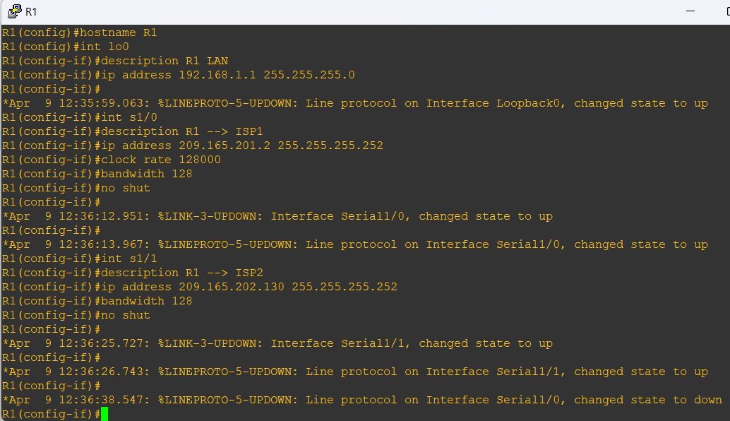

**Router ISP1 (R2) Console**

hostname ISP1

int lo0

description Simulated Internet Web Server

ip address 209.165.200.254 255.255.255.255

int lo1

description ISP1 DNS Server

ip address 209.165.201.30 255.255.255.255

int s1/0

description ISP1 -->R1

ip address 209.165.201.1 255.255.255.252

bandwidth 128

no shut

int s1/2

description ISP1 --> ISP2

ip address 209.165.200.225 255.255.255.252

clock rate 128000

bandwidth 128

no shutdown

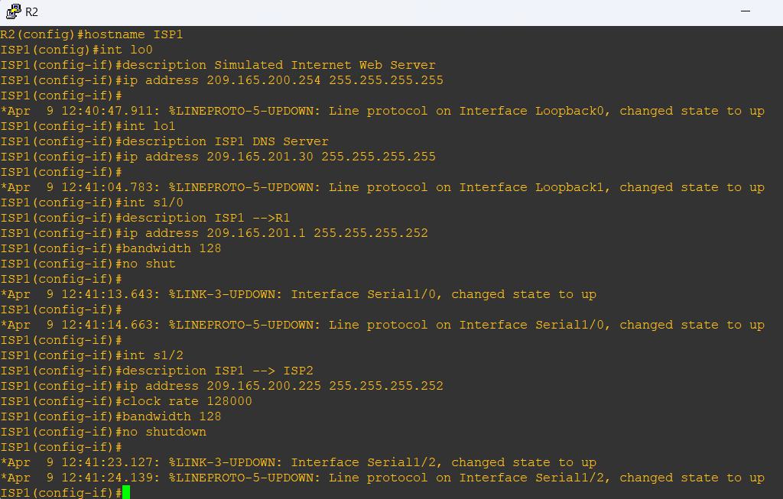

**Router ISP2 (R3) Console**

hostname ISP2

int lo0

description Simulated Internet Web Server

ip address 209.165.200.254 255.255.255.255

int lo1

description ISP2 DNS Server

ip address 209.165.202.158 255.255.255.255

int s1/1

description ISP2 --> R1

ip address 209.165.202.129 255.255.255.252

clock rate 128000

bandwidth 128

no shut

int s1/2

description ISP2 --> ISP1

ip address 209.165.200.226 255.255.255.252

bandwidth 128

no shut

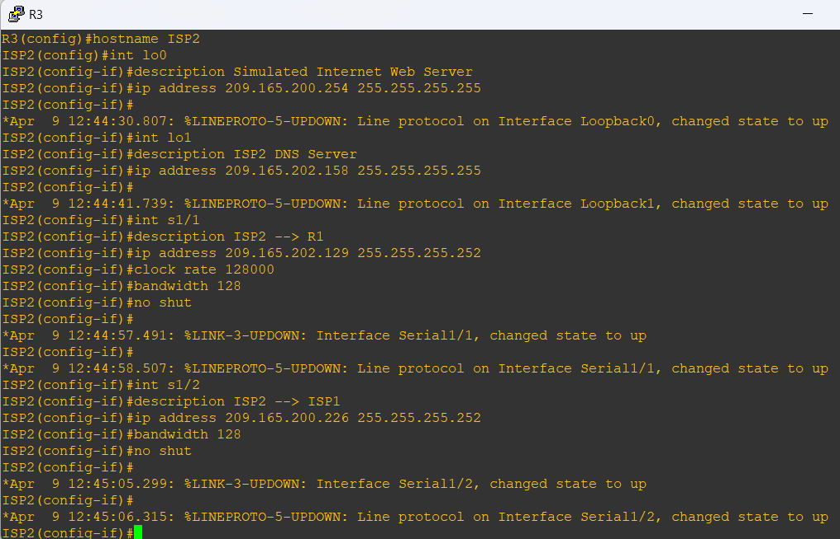

b. Verify the configuration by using the show interfaces description command. The output from router R1 is shown here as an example.

**R1 Console**

show int description

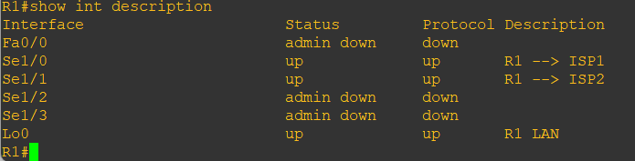

**Step 2:** Configure static routing.

The current routing policy in the topology is as follows:

* Router R1 establishes connectivity to the Internet through ISP1 using a default static route.
* ISP1 and ISP2 have dynamic routing enabled between them, advertising their respective public address pools.
* ISP1 and ISP2 both have static routes back to the ISP R1 LAN.

**Note:** For the purpose of this lab, the ISPs have a static route to an RFC 1918 private network address on the branch router R1. In an actual branch implementation, Network Address Translation (NAT) would be configured for all traffic exiting the branch LAN. Therefore, the static routes on the ISP routers would be pointing to the provided public pool of the branch office.

**R1 Console**

ip route 0.0.0.0 0.0.0.0 209.165.201.1

**Router ISP1 (R2) Console**

router eigrp 1

network 209.165.200.224 0.0.0.3

network 209.165.201.0 0.0.0.31

no auto-summary

exit

ip route 192.168.1.0 255.255.255.0 209.165.201.2

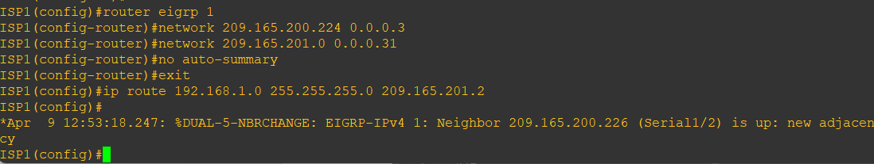

**Router ISP12 (R3) Console**

router eigrp 1

network 209.165.200.224 0.0.0.3

network 209.165.202.128 0.0.0.31

no auto-summary

exit

ip route 192.168.1.0 255.255.255.0 209.165.202.130

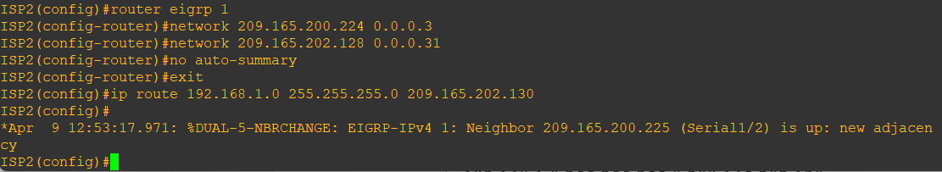

EIGRP neighbor relationship messages on ISP1 and ISP2 should be generated. Troubleshoot if necessary.

b. The Cisco IOS IP SLA feature enables an administrator to monitor network performance between Cisco devices (switches or routers) or from a Cisco device to a remote IP device. IP SLA probes continuously check the reachability of a specific destination, such as a provider edge router interface, the DNS server of the ISP, or any other specific destination, and can conditionally announce a default route only if the connectivity is verified.

Before implementing the Cisco IOS SLA feature, you must verify reachability to the Internet servers. From router R1, ping the web server, ISP1 DNS server, and ISP2 DNS server to verify connectivity. You can copy the following Tcl script and paste it into R1.

**R1 Console**

tclsh

foreach address {

209.165.200.254

209.165.201.30

209.165.202.158

} {

ping $address source 192.168.1.1

}

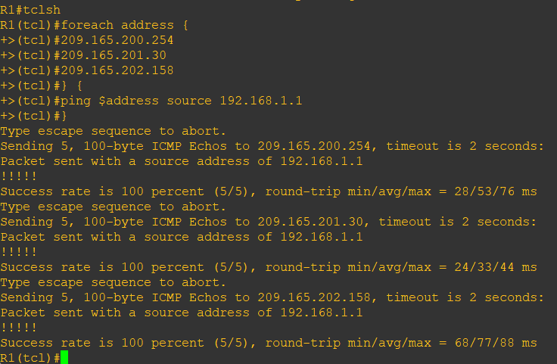

All pings should be successful.

c. Trace the path taken to the web server, ISP1 DNS server, and ISP2 DNS server. You can copy the following Tcl script and paste it into R1.

**R1 Console**

tclsh

foreach address {

209.165.200.254

209.165.201.30

209.165.202.158

} {

trace $address source 192.168.1.1

}

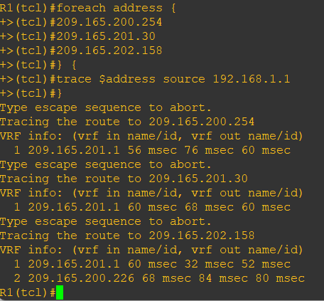

Through which ISP traffic is flowing?

* ISP1

**Step 3:** Configure IP SLA probes.

When the reachability tests are successful, you can configure the Cisco IOS IP SLAs probes. Different types of probes can be created, including FTP, HTTP, and jitter probes.

In this scenario, you will configure ICMP echo probes.

1. Create an ICMP echo probe on R1 to the primary DNS server on ISP1 using the ip sla command.

**R1 Console**

ip sla 11

icmp-echo 209.165.201.30

frequency 10

exit

ip sla schedule 11 life forever start-time now

The operation number of 11 is only locally significant to the router. The **frequency 10** command schedules the connectivity test to repeat every 10 seconds. The probe is scheduled to start now and to run forever.

1. Verify the IP SLAs configuration of operation 11 using the **show ip sla configuration 11** command.

**R1 Console**

show ip sla configuration 11

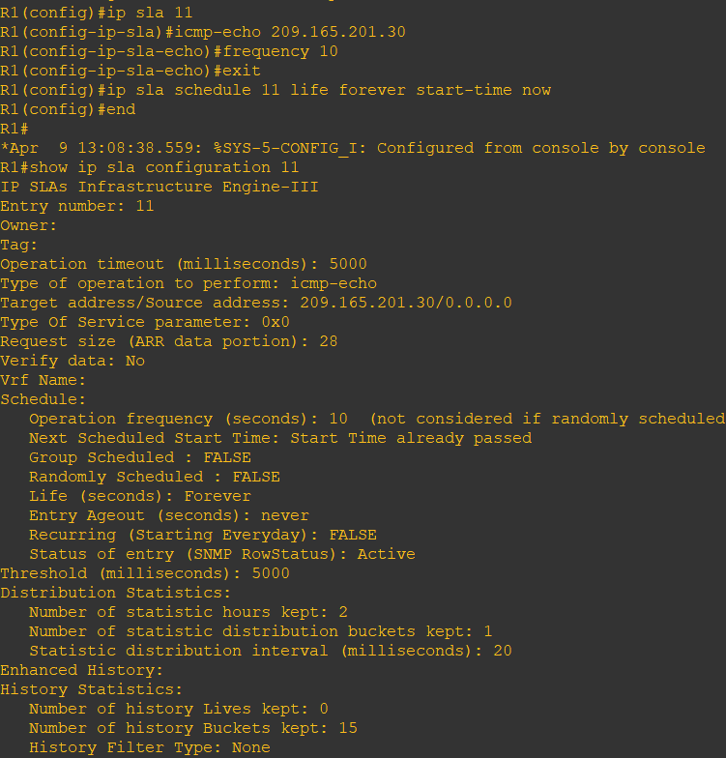

The output lists the details of the configuration of operation 11. The operation is an ICMP echo to 209.165.201.30, with a frequency of 10 seconds, and it has already started (the start time has already passed).

1. Issue the show ip sla statistics command to display the number of successes, failures, and results of the latest operations.

**R1 Console**

show ip sla statistics

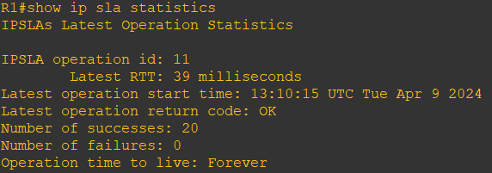

You can see that operation 11 has already succeeded 20 times, has had no failures, and the last operation returned an OK result.

1. Although not actually required because IP SLA session 11 alone could provide the desired fault tolerance, create a second probe, 22, to test connectivity to the second DNS server located on router ISP2.

**R1 Console**

ip sla 22

icmp-echo 209.165.202.158

frequency 10

exit

ip sla schedule 22 life forever start-time now

end

1. Verify the new probe using the show ip sla configuration and show ip sla statistics commands.

**R1 Console**

show ip sla configuration 22

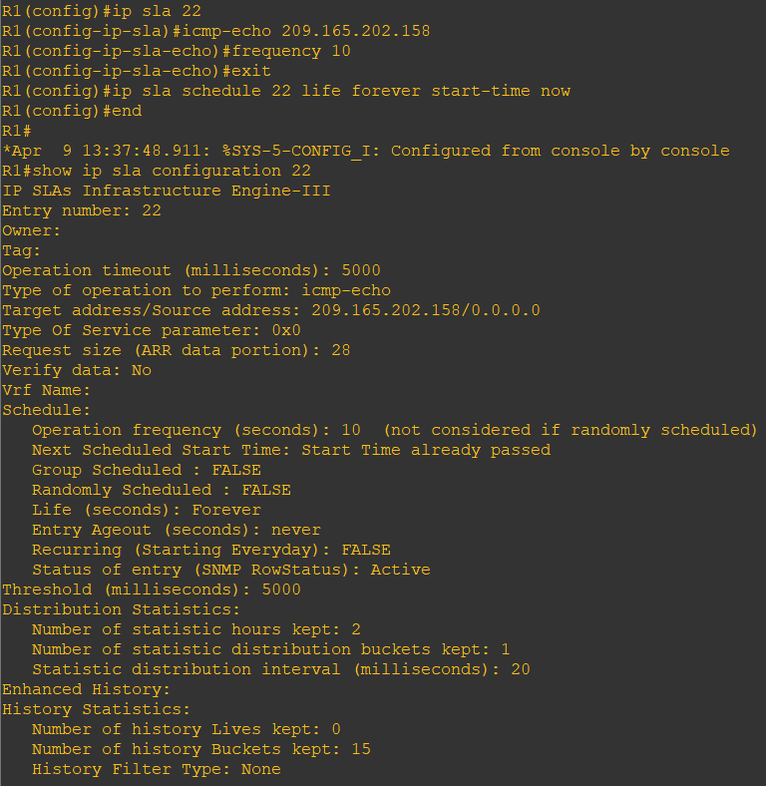

show ip sla statistics 22

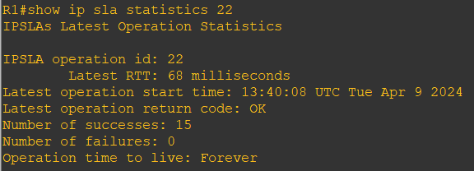

The output lists the details of the configuration of operation 22. The operation is an ICMP echo to 209.165.202.158, with a frequency of 10 seconds, and it has already started (the start time has already passed). The statistics also prove that operation 22 is active.

**Step 4:** Configure tracking options.

Although PBR could be used, you will configure a floating static route that appears or disappears depending on the success or failure of the IP SLA.

1. On R1, remove the current default route and replace it with a floating static route having an administrative distance of 5.

**R1 Console**

no ip route 0.0.0.0 0.0.0.0 209.165.201.1

ip route 0.0.0.0 0.0.0.0 209.165.201.1 5

exit

1. Verify the routing table.

**R1 Console**

show ip route

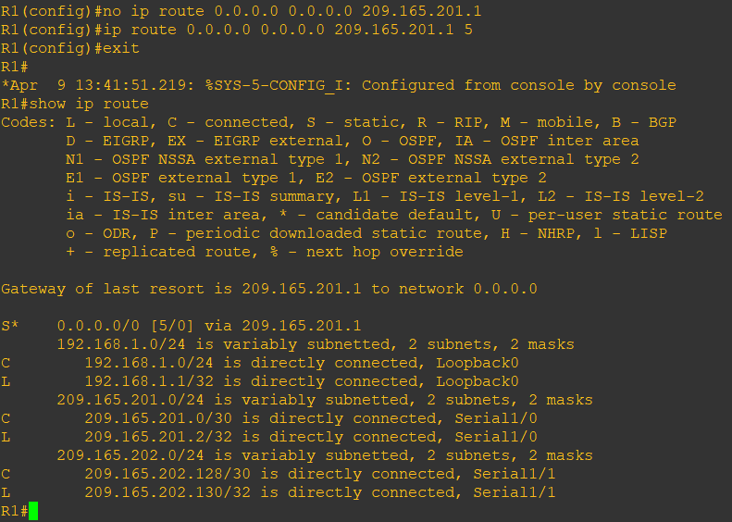

Notice that the default static route is now using the route with the administrative distance of 5. The first tracking object is tied to IP SLA object 11.

1. From global configuration mode on R1, use the track 1 ip sla 11 reachability command to enter the config-track subconfiguration mode.
2. Specify the level of sensitivity to changes of tracked objects to 10 seconds of down delay and 1 second of up delay using the delay down 10 up 1 command. The delay helps to alleviate the effect of flapping objects—objects that are going down and up rapidly. In this situation, if the DNS server fails momentarily and comes back up within 10 seconds, there is no impact.

**R1 Console**

track 1 ip sla 11 reachability

delay down 10 up 1

exit

1. To view routing table changes as they happen, first enable the debug ip routing command.

**R1 Console**

debug ip routing

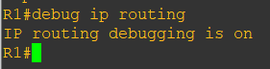

1. Configure the floating static route that will be implemented when tracking object 1 is active. Use the ip route 0.0.0.0 0.0.0.0 209.165.201.1 2 track 1 command to create a floating static default route via 209.165.201.1 (ISP1). Notice that this command references the tracking object number 1, which in turn references IP SLA operation number 11.

**R1 Console**

ip route 0.0.0.0 0.0.0.0 209.165.201.1 2 track 1

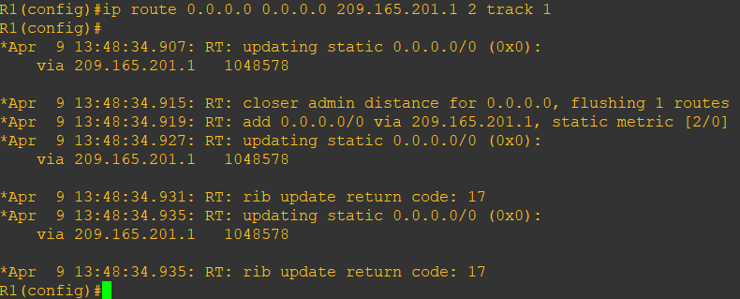

Notice that the default route with an administrative distance of 5 has been immediately flushed because of a route with a better admin distance. It then adds the new default route with the admin distance of 2.

1. Repeat the steps for operation 22, track number 2, and assign the static route an admin distance higher than track 1 and lower than 5. On R1, copy the following configuration, which sets an admin distance of 3.

**R1 Console**

track 2 ip sla 22 reachability

delay down 10 up 1

exit

ip route 0.0.0.0 0.0.0.0 209.165.202.129 3 track 2

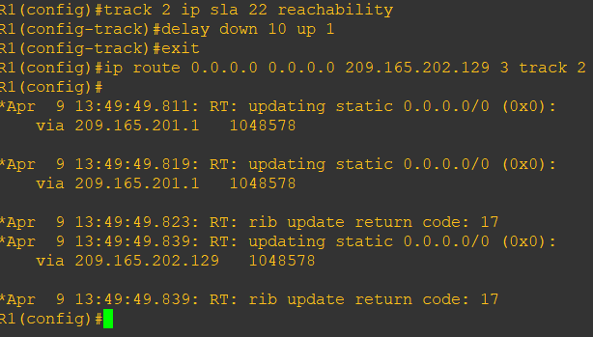

1. Verify the routing table again.

**R1 Console**

show ip route

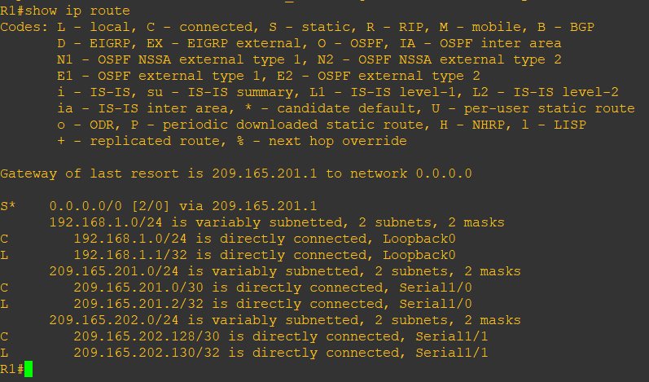

Although a new default route was entered, its administrative distance is not better than 2. Therefore, it does not replace the previously entered default route.

**Step 5:** Verify IP SLA operation.

In this step you observe and verify the dynamic operations and routing changes when tracked objects fail. The following summarizes the process:

* Disable the DNS loopback interface on ISP1 (R2).
* Observe the output of the debug command on R1.
* Verify the static route entries in the routing table and the IP SLA statistics of R1.
* Re-enable the loopback interface on ISP1 (R2) and again observe the operation of the IP SLA tracking feature.

1. On ISP1, disable the loopback interface 1.

**ISP1 (R2) Console**

int lo1

shutdown

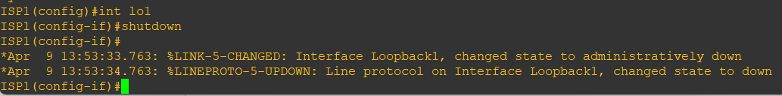

1. On R1, observe the debug output being generated. Recall that R1 will wait up to 10 seconds before initiating action therefore several seconds will elapse before the output is generated.

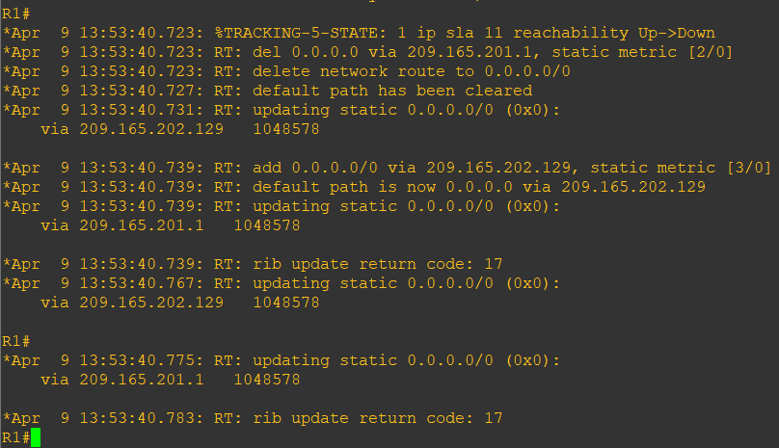

The tracking state of track 1 changes from up to down. This is the object that tracked reachability for IP SLA object 11, with an ICMP echo to the ISP1 DNS server at 209.165.201.30.

R1 then proceeds to delete the default route with the administrative distance of 2 and installs the next highest default route to ISP2 with the administrative distance of 3.

1. On R1, verify the routing table.

**R1 Console**

show ip route | begin Gateway

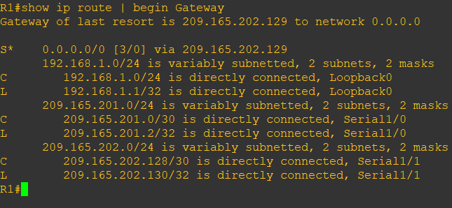

The new static route has an administrative distance of 3 and is being forwarded to ISP2 as it should.

1. Verify the IP SLA statistics.

**R1 Console**

show ip sla statistics

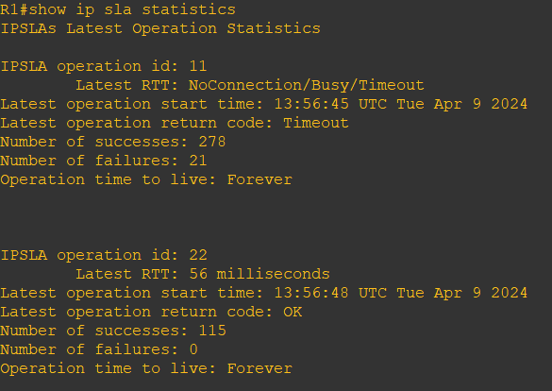

Notice that the latest return code is Timeout and there have been 21 failures on IP SLA object 11.

1. On R1, initiate a trace to the web server from the internal LAN IP address.

**R1 Console**

trace 209.165.200.254 source 192.168.1.1

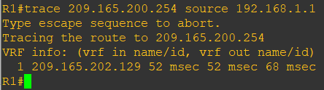

This confirms that traffic is leaving router R1 and being forwarded to the ISP2 router.

1. On ISP1, re-enable the DNS address by issuing the no shutdown command on the loopback 1 interface to examine the routing behavior when connectivity to the ISP1 DNS is restored.

**ISP1 (R2) Console**

no shutdown



Notice the output of the debug ip routing command on R1

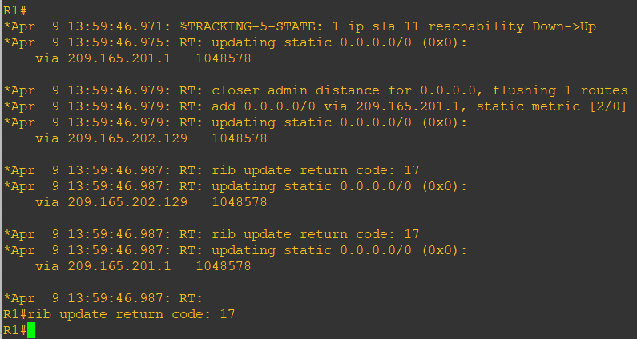

Now the IP SLA 11 operation transitions back to an up state and reestablishes the default static route to ISP1 with an administrative distance of 2.

1. Again examine the IP SLA statistics.

**R1 Console**

show ip sla statistics

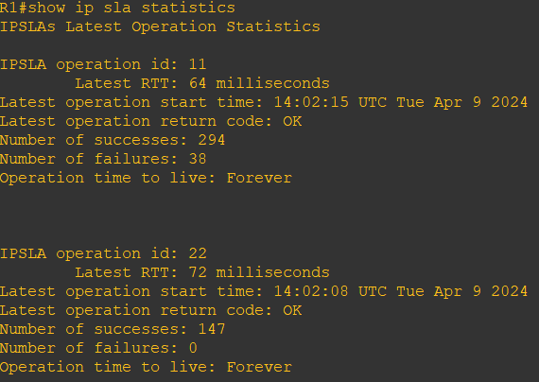

The IP SLA 11 operation is active again, as indicated by the OK return code, and the number of successes is incrementing.

1. Verify the routing table.

**R1 Console**

show ip route | begin Gateway

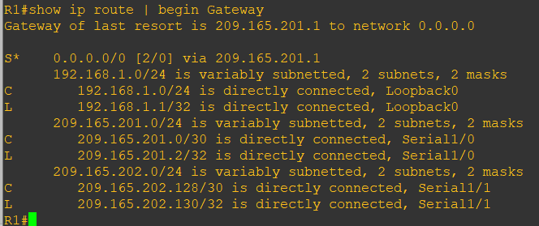

The default static through ISP1 with an administrative distance of 2 is reestablished.

There are many possibilities available with object tracking and Cisco IOS IP SLAs. As shown in this lab, a probe can be based on reachability, changing routing operations, and path control based on the ability to reach an object. However, Cisco IOS IP SLAs also allow paths to be changed based on network conditions such as delay, load, and other factors.

Before deploying a Cisco IOS IP SLA solution, the impact of the additional probe traffic being generated should be considered, including how that traffic affects bandwidth utilization, and congestion levels. Tuning the configuration (for example, with the delay and frequency commands) is critical to mitigate possible issues related to excessive transitions and route changes in the presence of flapping tracked objects.

The benefits of running IP SLAs should be carefully evaluated. The IP SLA is an additional task that must be performed by the router’s CPU. A large number of intensive SLAs could be a significant burden on the CPU, possibly interfering with other router functions and having detrimental impact on the overall router performance. The CPU load should be monitored after the SLAs are deployed to verify that they do not cause excessive utilization of the router CPU.

# **Practical 2**

**Aim: Use the AS_PATH Attribute**

**Topology:**

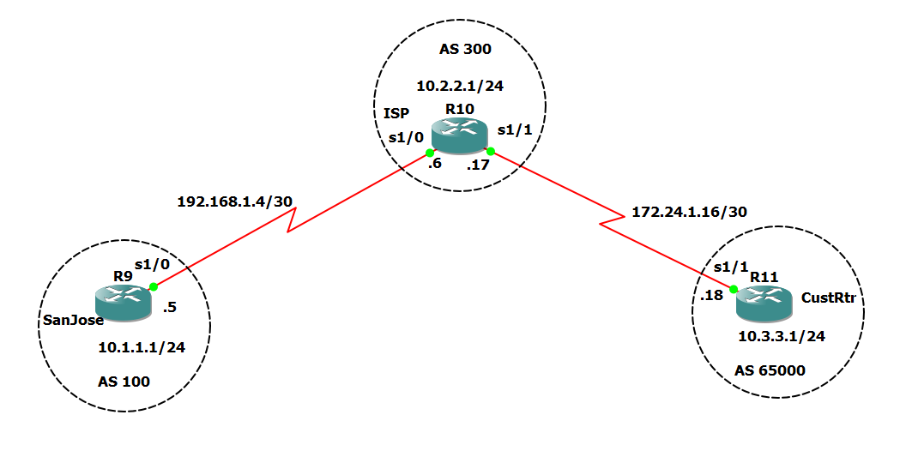

**Step 1: Prepare the routers for the lab.**

Cable the network as shown in the topology diagram. Erase the startup configuration and

reload each router to clear previous configurations.

**Step 2: Configure the hostname and interface addresses.**

a) Enter the following configurations into your routers to begin.

**Router R9 (hostname SanJose)**

hostname SanJose

interface Loopback0

ip address 10.1.1.1 255.255.255.0

exit

interface S1/0

ip address 192.168.1.5 255.255.255.252

clock rate 128000

no shutdown

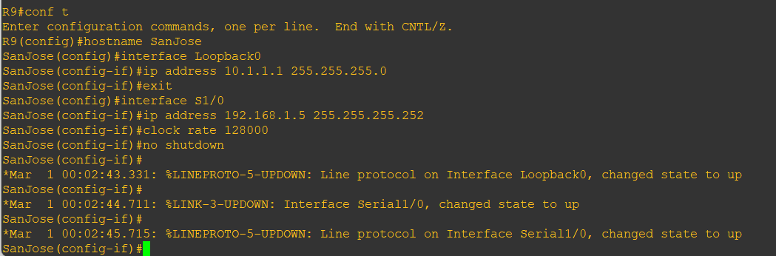

**Router R10 (hostname ISP)**

hostname ISP

interface Loopback0

ip address 10.2.2.1 255.255.255.0

exit

interface S1/0

ip address 192.168.1.6 255.255.255.252

no shutdown

exit

interface S1/1

ip address 172.24.1.17 255.255.255.252

clock rate 128000

no shutdown

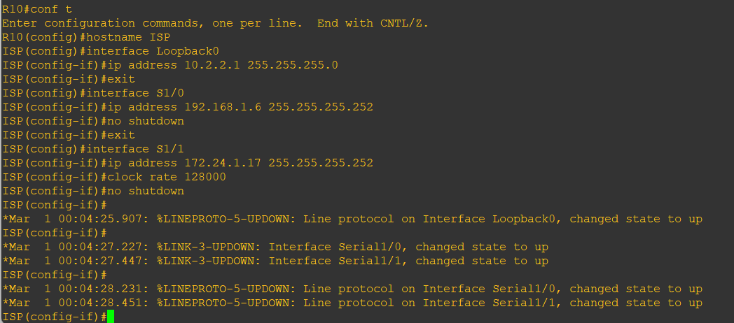

**Router R11 (hostname CustRtr)**

hostname CustRtr

interface Loopback0

ip address 10.3.3.1 255.255.255.0

exit

interface S1/1

ip address 172.24.1.18 255.255.255.252

no shutdown

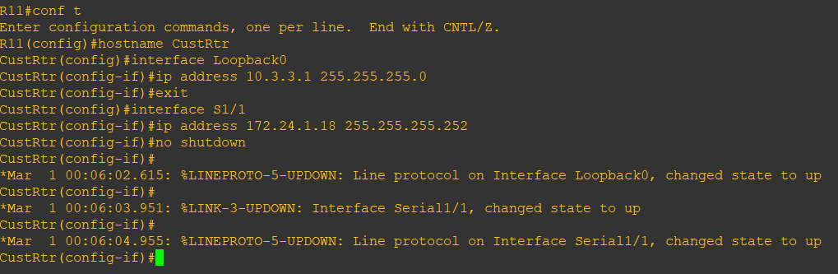

b) Use ping to test the connectivity between the directly connected routers.

**Note:** SanJose will not be able to reach either ISP’s loopback (10.2.2.1) or CustRtr’s

loopback (10.3.3.1), nor will it be able to reach either end of the link joining ISP or CustRtr

(172.24.1.17 or 172.24.1.18).

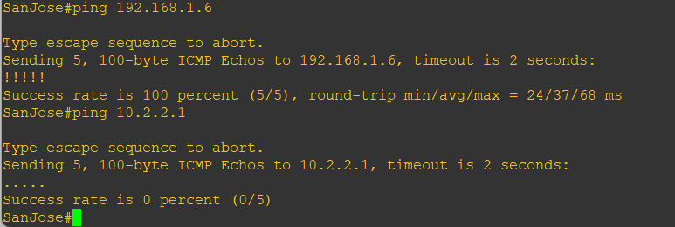

**Step 3: Configure BGP**

a) Configure BGP for normal operation. Enter the appropriate BGP commands on each router

so that they identify their BGP neighbors and advertise their loopback networks.

**Router R9 (hostname SanJose)**

router bgp 100

neighbor 192.168.1.6 remote-as 300

network 10.1.1.0 mask 255.255.255.0

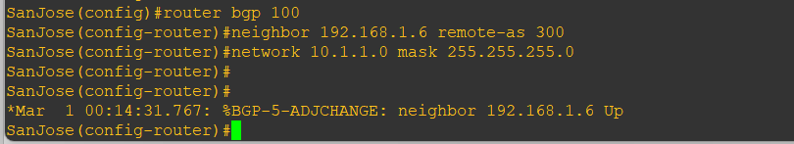

**Router R10 (hostname ISP)**

router bgp 300

neighbor 192.168.1.5 remote-as 100

neighbor 172.24.1.18 remote-as 65000

network 10.2.2.0 mask 255.255.255.0

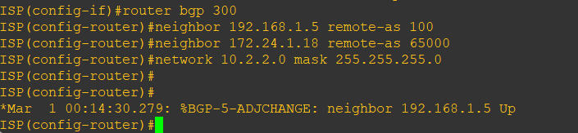

**Router R11 (hostname CustRtr)**

router bgp 65000

neighbor 172.24.1.17 remote-as 300

network 10.3.3.0 mask 255.255.255.0

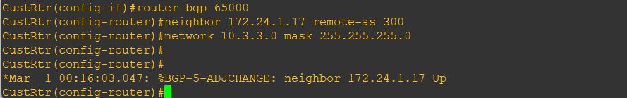

b) Verify that these routers have established the appropriate neighbor relationships by issuing the show ip bgp neighbors command on each router.

**Router R10 (hostname ISP)**

show ip bgp neighbors

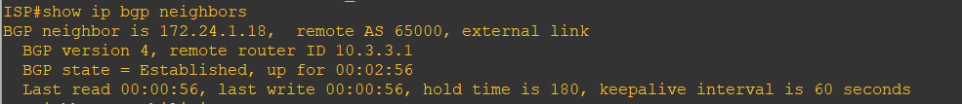



**Step 4: Remove the private AS.**

a) Display the SanJose routing table using the show ip route command. SanJose should have

a route to both 10.2.2.0 and 10.3.3.0. Troubleshoot if necessary.

**Router R9 (hostname SanJose)**

show ip route

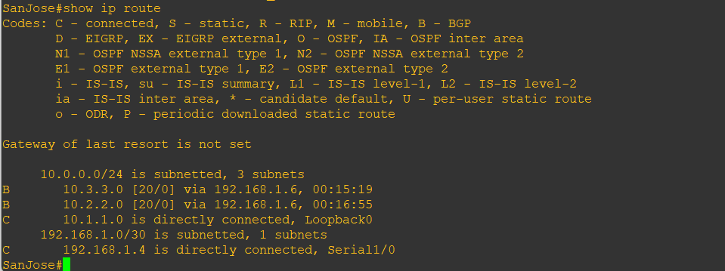

b) Ping the 10.3.3.1 address from the SanJose.

ping 10.3.3.1

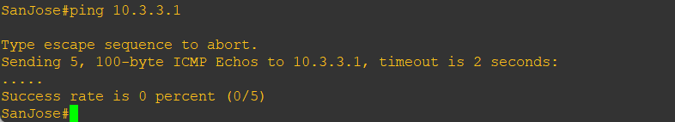

c) Ping again, this time as an extended ping, sourcing from the Loopback0 interface address.

ping 10.3.3.1 source 10.1.1.1

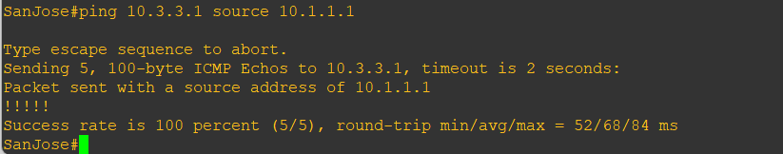

d) Check the BGP table from SanJose by using the show ip bgp command. Note the AS path

for the 10.3.3.0 network. The AS 65000 should be listed in the path to 10.3.3.0.

show ip bgp

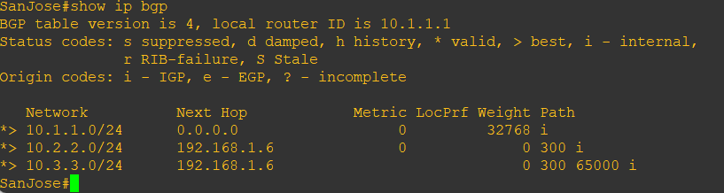

e) Configure ISP to strip the private AS numbers from BGP routes exchanged with SanJose

using the following commands.

**Router R10 (hostname ISP)**

router bgp 300

neighbor 192.168.1.5 remove-private-as

f) After issuing these commands, use the clear ip bgp * command on ISP to re-establish the

BGP relationship between the three routers. Wait several seconds and then return to SanJose

to check its routing table.

**Note:** The clear ip bgp * soft command can also be used to force each router to resend its

BGP table.

**Router R10 (hostname ISP)**

clear ip bgp *

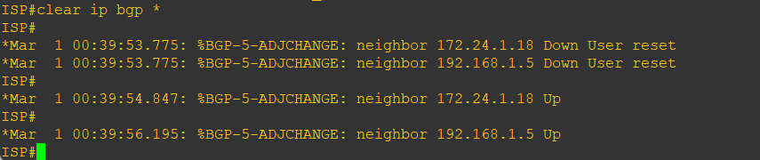

**Router R9 (hostname SanJose)**

show ip route

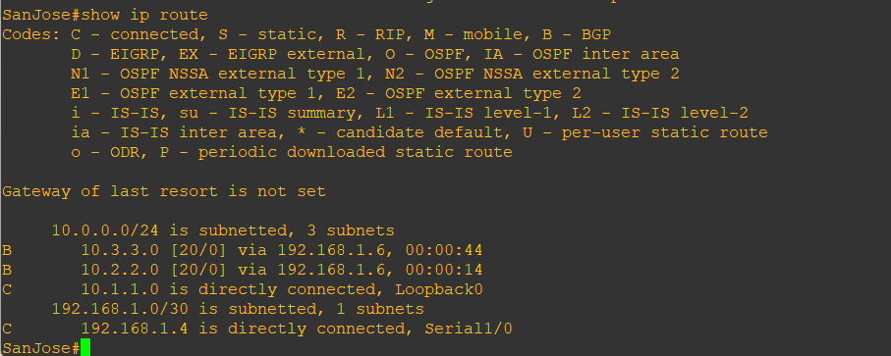

SanJose should be able to ping 10.3.3.1 using its loopback0 interface as the source of the

ping.

**Router R9 (hostname SanJose)**

ping 10.3.3.1 source 10.1.1.1

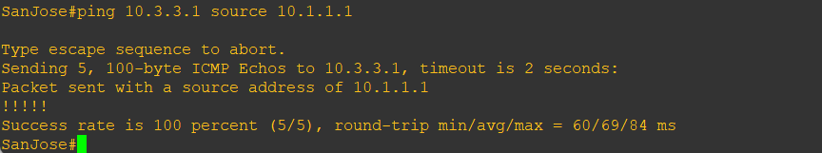

g) Now check the BGP table on SanJose. The AS_PATH to the 10.3.3.0 network should be

AS 300. It no longer has the private AS in the path.

**Router R9 (hostname SanJose)**

show ip bgp

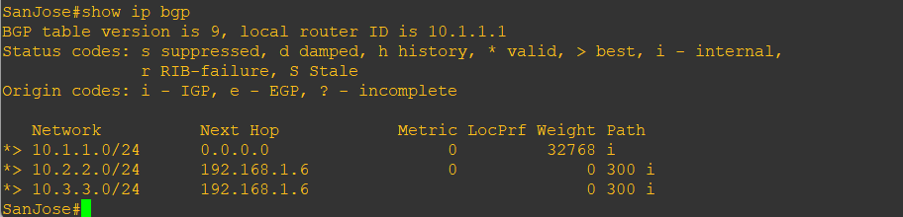

**Step 5: Use the AS_PATH attribute to filter routes.**

As a final configuration, use the AS_PATH attribute to filter routes based on their origin. In a

complex environment, you can use this attribute to enforce routing policy. In this case, the

provider router, ISP, must be configured so that it does not propagate routes that originate

from AS 100 to the customer router CustRtr.

AS-path access lists are read like regular access lists. The statements are read sequentially,

and there is an implicit deny at the end. Rather than matching an address in each statement

like a conventional access list, AS path access lists match on something called a regular

expression. Regular expressions are a way of matching text patterns and have many uses. In

this case, you will be using them in the AS path access list to match text patterns in AS paths.

a) Configure a special kind of access list to match BGP routes with an AS_PATH attribute

that both begins and ends with the number 100. Enter the following commands on ISP.

**Router R10 (hostname ISP)**

ip as-path access-list 1 deny ^100$

ip as-path access-list 1 permit .*

The first command uses the ^ character to indicate that the AS path must begin with the given

number 100. The $ character indicates that the AS_PATH attribute must also end with 100.

Essentially, this statement matches only paths that are sourced from AS 100. Other paths,

which might include AS 100 along the way, will not match this list.

In the second statement, the . (period) is a wildcard, and the * (asterisk) stands for a repetition

of the wildcard. Together, .* matches any value of the AS_PATH attribute, which in effect

permits any update that has not been denied by the previous access-list statement.

b) Apply the configured access list using the neighbor command with filter-list option.

**Router R10 (hostname ISP)**

router bgp 300

neighbor 172.24.1.18 filter-list 1 out

The out keyword specifies that the list is applied to routing information sent to this neighbor.

c) Use the clear ip bgp * command to reset the routing information. Wait several seconds

and then check the routing table for ISP. The route to 10.1.1.0 should be in the routing table.

**Note:** To force the local router to resend its BGP table, a less disruptive option is to use the

clear ip bgp * out or clear ip bgp * soft command (the second command performs both

outgoing and incoming route resync).

**Router R10 (hostname ISP)**

clear ip bgp *

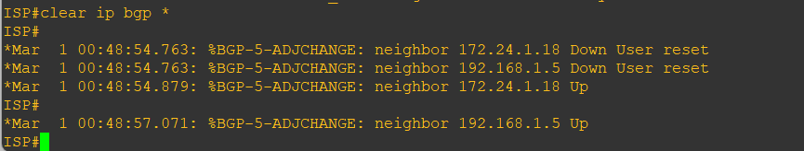

show ip route

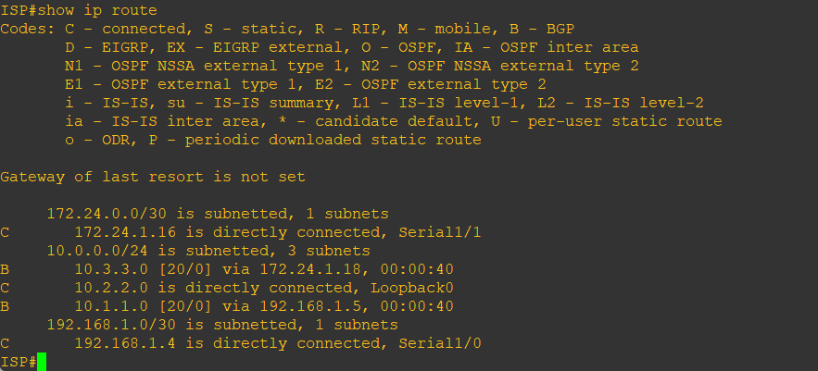

d) Check the routing table for CustRtr. It should not have a route to 10.1.1.0 in its routing

table.

**Router R11 (hostname CustRtr)**

show ip route

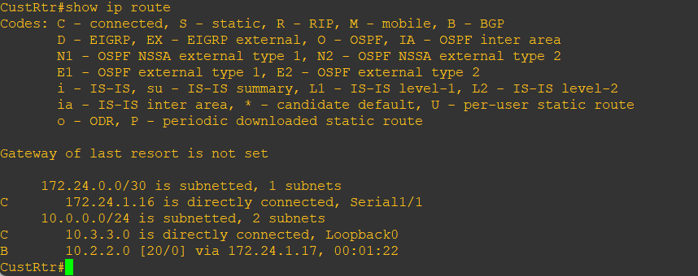

e) Return to ISP and verify that the filter is working as intended. Issue the show ip bgp

regexp ^100$ command.

**Router R10 (hostname ISP)**

show ip bgp regexp ^100$

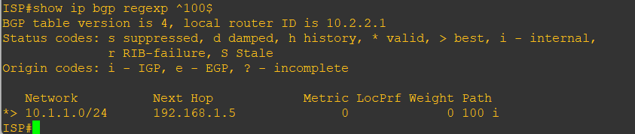

The output of this command shows all matches for the regular expressions that were used in

the access list. The path to 10.1.1.0 matches the access list and is filtered from updates to

CustRtr.

f) Run the following Tcl script on all routers to verify whether there is connectivity. All pings

from ISP should be successful. SanJose should not be able to ping the CustRtr loopback

10.3.3.1 or the WAN link 172.24.1.16/30. CustRtr should not be able to ping the SanJose

loopback 10.1.1.1 or the WAN link 192.168.1.4/30.

**Router R10 (hostname ISP)**

tclsh

foreach address {

10.1.1.1

10.2.2.1

10.3.3.1

192.168.1.5

192.168.1.6

172.24.1.17

172.24.1.18 } { ping $address }

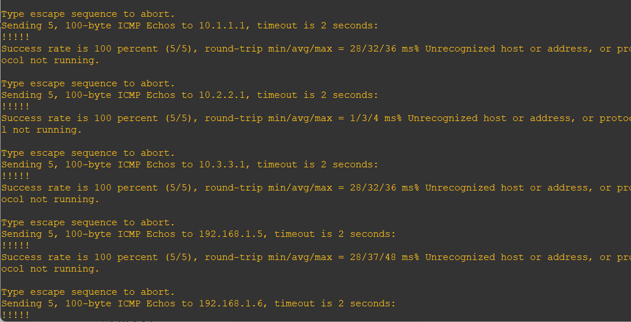

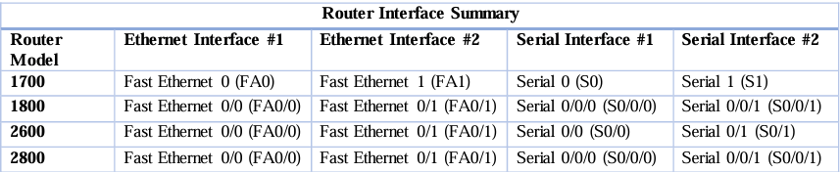

**Note:** To find out how the router is configured, look at the interfaces to identify the type of

router and how many interfaces the router has. Rather than list all combinations of

configurations for each router class, this table includes identifiers for the possible

combinations of Ethernet and serial interfaces in the device. The table does not include any

other type of interface, even though a specific router might contain one. For example, for an

ISDN BRI interface, the string in parenthesis is the legal abbreviation that can be used in

Cisco IOS commands to represent the interface.

# Practical 3

**Aim:** **Configuring IBGP and EBGP Sessions, Local Preference, and MED**

**Topology:**

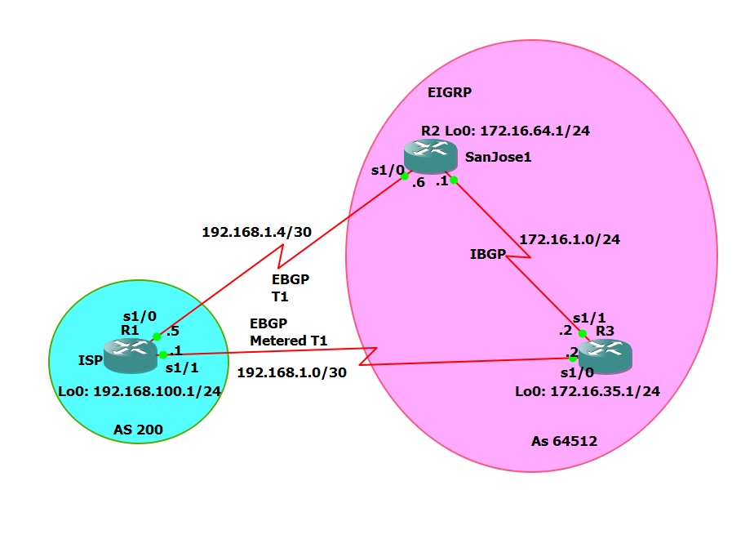

**Objectives:**

* For IBGP peers to correctly exchange routing information, use the next-hop-self command with the Local-Preference and MED attributes.
* Ensure that the flat-rate, unlimited-use T1 link is used for sending and receiving data to and from the AS 200 on ISP and that the metered T1 only be used in the event that the primary T1 link has failed.

**Required Resources**

* 3 routers (Cisco IOS Release 15.2 or comparable)
* Serial and Ethernet cables

**Step 0:** Suggested starting configurations.

1. Apply the following configuration to each router along with the appropriate hostname. The exec-timeout 0 0 command should only be used in a lab environment.

Router(config)# no ip domain-lookup

line con 0

logging synchronous

exec-timeout 0 0

**Step 1:** Configure interface addresses.

1. Using the addressing scheme in the diagram, create the loopback interfaces and apply IPv4 addresses to these and the serial interfaces on ISP (R1), SanJose1 (R2), and SanJose2 (R3).

**R1 (ISP) Console**

int lo0

ip add 192.168.100.1 255.255.255.0

exit

int s1/0

ip add 192.168.1.5 255.255.255.252

clock rate 128000

no shut

exit

int s1/1

ip add 192.168.1.1 255.255.255.252

no shut

end

**R2 (SanJose1) Console**

int lo0

ip add 172.16.64.1 255.255.255.0

exit

int s1/0

ip add 192.168.1.6 255.255.255.252

no shut

exit

int s1/1

ip add 172.16.1.1 255.255.255.0

clock rate 128000

no shut

end

**R3 (SanJose2) Console**

int lo0

ip add 172.16.32.1 255.255.255.0

exit

int s1/0

ip address 192.168.1.2 255.255.255.252

clock rate 128000

no shut

exit

int s1/1

ip add 172.16.1.2 255.255.255.0

no shut

end

1. Use ping to test the connectivity between the directly connected routers. Both SanJose routers should be able to ping each other and their local ISP serial link IP address. The ISP router cannot reach the segment between SanJose1 and SanJose2.

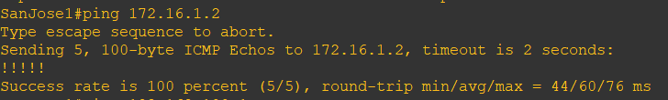

**Step 2:** Configure EIGRP.

Configure EIGRP between the SanJose1 and SanJose2 routers.

**R2 console**

router eigrp 1

network 172.16.0.0

router eigrp 1

network 172.16.0.0

**Step 3:** Configure IBGP and verify BGP neighbors.

1. Configure IBGP between the SanJose1 and SanJose2 routers. On the SanJose1 router, enter the following configuration.

**R2 Console**

router bgp 64512

neighbor 172.16.32.1 remote-as 64512

neighbor 172.16.32.1 update-source lo0

1. Complete the IBGP configuration on SanJose2 using the following commands.

**R3 Console**

router bgp 64512

neighbor 172.16.64.1 remote-as 64512

neighbor 172.16.64.1 update-source lo0

1. Verify that SanJose1 and SanJose2 become BGP neighbors by issuing the show ip bgp neighbors command on SanJose1. View the following partial output. If the BGP state is not established, troubleshoot the connection.

**R3 Console**

show ip bgp neighbors

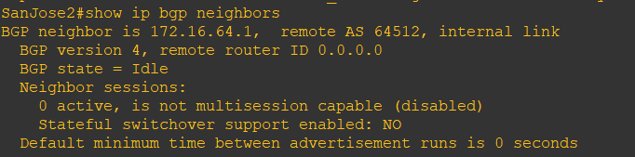

The link between SanJose1 and SanJose2 should be identified as an internal link indicating an IBGP peering relationship, as shown in the output.

**Step 4:** Configure EBGP and verify BGP neighbors.

1. Configure ISP to run EBGP with SanJose1 and SanJose2. Enter the following commands on ISP.

**R1 Console**

router bgp 200

neighbor 192.168.1.6 remote-as 64512

neighbor 192.168.1.2 remote-as 64512

network 192.168.100.0

1. Configure a discard static route for the 172.16.0.0/16 network. Any packets that do not have a more specific match (longer match) for a 172.16.0.0 subnet will be dropped instead of sent to the ISP. Later in this lab we will configure a default route to the ISP.

**R2 Console**

ip route 172.16.0.0 255.255.0.0 null0

1. Configure SanJose1 as an EBGP peer to ISP.

**R2 Console**

router bgp 64512

neighbor 192.168.1.5 remote-as 200

network 172.16.0.0

1. Use the show ip bgp neighbors command to verify that SanJose1 and ISP have reached the established state. Troubleshoot if necessary.

**R2 Console**

show ip bgp neighbors

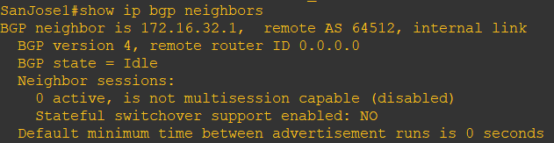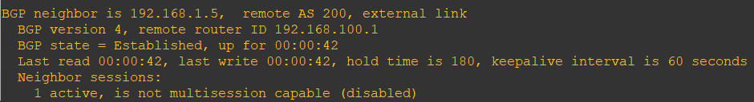

Notice that the “external link” indicates that an EBGP peering session has been established. You should also see an informational message indicating the establishment of the BGP neighbor relationship.

1. Configure a discard static route for 172.16.0.0/16 on SanJose2 and as an EBGP peer to ISP.

**R3 Console**

ip route 172.16.0.0 255.255.0.0 null0

router bgp 64512

neighbor 192.168.1.1 remote-as 200

network 172.16.0.0

**Step 5:** View BGP summary output.

In Step 4, the show ip bgp neighbors command was used to verify that SanJose1 and ISP had reached the established state. A useful alternative command is show ip bgp summary. The output should be similar to the following.

R3 Console

show ip bgp summary

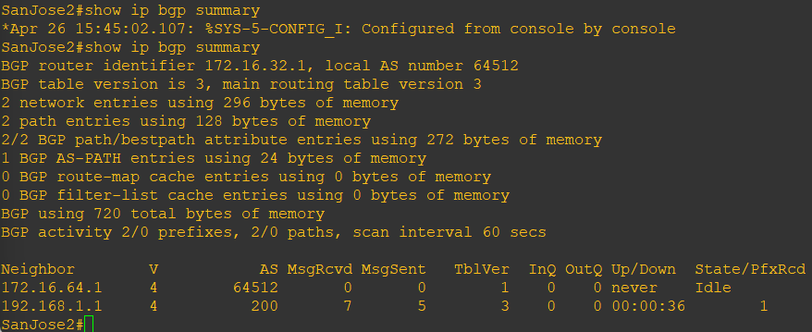

**Step 6:** Verify which path the traffic takes.

1. Clear the IP BGP conversation with the clear ip bgp * command on ISP. Wait for the conversations to reestablish with each SanJose router.

**R1 Console**

clear ip bgp *

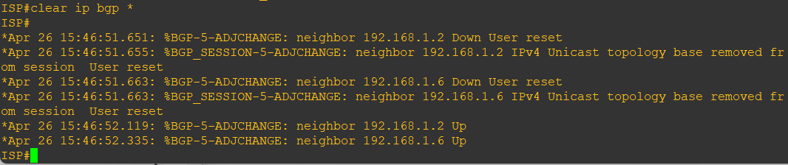

1. Test whether ISP can ping the loopback 0 address of 172.16.64.1 on SanJose1 and the serial link between SanJose1 and SanJose2, 172.16.1.1.

**R1 Console**

ping 172.16.64.1

ping 172.16.1.1

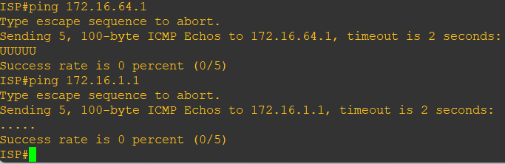

1. Now ping from ISP to the loopback 0 address of 172.16.32.1 on SanJose2 and the serial link between SanJose1 and SanJose2, 172.16.1.2.

**R1 Console**

ping 172.16.32.1

ping 172.16.1.2

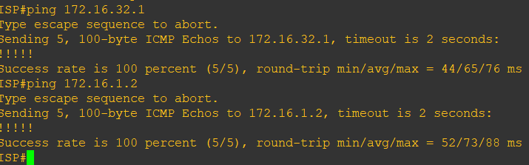

1. Issue the show ip bgp command on ISP to verify BGP routes and metrics.

**R1 Console**

show ip bgp

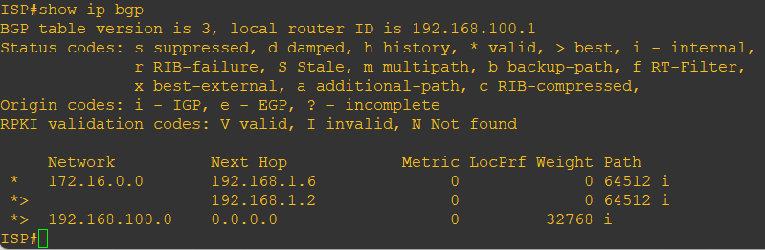

BGP operates differently than all other protocols. Unlike other routing protocols that use complex algorithms involving factors such as bandwidth, delay, reliability, and load to formulate a metric, BGP is policy-based. BGP determines the best path based on variables, such as AS path, weight, local preference, MED, and so on. If all things are equal, BGP prefers the route leading to the BGP speaker with the lowest BGP router ID. The SanJose2 router with BGP router ID 172.16.32.1 was preferred to the higher BGP router ID of the SanJose1 router (172.16.64.1).

1. At this point, the ISP router should be able to get to each network connected to SanJose1 and SanJose2 from the loopback address 192.168.100.1. Use the extended ping command and specify the source address of ISP Lo0 to test.

**R1 Console**

ping 172.16.1.1 source 192.168.100.1

ping 172.16.32.1 source 192.168.100.1

ping 172.16.1.2 source 192.168.100.1

ping 172.16.64.1 source 192.168.100.1

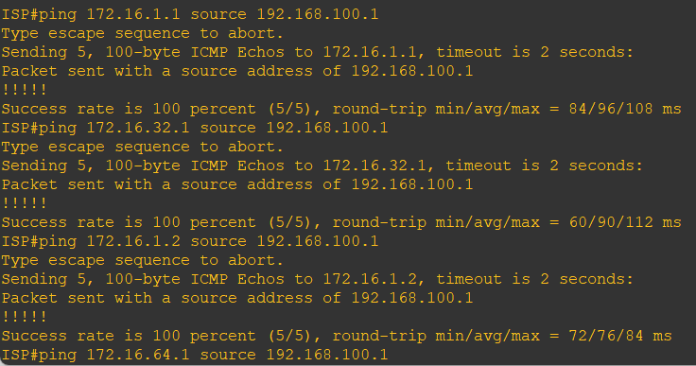

**Step 7:** Configure the BGP next-hop-self feature.

SanJose1 is unaware of the link between ISP and SanJose2, and SanJose2 is unaware of the link between ISP and SanJose1. Before ISP can successfully ping all the internal serial interfaces of AS 64512, these serial links should be advertised via BGP on the ISP router. This can also be resolved via EIGRP on each SanJose router. One method is for ISP to advertise these links.

1. Issue the following commands on the ISP router.

**R1 Console**

router bgp 200

network 192.168.1.0 mask 255.255.255.252

network 192.168.1.4 mask 255.255.255.252

1. Issue the show ip bgp command to verify that the ISP is correctly injecting its own WAN links into BGP.

**R1 Console**

show ip bgp

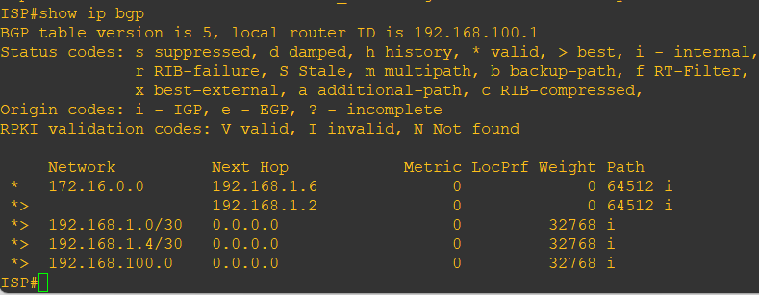

1. Verify on SanJose1 and SanJose2 that the opposite WAN link is included in the routing table. The output from SanJose2 is as follows.

**R3 Console**

show ip route

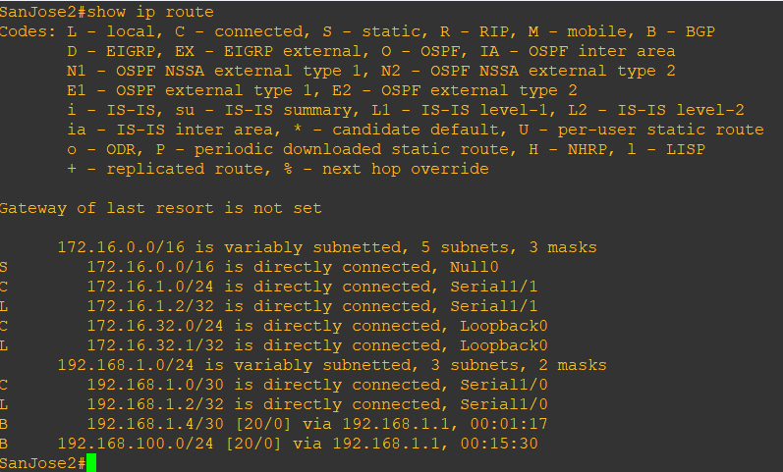

1. To better understand the next-hop-self command we will remove ISP advertising its two WAN links and shutdown the WAN link between ISP and SanJose2. The only possible path from SanJose2 to ISP’s 192.168.100.0/24 is through SanJose1.

**R1 Console**

router bgp 200

no network 192.168.1.0 mask 255.255.255.252

no network 192.168.1.4 mask 255.255.255.252

exit

int s1/1

shutdown

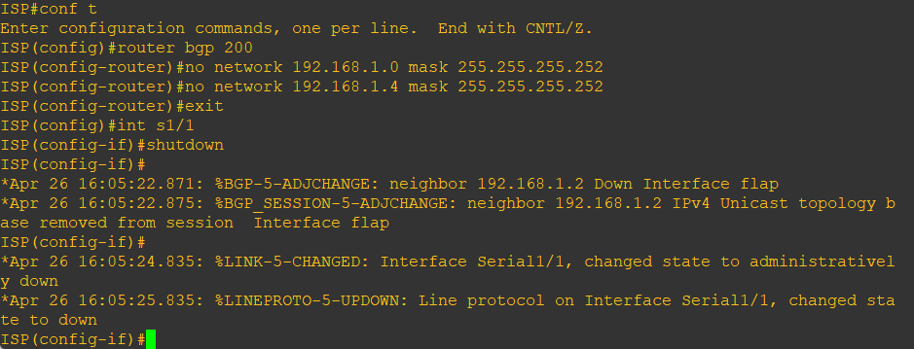

1. Display SanJose2’s BGP table using the show ip bgp command and the IPv4 routing table with show ip route.

**R3 Console**

show ip bgp

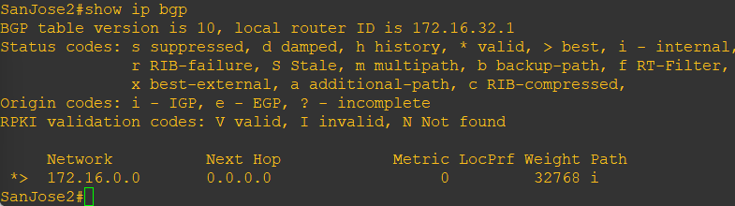

show ip route

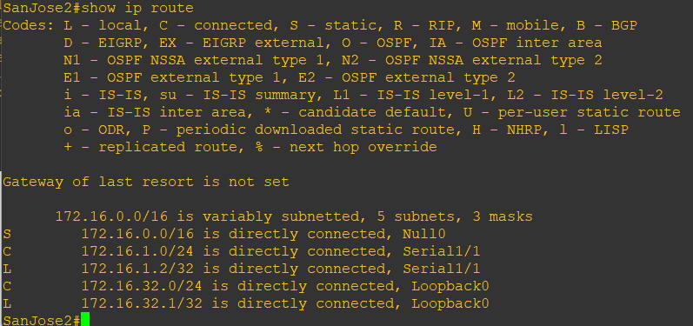

1. Issue the next-hop-self command on SanJose1 and SanJose2 to advertise themselves as the next hop to their IBGP peer.

**R2 Console**

router bgp 64512

neighbor 172.16.32.1 next-hop-self

router bgp 64512

neighbor 172.16.64.1 next-hop-self

1. Reset BGP operation on either router with the clear ip bgp * command.

**R2 Console**

clear ip bgp *

**R3 Console**

clear ip bgp *

1. After the routers have returned to established BGP speakers, issue the show ip bgp command on SanJose2 and notice that the next hop is now SanJose1 instead of ISP.

**R3 Console**

show ip bgp

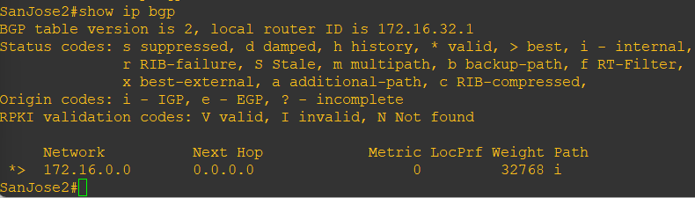

1. The show ip route command on SanJose2 now displays the 192.168.100.0/24 network because SanJose1 is the next hop, 172.16.64.1, which is reachable from SanJose2.

**R3 Console**

show ip route

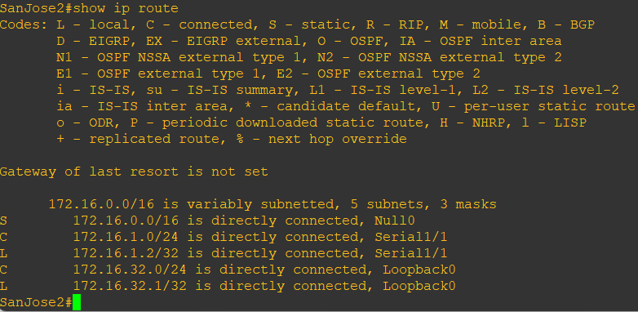

1. Before configuring the next BGP attribute, restore the WAN link between ISP and SanJose3. This will change the BGP table and routing table on both routers. For example, SanJose2’s routing table shows 192.168.100.0/24 will now have a better path through ISP.

**R1 Console**

int s1/1

no shut

**R3 Console**

show ip route

**Step 8:** Set BGP local preference.

At this point, everything looks good, with the exception of default routes, the outbound flow of data, and inbound packet flow.

1. Because the local preference value is shared between IBGP neighbors, configure a simple route map that references the local preference value on SanJose1 and SanJose2. This policy adjusts outbound traffic to prefer the link off the SanJose1 router instead of the metered T1 off SanJose2.

**R2 Console**

route-map PRIMARY_T1_IN permit 10

set local-preference 150

exit

router bgp 64512

neighbor 192.168.1.5 route-map PRIMARY_T1_IN in

**R3 Console**

route-map SECONDARY_T1_IN permit 10

set local-preference 125

exit

router bgp 64512

neighbor 192.168.1.1 route-map SECONDARY_T1_IN in

1. Use the clear ip bgp * soft command after configuring this new policy. When the conversations have been reestablished, issue the show ip bgp command on SanJose1 and SanJose2.

**R2 Console**

clear ip bgp * soft

**R3 Console**

clear ip bgp * soft

**R2 Console**

show ip bgp

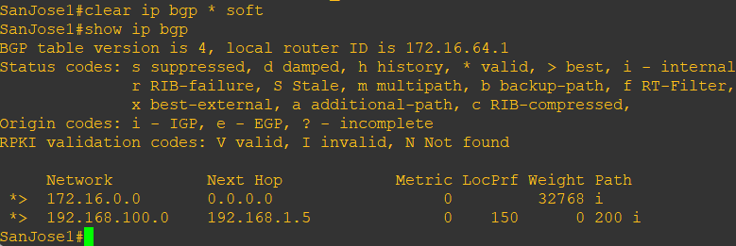

**R3 Console**

show ip bgp

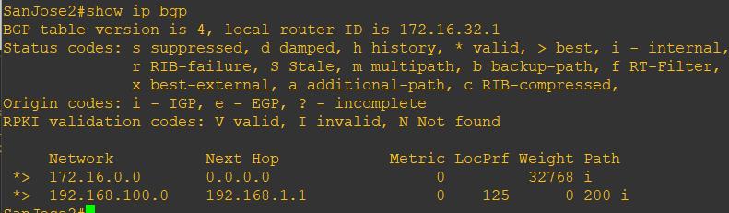

This now indicates that routing to the loopback segment for ISP 192.168.100.0 /24 can be reached only through the link common to SanJose1 and ISP. SanJose2’s next hop to 192.168.100.0/24 is SanJose1 because both routers have been configured using the next-hop-self command.

Step 9: Set BGP MED.

1. In the previous step we saw that SanJose1 and SanJose2 will route traffic for 192.168.100.0/24 using the link between SanJose1 and ISP. Examine what the return path ISP takes to reach AS 64512. Notice that the return path is different from the original path. This is known as asymmetric routing and is not necessarily an unwanted trait.

**R1 Console**

show ip bgp

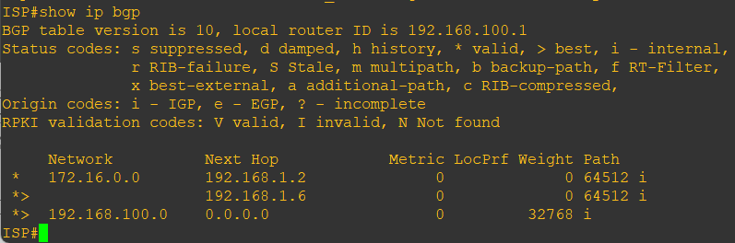

show ip route

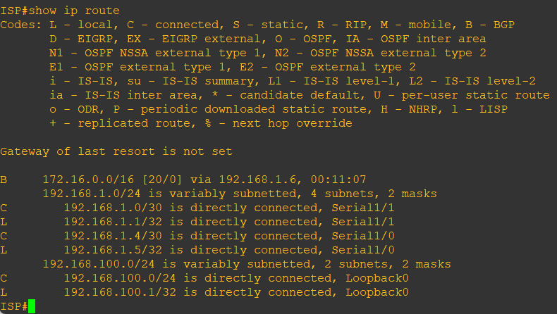

How will traffic from network 192.168.100.0 /24 on ISP return to SanJose1 or SanJose2? Will it be routed through SanJose1 or SanJose2?

_______________________________________________________________

To verify this, the simplest solution is to issue the show ip bgp command on the ISP router as was done above. What if access was not given to the ISP router? Traffic returning from the Internet should not be passed across the metered T1. Is there a simple way to verify before receiving the monthly bill? How can it be checked instantly?

__________________________________________________________________

1. Use an extended ping command to verify this situation. Specify the record option and compare your output to the following. Notice the return path using the exit interface 192.168.1.1 to SanJose2.

**R3 Console:**

ping

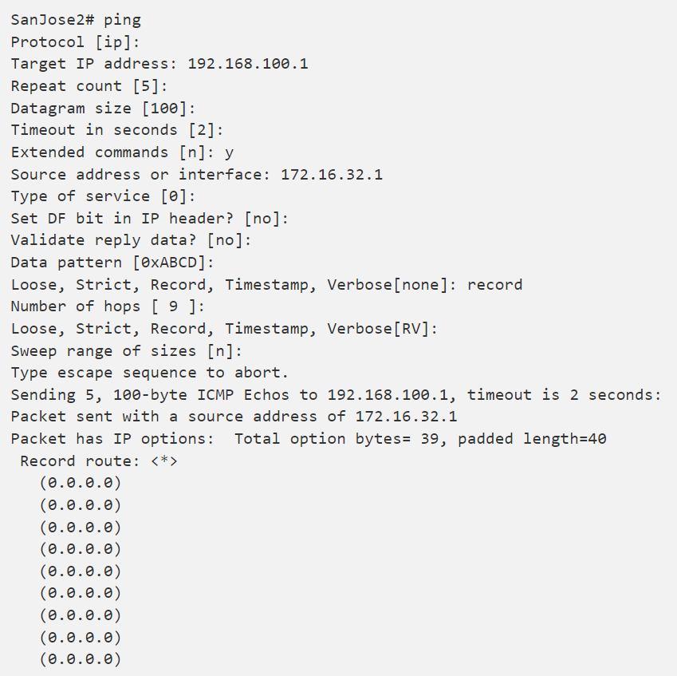 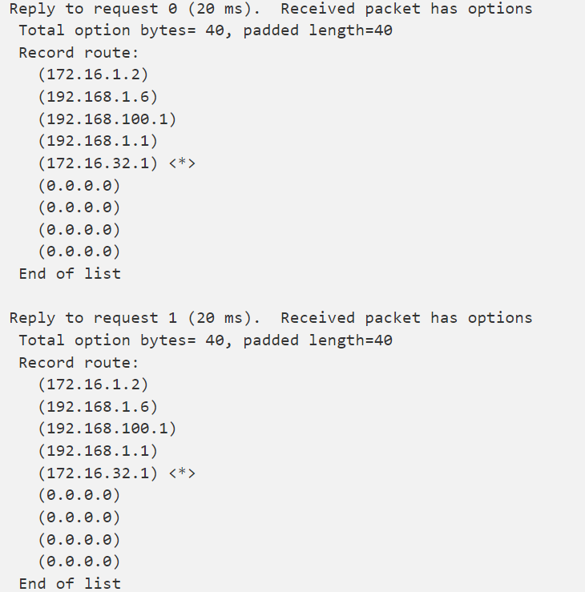

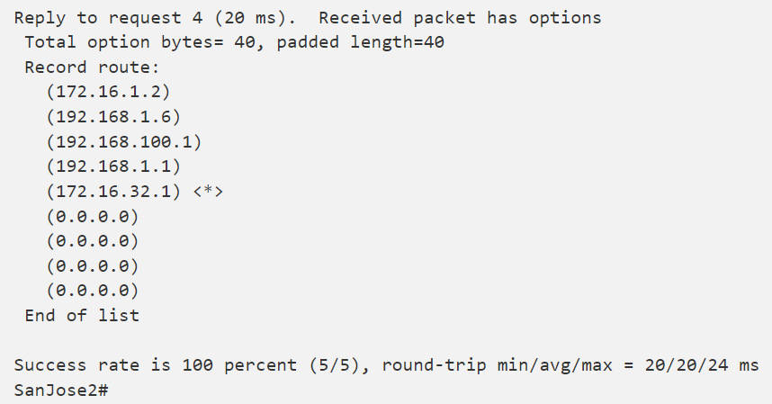

If you are unfamiliar with the record option, the important thing to note is that each IP address in brackets is an outgoing interface. The output can be interpreted as follows:

1. A ping that is sourced from 172.16.32.1 exits SanJose2 through s0/0/1, 172.16.1.2. It then arrives at the s0/0/1 interface for SanJose1.

2. SanJose1 S0/0/0, 192.168.1.6, routes the packet out to arrive at the S0/0/0 interface of ISP.

3. The target of 192.168.100.1 is reached: 192.168.100.1.

4. The packet is next forwarded out the S0/0/1, 192.168.1.1 interface for ISP and arrives at the S0/0/0 interface for SanJose2.

5. SanJose2 then forwards the packet out the last interface, loopback 0, 172.16.32.1.

Although the unlimited use of the T1 from SanJose1 is preferred here, ISP currently takes the link from SanJose2 for all return traffic.

1. Create a new policy to force the ISP router to return all traffic via SanJose1. Create a second route map utilizing the MED (metric) that is shared between EBGP neighbors.

**R2 Console**

route-map PRIMARY_T1_MED_OUT permit 10

set Metric 50

exit

router bgp 64512

neighbor 192.168.1.5 route-map PRIMARY_T1_MED_OUT out

**R3 Console**

route-map SECONDARY_T1_MED_OUT permit 10

set Metric 75

exit

router bgp 64512

neighbor 192.168.1.1 route-map SECONDARY_T1_MED_OUT out

1. Use the clear ip bgp * soft command after issuing this new policy. Issuing the show ip bgp command as follows on SanJose1 or SanJose2 does not indicate anything about this newly defined policy.

**R2 Console**

clear ip bgp * soft

**R3 Console**

clear ip bgp * soft

**R2 Console**

show ip bgp

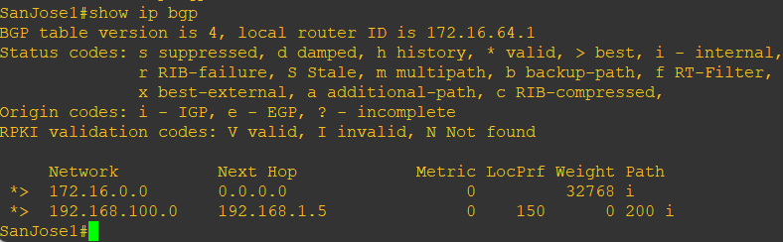

**R3 Console**

show ip bgp

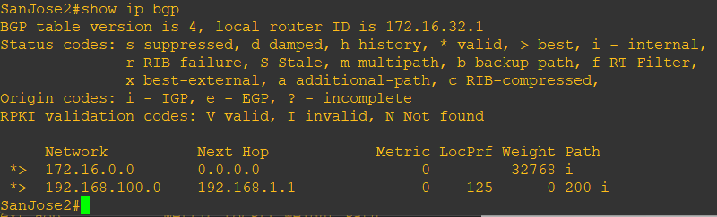

1. Reissue an extended ping command with the record command. Notice the change in return path using the exit interface 192.168.1.5 to SanJose1.

**R3 Console**

ping

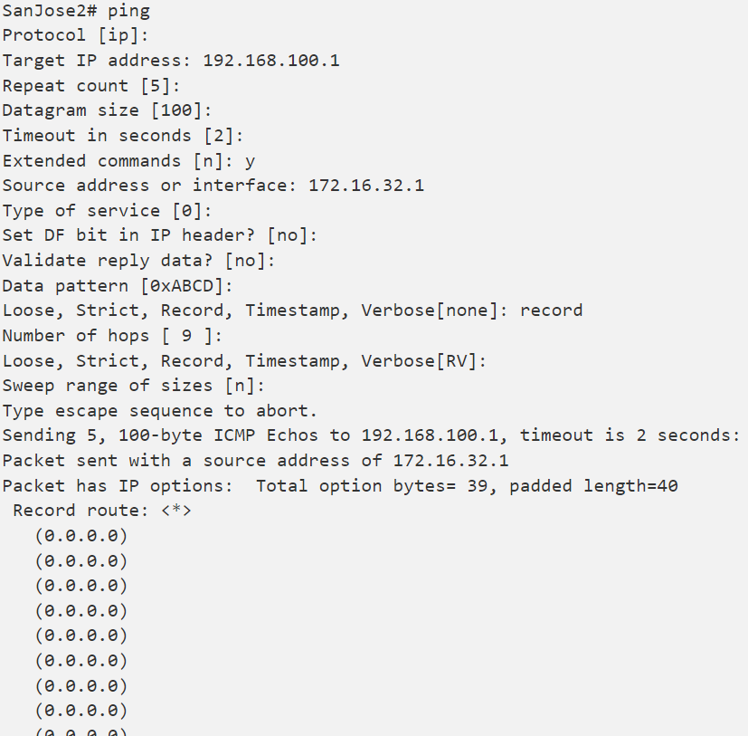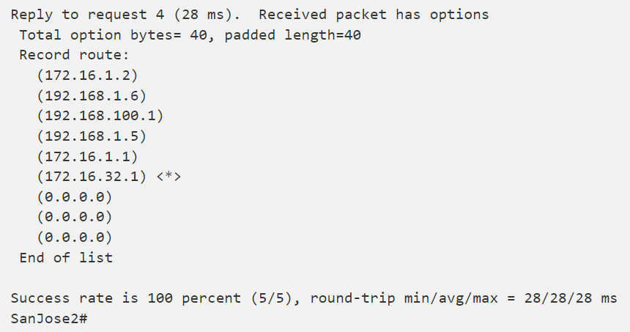

The newly configured policy MED shows that the lower MED value is considered best. The ISP now prefers the route with the lower MED value of 50 to AS 64512. This is just opposite from the local-preference command configured earlier.

**R1 Console**

show ip bgp

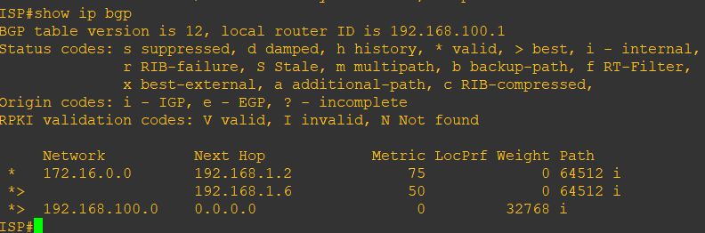

**Step 10:** Establish a default route.

The final step is to establish a default route that uses a policy statement that adjusts to changes in the network.

1. Configure ISP to inject a default route to both SanJose1 and SanJose2 using BGP using the default-originate command. This command does not require the presence of 0.0.0.0 in the ISP router. Configure the 10.0.0.0/8 network which will not be advertised using BGP. This network will be used to test the default route on SanJose1 and SanJose2.

**R1 Console**

router bgp 200

neighbor 192.168.1.6 default-originate

neighbor 192.168.1.2 default-originate

exit

int lo10

ip address 10.0.0.1 255.255.255.0

1. Verify that both routers have received the default route by examining the routing tables on SanJose1 and SanJose2. Notice that both routers prefer the route between SanJose1 and ISP.

**R2 Console**

show ip route

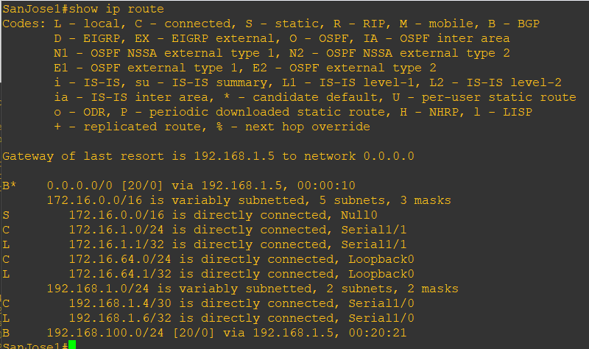

**R3 Console**

show ip route

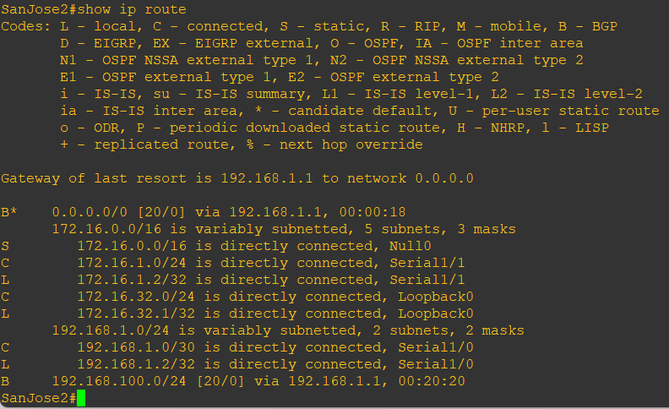

1. The preferred default route is by way of SanJose1 because of the higher local preference attribute configured on SanJose1 earlier.

**R3 Console**

show ip bgp

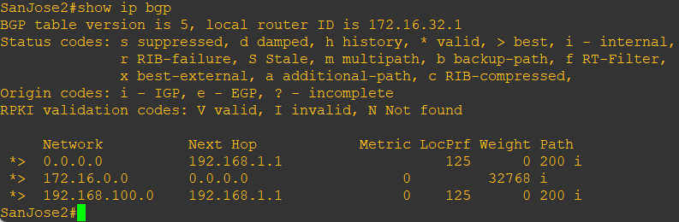

1. Using the traceroute command verify that packets to 10.0.0.1 is using the default route through SanJose1.

**R3 Console**

traceroute 10.0.0.1

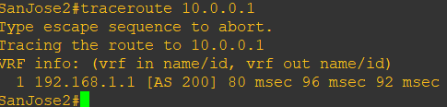

1. Next, test how BGP adapts to using a different default route when the path between SanJose1 and ISP goes down.

**R1 Console**

int s1/0

shutdown

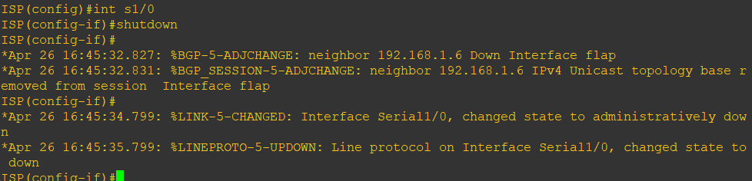

1. Verify that both routers are modified their routing tables with the default route using the path between SanJose2 and ISP.

**R2 Console**

show ip route

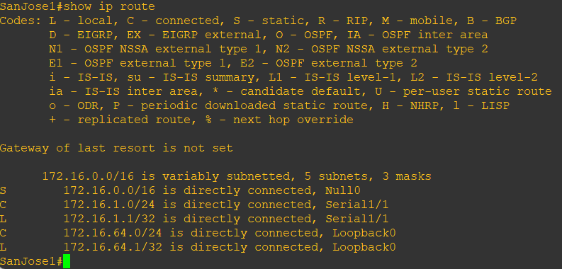

**R3 Console**

show ip route

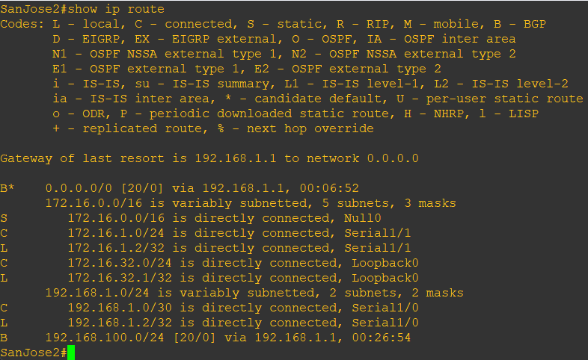

1. Verify the new path using the traceroute command to 10.0.0.1 from SanJose1. Notice the default route is now through SanJose2.

**R1 Console**

trace 10.0.0.1

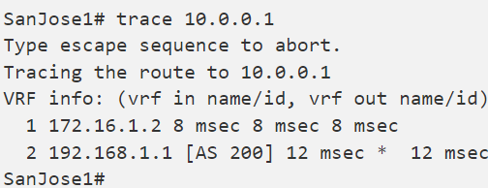

# **Practical 4**

**Aim: Secure the Management Plane**

**Topology:**

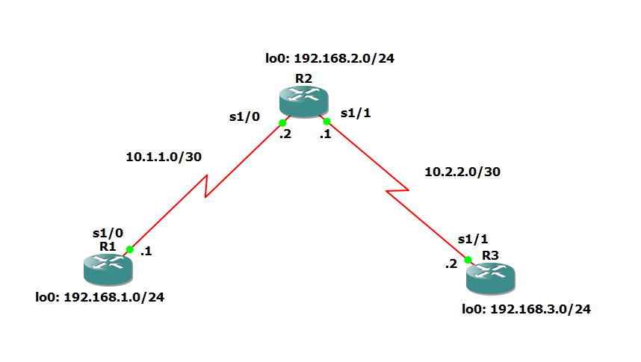

**Objectives:**

* Secure management access.
* Configure enhanced username password security.
* Enable AAA RADIUS authentication.
* Enable secure remote management.

**Background:**

The management plane of any infrastructure device should be protected as much as possible. Controlling access to routers and enabling reporting on routers are critical to network security and should be part of a comprehensive security policy.

In this lab, you build a multi-router network and secure the management plane of routers R1 and R3. Authentication, authorization, and accounting AAA is a set of services for controlling access to computer resources, enforcing policies, assessing usage, and providing the information necessary to bill for services.

**Note:** This lab uses Cisco 1941 routers with Cisco IOS Release 15.2 with IP Base. Depending on the router or switch model and Cisco IOS Software version, the commands available and output produced might vary from what is shown in this lab.

**Required Resources:**

* 3 routers (Cisco IOS Release 15.2 or comparable)
* Serial and Ethernet cables

**Step 1:** Configure loopbacks and assign addresses.

Cable the network as shown in the topology diagram. Erase the startup configuration and reload each router to clear previous configurations. Using the addressing scheme in the diagram, apply the IP addresses to the interfaces on the R1, R2, and R3 routers.

**Note:** Depending on the router model, interfaces might be numbered differently than those listed. You might need to alter the designations accordingly.

**R1 Console**

hostname R1

int lo0

description R1 LAN

ip address 192.168.1.1 255.255.255.0

exit

int s1/0

description R1 --> R2

ip address 10.1.1.1 255.255.255.252

clock rate 128000

no shut

exit

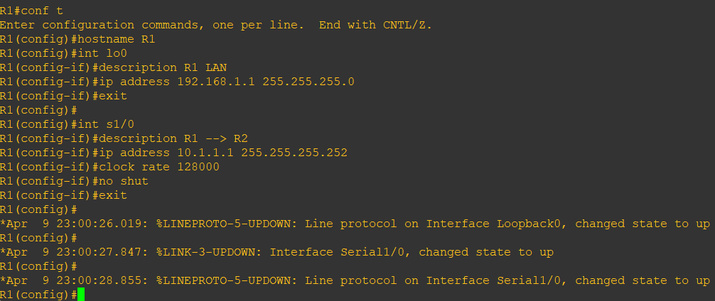

**R2 Console**

hostname R2

int s1/0

description R2 --> R1

ip address 10.1.1.2 255.255.255.252

no shut

exit

int s1/1

description R2-->R3

ip address 10.2.2.1 255.255.255.252

clock rate 128000

no shut

exit

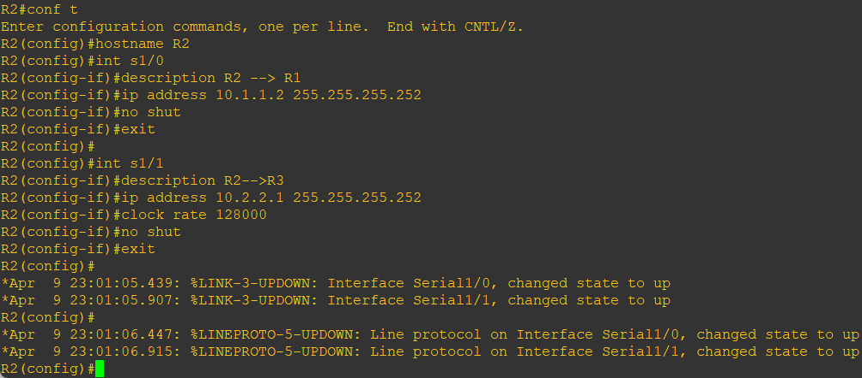

**R3 Console**

hostname R3

int lo0

description R3 LAN

ip address 192.168.3.1 255.255.255.0

exit

int s1/1

description R3 --> R2

ip address 10.2.2.2 255.255.255.252

no shutdown

exit

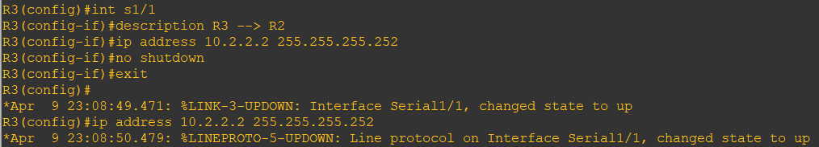

**Step 2:** Configure static routes.

1. On R1, configure a default static route to ISP.

**R1 Console** ip route 0.0.0.0 0.0.0.0 10.1.1.2

1. On R3, configure a default static route to ISP.

**R3 Console** ip route 0.0.0.0 0.0.0.0 10.2.2.1

1. On R2, configure two static routes.

**R2 Console** ip route 192.168.1.0 255.255.255.0 10.1.1.1

**R2 Console** ip route 192.168.3.0 255.255.255.0 10.2.2.2

1. From the R1 router, run the following Tcl script to verify connectivity.

**R1 Console**

tclsh

foreach address {

192.168.1.1

10.1.1.1

10.1.1.2

10.2.2.1

10.2.2.2

192.168.3.1

} { ping $address }

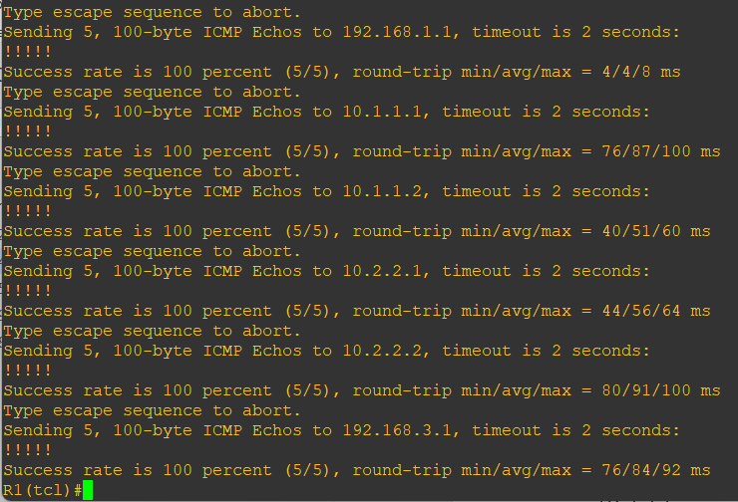

**Step 3:** Secure management access.

1. On R1, use the security passwords command to set a minimum password length of 10 characters.

**R1 Console** security passwords min-length 10

1. Configure the enable secret encrypted password on both routers.

**R1 Console** enable secret class12345

**Note:** Passwords in this task are set to a minimum of 10 characters but are relatively simple for the benefit of performing the lab. More complex passwords are recommended in a production network.

1. Configure a console password and enable login for routers. For additional security, the exec-timeout command causes the line to log out after 5 minutes of inactivity. The logging synchronous command prevents console messages from interrupting command entry.

**Note:** To avoid repetitive logins during this lab, the exec-timeout command can be set to 0 0, which prevents it from expiring. However, this is not considered a good security practice.

**R1 Console**

line console 0

password ciscoconpass

exec-timeout 5 0

login

logging synchronous

exit

1. Configure the password on the vty lines for router R1. (Virtual Teletype)

**R1 Console**

line vty 0 4

password ciscovtypass

exec-timeout 5 0

login

exit

1. The aux port is a legacy port used to manage a router remotely using a modem and is hardly ever used. Therefore, disable the aux port.

**R1 Console**

line aux 0

no exec

end

1. Enter privileged EXEC mode and issue the show run command. Can you read the enable secret password? Why or why not?

No, the enable secret password is encrypted automatically using the MD5 or SHA hash algorithm. IOS 15.0(1)S and later default to SHA256 hashing algorithm. SHA256 which is considered to be a very strong hashing algorithm and is extremely difficult to reverse. Earlier IOS versions use the weaker MD5 hashing algorithm.

**Note:** If the enable secret password command is lost or forgotten, it must be replaced using the Cisco router password recovery procedure. Refer to cisco.com for more information.

Can you read the console, aux, and vty passwords?

Yes. They are all in clear text.

1. Use the service password-encryption command to encrypt the line console and vty passwords.

**R1 Console**

service password-encryption

**Note:** Password encryption is applied to all the passwords, including the username passwords, the authentication key passwords, the privileged command password, the console and the virtual terminal line access passwords, and the BGP neighbor passwords.

1. Issue the show run command. Can you read the console, aux, and vty passwords? Why or why not?

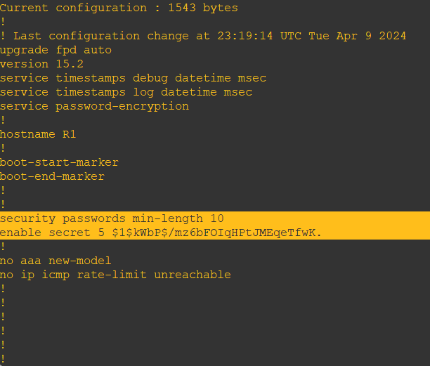

No. The passwords are now encrypted.

Note: Type 7 passwords are encrypted using a Vigenère cipher which can be easily reversed. Therefore, this command primarily protects from shoulder surfing attacks

1. Configure a warning to unauthorized users with a message-of-the-day (MOTD) banner using the banner motd command. When a user connects to one of the routers, the MOTD banner appears before the login prompt. In this example, the dollar sign ($) is used to start and end the message.

**R1 Console**

banner motd $Unauthorized access strictly prohibited!$

exit

1. Issue the show run command. What does the $ convert to in the output?

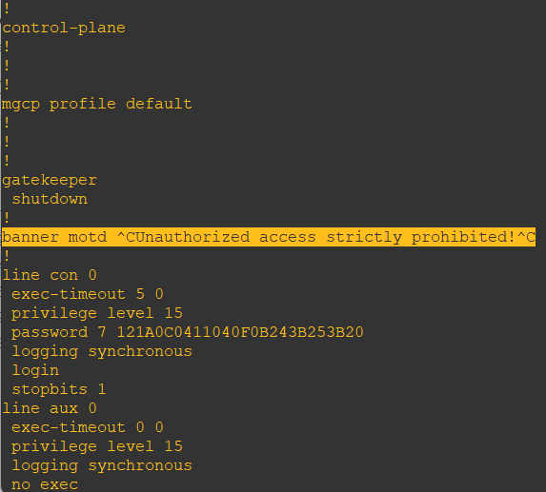

The $ is converted to ^C when the running-config is displayed.

1. Exit privileged EXEC mode using the disable or exit command and press Enter to get started. Does the MOTD banner look like what you created with the banner motd command? If the MOTD banner is not as you wanted it, recreate it using the banner motd command.
2. Repeat the configuration portion of steps 3a through 3k on router R3.

**Step 4:** Configure enhanced username password security.

To increase the encryption level of console and VTY lines, it is recommended to enable authentication using the local database. The local database consists of usernames and password combinations that are created locally on each device. The local and VTY lines are configured to refer to the local database when authenticating a user.

1. To create local database entry encrypted to level 4 (SHA256), use the username name secret password global configuration command. In global configuration mode, enter the following command:

**R1 Console**

username JR-ADMIN secret class12345

username ADMIN secret class54321

1. Set the console line to use the locally defined login accounts.

**R1 Console**

line console 0

login local

exit

1. Set the vty lines to use the locally defined login accounts.

**R1 Console**

line vty 0 4

login local

end

1. Repeat the steps 4a to 4c on R3.
2. To verify the configuration, telnet to R3 from R1 and login using the ADMIN local database account.

**R1 Console**

telnet 10.2.2.2

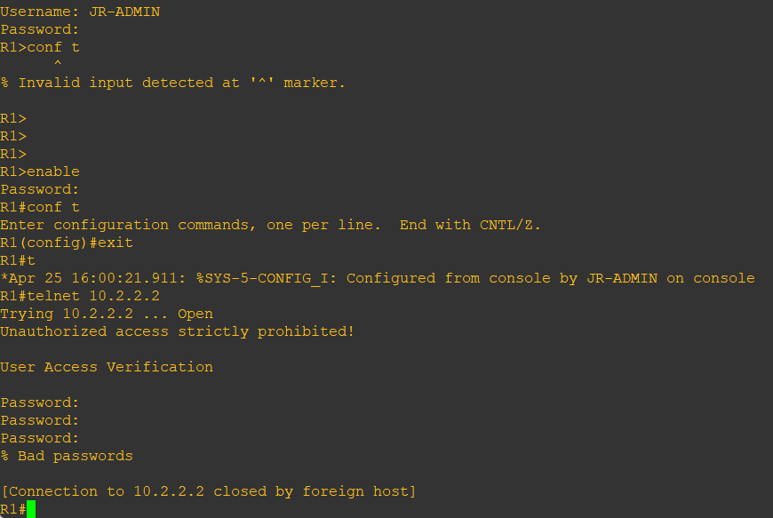

**Step 5:** Enabling AAA RADIUS Authentication with Local User for Backup.

Authentication, authorization, and accounting (AAA) is a standards-based framework that can be implemented to control who is permitted to access a network (authenticate), what they can do on that network (authorize), and audit what they did while accessing the network (accounting).

1. Always have local database accounts created before enabling AAA. Since we created two local database accounts in the previous step, then we can proceed and enable AAA on R1.

**R1 Console**

aaa new-model

1. Configure the specifics for the first RADIUS server located at 192.168.1.101. Use RADIUS-1-pa55w0rd as the server password.

**R1 Console**

radius server RADIUS-1

address ipv4 192.168.1.101

key RADIUS-1-pa55w0rd

exit

1. Configure the specifics for the second RADIUS server located at 192.168.1.102. Use RADIUS-2-pa55w0rd as the server password.

**R1 Console**

radius server RADIUS-2

address ipv4 192.168.1.102

key RADIUS-2-pa55w0rd

exit

1. Assign both RADIUS servers to a server group.

**R1 Console**

aaa group server radius RADIUS-GROUP

server name RADIUS-1

server name RADIUS-2

exit

1. Enable the default AAA authentication login to attempt to validate against the server group. If they are not available, then authentication should be validated against the local database.

R1(config)# aaa authentication login default group RADIUS-GROUP local

1. Enable the default AAA authentication Telnet login to attempt to validate against the server group. If they are not available, then authentication should be validated against a case sensitive local database.

R1(config)# aaa authentication login TELNET-LOGIN group RADIUS-GROUP local-case

1. Alter the VTY lines to use the TELNET-LOGIN AAA authentiaito0n method.

R1(config)# line vty 0 4

login authentication TELNET-LOGIN

exit

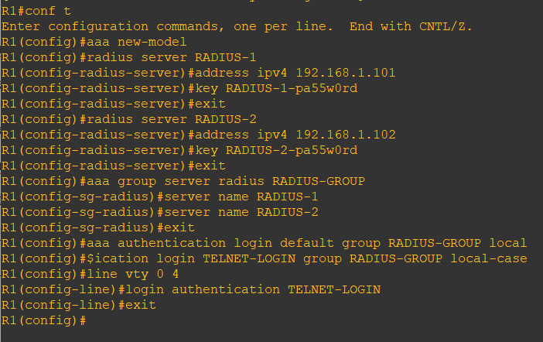

h. Repeat the steps 5a to 5g on R3.

i. To verify the configuration, telnet to R3 from R1 and login using the ADMIN local database account.

R1# telnet 10.2.2.2

**Step 6:** Enabling secure remote management using SSH.

1. SSH requires that a device name and a domain name be configured. Since the router already has a name assigned, configure the domain name.

R1(config)# ip domain-name ccnasecurity.com

1. The router uses the RSA key pair for authentication and encryption of transmitted SSH data. Although optional it may be wise to erase any existing key pairs on the router.

R1(config)# crypto key zeroize rsa

**Note:** If no keys exist, you might receive this message: % No Signature RSA Keys found in configuration.

1. Generate the RSA encryption key pair for the router. Configure the RSA keys with 1024 for the number of modulus bits. The default is 512, and the range is from 360 to 2048.

R1(config)# crypto key generate rsa general-keys modulus 1024

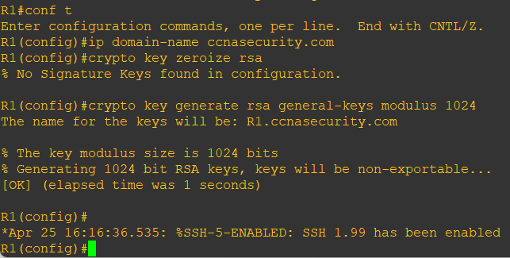

1. Cisco routers support two versions of SSH:

• SSH version 1 (SSHv1): Original version but has known vulnerabilities.

• SSH version 2 (SSHv2): Provides better security using the Diffie-Hellman key exchange and the strong integrity-checking message authentication code (MAC).

Configure SSH version 2 on R1.

R1(config)# ip ssh version 2

1. Configure the vty lines to use only SSH connections.

R1(config)# line vty 0 4

transport input ssh

end

1. Verify the SSH configuration using the show ip ssh command.

R1# show ip ssh

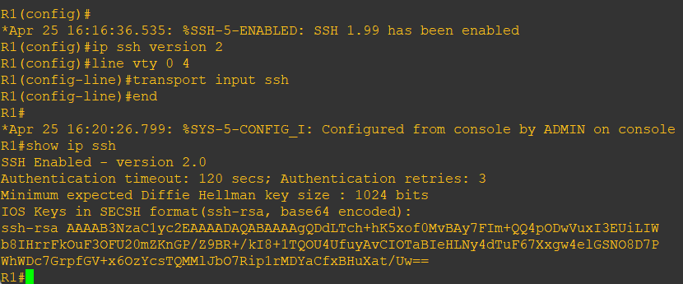

1. Repeat the steps 6a to 6f on R3.
2. Although a user can SSH from a host using the SSH option of TeraTerm of PuTTY, a router can also SSH to another SSH enabled device. SSH to R3 from R1.

R1# ssh -l ADMIN 10.2.2.2

# **Practical 5**

**Aim: Configure and Verify Path Control Using PBR**

**Topology:**

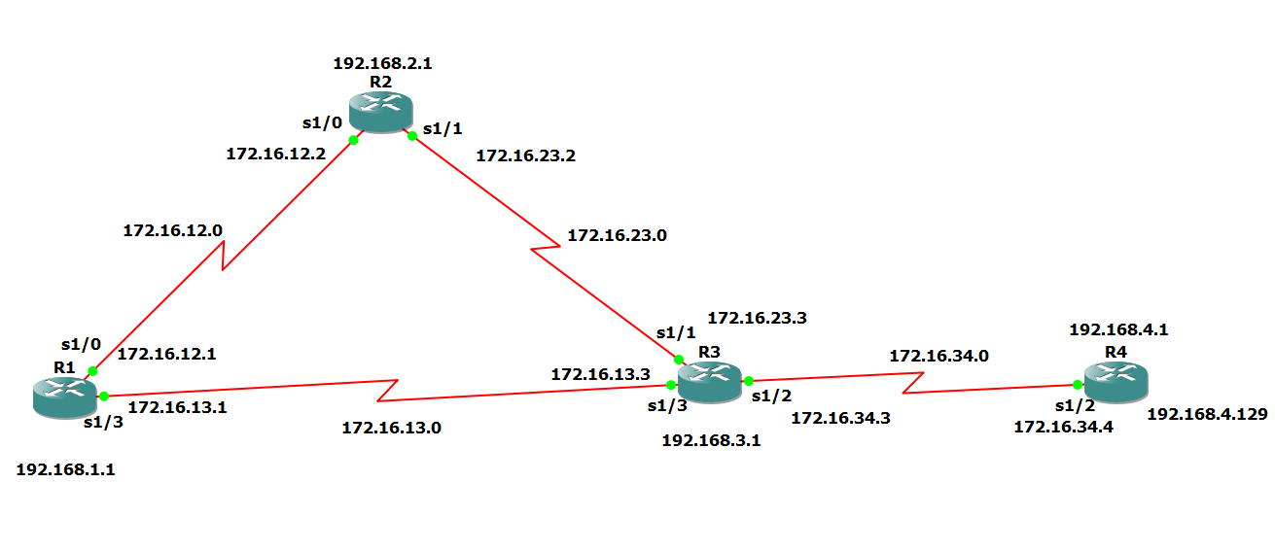

**Step 1: Configure loopbacks and assign addresses.**

a) Cable the network as shown in the topology diagram. Erase the startup configuration, and

reload each router to clear previous configurations.

b) Using the addressing scheme in the diagram, create the loopback interfaces and apply IP

addresses to these and the serial interfaces on R1, R2, R3, and R4. On the serial interfaces

connecting R1 to R3 and R3 to R4, specify the bandwidth as 64 Kb/s and set a clock rate on

the DCE using the clock rate 64000 command. On the serial interfaces connecting R1 to R2

and R2 to R3, specify the bandwidth as 128 Kb/s and set a clock rate on the DCE using the

clock rate 128000 command.

**Router R1 Console**

interface Lo1

description R1 LAN

ip address 192.168.1.1 255.255.255.0

exit

interface S1/0

description R1 --> R2

ip address 172.16.12.1 255.255.255.248

clock rate 128000

bandwidth 128

no shutdown

exit

interface S1/3

description R1 --> R3

ip address 172.16.13.1 255.255.255.248

bandwidth 64

no shutdown

exit

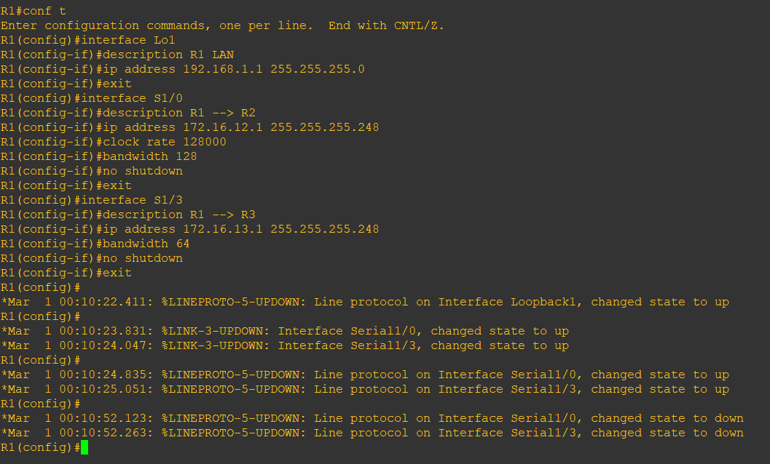

**Router R2 Console**

interface Lo2

description R2 LAN

ip address 192.168.2.1 255.255.255.0

exit

interface S1/0

description R2 --> R1

ip address 172.16.12.2 255.255.255.248

bandwidth 128

no shutdown

exit

interface S1/1

description R2 --> R3

ip address 172.16.23.2 255.255.255.248

clock rate 128000

bandwidth 128

no shutdown

exit

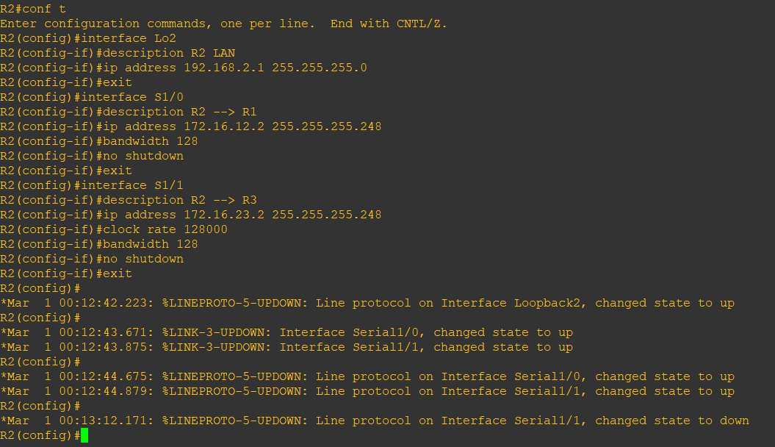

**Router R3 Console**

interface Lo3

description R3 LAN

ip address 192.168.3.1 255.255.255.0

exit

interface S1/3

description R3 --> R1

ip address 172.16.13.3 255.255.255.248

clock rate 64000

bandwidth 64

no shutdown

exit

interface S1/1

description R3 --> R2

ip address 172.16.23.3 255.255.255.248

bandwidth 128

no shutdown

exit

interface S1/2

description R3 → R4

ip address 172.16.34.3 255.255.255.248

clock rate 64000

bandwidth 64

no shutdown

exit

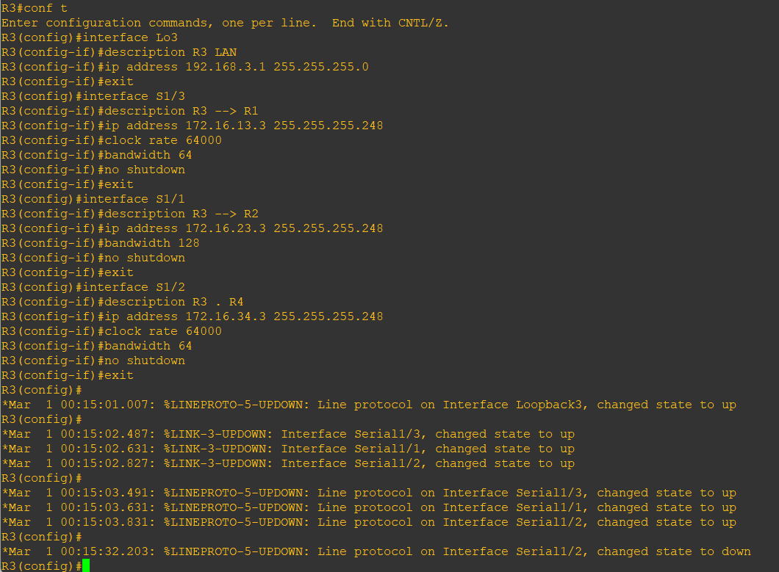

**Router R4 Console**

interface Lo4

description R4 LAN A

ip address 192.168.4.1 255.255.255.128

exit

interface Lo5

description R4 LAN B

ip address 192.168.4.129 255.255.255.128

exit

interface S1/2

description R4 → R3

ip address 172.16.34.4 255.255.255.248

bandwidth 64

no shutdown

exit

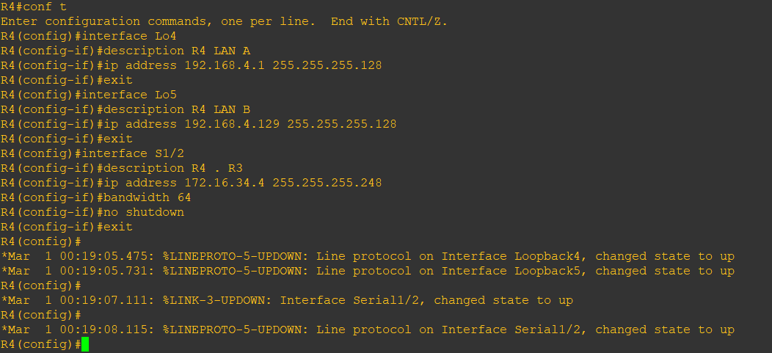

c) Verify the configuration with the show ip interface brief, show interfaces description

commands. The output from router R3 is shown below.

**Router R3 Console**

show ip interface brief | include up

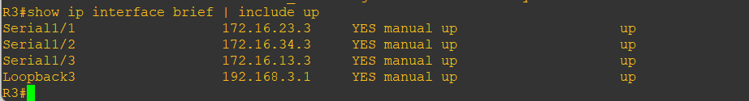

show interfaces description | include up

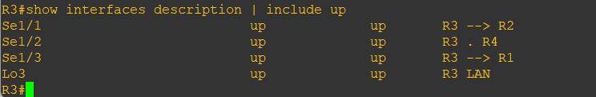

**Step 3: Configure basic EIGRP**

a) Implement EIGRP AS 1 over the serial and loopback interfaces as you have configured it

for the other EIGRP labs.

b) Advertise networks 172.16.12.0/29, 172.16.13.0/29, 172.16.23.0/29, 172.16.34.0/29,

192.168.1.0/24, 192.168.2.0/24, 192.168.3.0/24, and 192.168.4.0/24 from their respective

routers.

**Router R1 Console**

router eigrp 1

network 192.168.1.0

network 172.16.12.0 0.0.0.7

network 172.16.13.0 0.0.0.7

no auto-summary

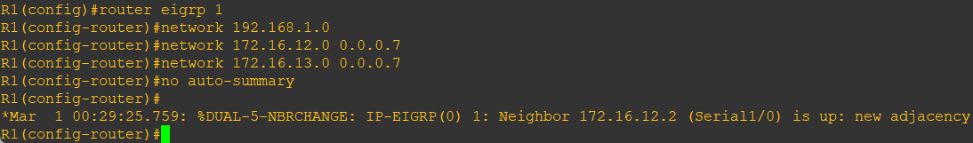

**Router R2 Console**

router eigrp 1

network 192.168.2.0

network 172.16.12.0 0.0.0.7

network 172.16.23.0 0.0.0.7

no auto-summary

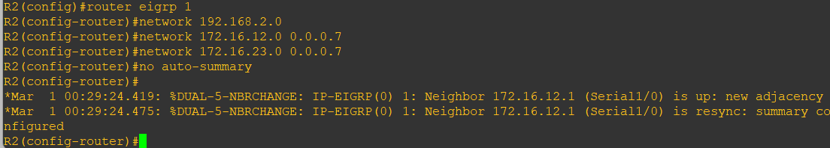

**Router R3 Console**

router eigrp 1

network 192.168.3.0

network 172.16.13.0 0.0.0.7

network 172.16.23.0 0.0.0.7

network 172.16.34.0 0.0.0.7

no auto-summary

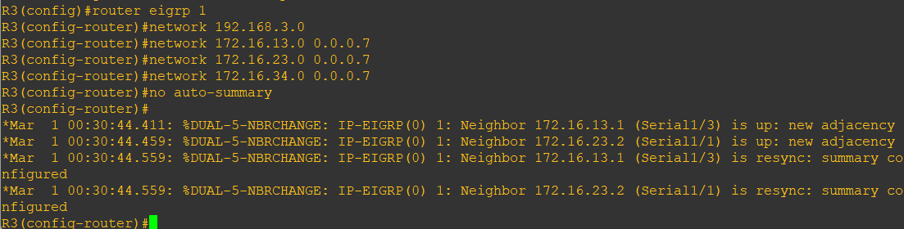

**Router R4 Console**

router eigrp 1

network 192.168.4.0

network 172.16.34.0 0.0.0.7

no auto-summary

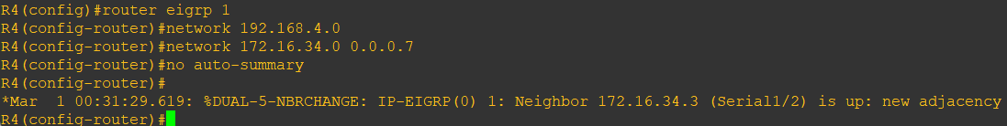

**Step 4: Verify EIGRP connectivity.**

a) Verify the configuration by using the show ip eigrp neighbors command to check which

routers have EIGRP adjacencies.

**Router R1 Console**

show ip eigrp neighbors

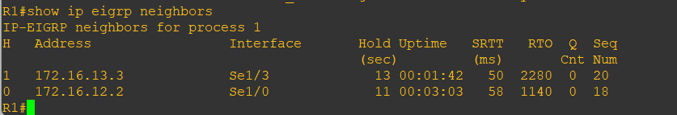

**Router R2 Console**

show ip eigrp neighbors

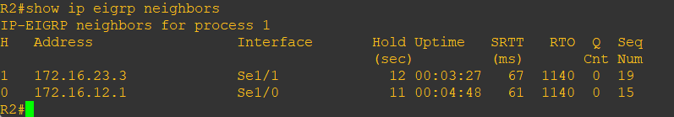

**Router R3 Console**

show ip eigrp neighbors

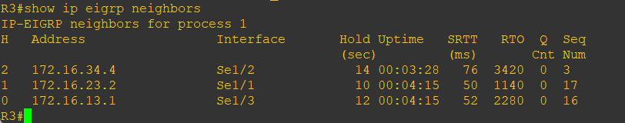

**Router R4 Console**

show ip eigrp neighbors

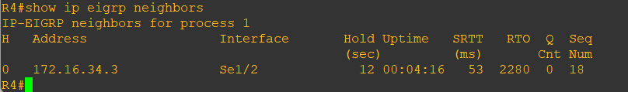

b) Run the following Tcl script on all routers to verify full connectivity.

**Router R1 Console**

tclsh

foreach address {

172.16.12.1

172.16.12.2

172.16.13.1

172.16.13.3

172.16.23.2

172.16.23.3

172.16.34.3

172.16.34.4

192.168.1.1

192.168.2.1

192.168.3.1

192.168.4.1

192.168.4.129

} { ping $address }

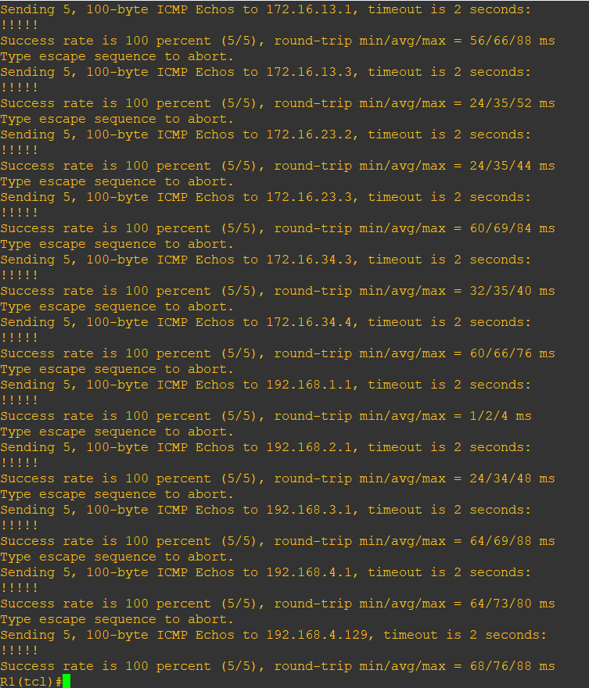

**Step 5: Verify the current path.**

Before you configure PBR, verify the routing table on R1.

a) On R1, use the show ip route command. Notice the next-hop IP address for all networks

discovered by EIGRP.

**Router R1 Console**

show ip route | begin Gateway

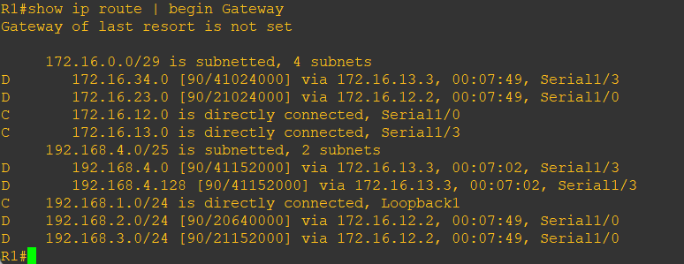

b) On R4, use the traceroute command to the R1 LAN address and source the ICMP packet

from R4 LAN A and LAN B.

**Note:** You can specify the source as the interface address (for example 192.168.4.1) or the

interface designator (for example, Fa0/0).

**Router R4 Console**

traceroute 192.168.1.1 source 192.168.4.1 (R4 LAN A)

traceroute 192.168.1.1 source 192.168.4.129 (R4 LAN B)

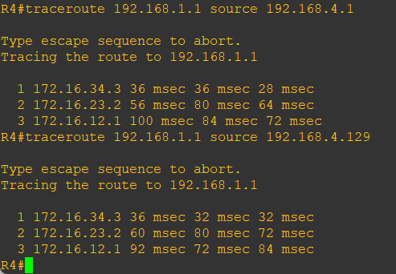

Notice that the path taken for the packets sourced from the R4 LANs are going through R3-->R2-->R1.

c) On R3, use the show ip route command and note that the preferred route from R3 to R1

LAN 192.168.1.0/24 is via R2 using the R3 exit interface S1/1.

**Router R3 Console**

show ip route | begin Gateway

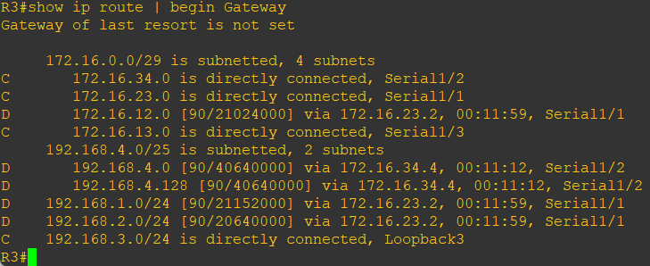

d) On R3, use the show interfaces S1/3 and show interfaces S1/1 commands.

**Router R3 Console**

show interfaces S1/3

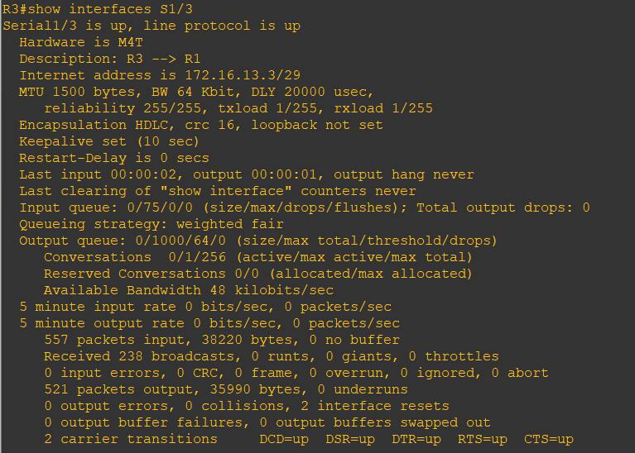

**Router R3 Console**

show interfaces S1/1

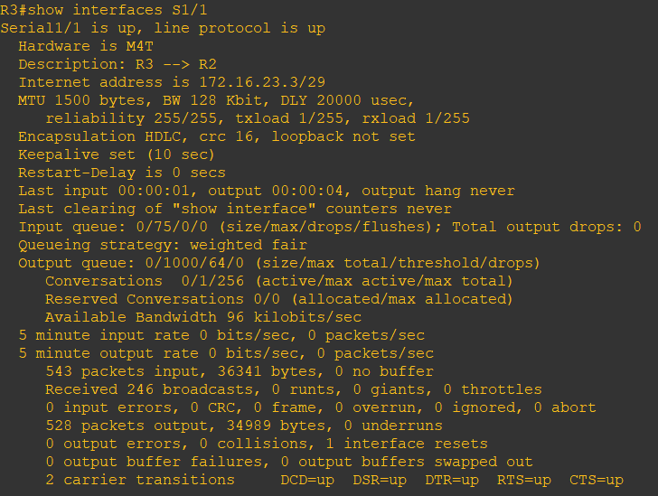

Notice that the bandwidth of the serial link between R3 and R1 (S1/3) is set to 64 Kb/s, while

the bandwidth of the serial link between R3 and R2 (S1/1) is set to 128 Kb/s.

e) Confirm that R3 has a valid route to reach R1 from its serial 0/0/0 interface using the show

ip eigrp topology 192.168.1.0 command.

**Router R3 Console**

show ip eigrp topology 192.168.1.0

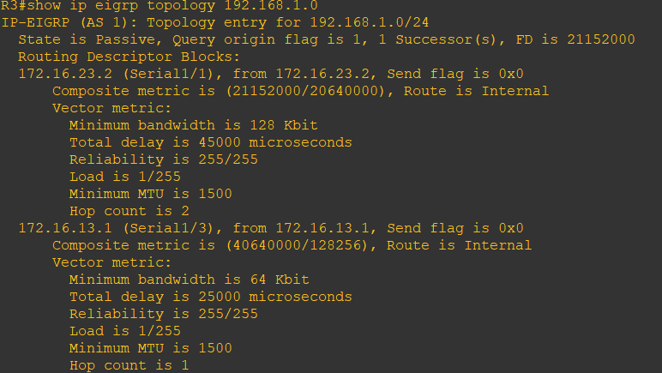

As indicated, R4 has two routes to reach 192.168.1.0. However, the metric for the route to R1

(172.16.13.1) is much higher (40640000) than the metric of the route to R2 (21152000),

making the route through R2 the successor route.

**Step 6: Configure PBR to provide path control.**

Now you will deploy source-based IP routing by using PBR. You will change a default IP

routing decision based on the EIGRP-acquired routing information for selected IP source-to

destination flows and apply a different next-hop router.

Recall that routers normally forward packets to destination addresses based on information in

their routing table. By using PBR, you can implement policies that selectively cause packets

to take different paths based on source address, protocol type, or application type. Therefore,

PBR overrides the router’s normal routing behavior.

Configuring PBR involves configuring a route map with match and set commands and then

applying the route map to the interface.

a) On router R3, create a standard access list called PBR-ACL to identify the R4 LAN B

network.

**Router R3 Console**

ip access-list standard PBR-ACL

remark ACL matches R4 LAN B traffic

permit 192.168.4.128 0.0.0.127

exit

b) Create a route map called R3-to-R1 that matches PBR-ACL and sets the next-hop

interface to the R1 S1/1 interface.

**Router R3 Console**

route-map R3-to-R1 permit

description RM to forward LAN B traffic to R1

match ip address PBR-ACL

set ip next-hop 172.16.13.1

exit

c) Apply the R3-to-R1 route map to the serial interface on R3 that receives the traffic from

R4. Use the ip policy route-map command on interface S1/2.

**Router R3 Console**

interface S1/2

ip policy route-map R3-to-R1

end

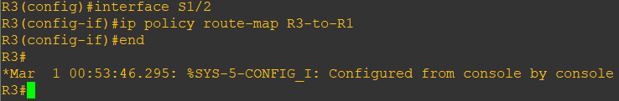

d) On R3, display the policy and matches using the show route-map command.

**Router R3 Console**

show route-map

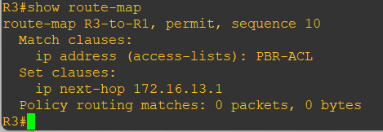

**Note:** There are currently no matches because no packets matching the ACL have passed

through R3 S1/2.

**Step 7: Test the policy.**

Now we are ready to test the policy configured on R3. Enable the debug ip policy command

on R3 so that you can observe the policy decision-making in action. To help filter the traffic,

first create a standard ACL that identifies all traffic from the R4 LANs.

a) On R3, create a standard ACL which identifies all of the R4 LANs.

**Router R3 Console**

access-list 1 permit 192.168.4.0 0.0.0.255

exit

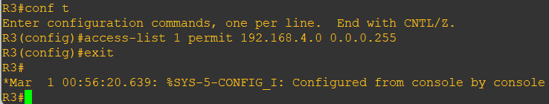

b) Enable PBR debugging only for traffic that matches the R4 LANs.

**Router R3 Console**

debug ip policy ?

debug ip policy 1

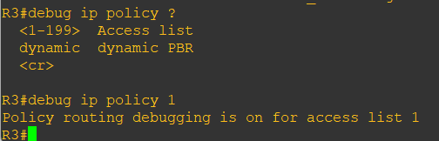

c) Test the policy from R4 with the traceroute command, using R4 LAN A as the source

network.

**Router R4 Console**

traceroute 192.168.1.1 source 192.168.4.1

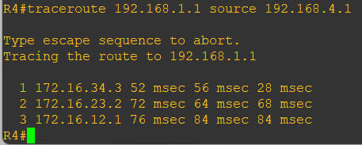

Notice the path taken for the packet sourced from R4 LAN A is still going through R3 --> R2 -->R1.

As the traceroute was being executed, router R3 should be generating the following debug

output.

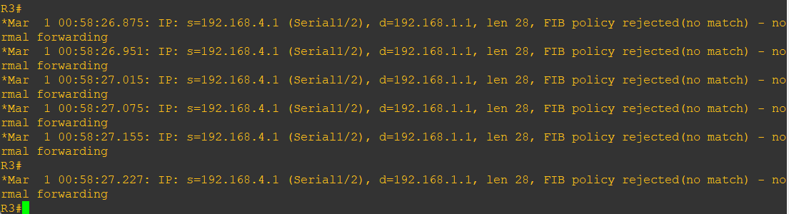

d) Test the policy from R4 with the traceroute command, using R4 LAN B as the source

network.

**Router R4 Console**

traceroute 192.168.1.1 source 192.168.4.129

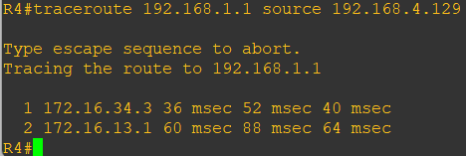

Now the path taken for the packet sourced from R4 LAN B is R3 --> R1, as expected.

The debug output on R3 also confirms that the traffic meets the criteria of the R3-to-R1

policy.

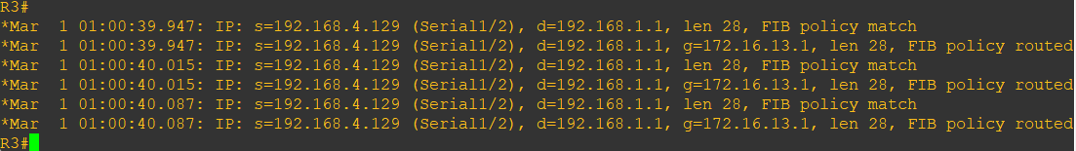

e) On R3, display the policy and matches using the show route-map command.

**Router R3 Console**

show route-map

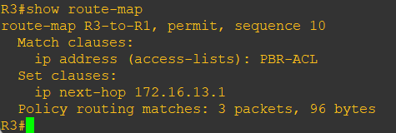

**Note:** There are now matches to the policy because packets matching the ACL have passed

through R3 S1/2.

# **Practical 6**

**Aim: To Simulate IP Service Level Agreements and Remote SPAN in a Campus Environment**

**Topology:** 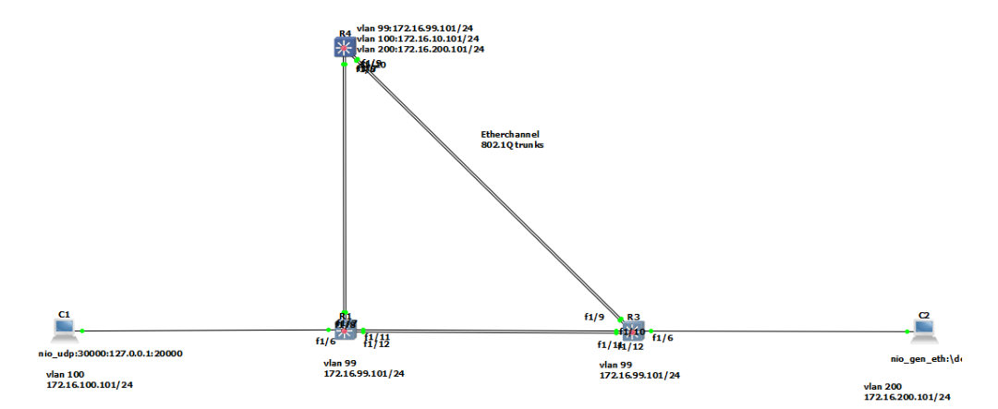

**Step 1:** Configure loopbacks and assign addresses.

**DLS1**

DLS1# conf t

Enter configuration commands, one per line. End with CNTL/Z.

DLS1(config)# interface vlan 99

DLS1(config-if)# ip address 172.16.99.1 255.255.255.0

DLS1(config-if)# no shutdown

DLS1(config-if)# exit

DLS1(config)# enable secret class

DLS1(config)# line vty 0 15

DLS1(config-line)# no login

DLS1(config-line)# privilege level 15

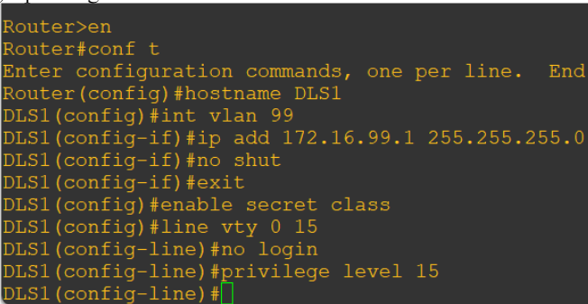

**ALS1**

Router>en

Router#conf t

Enter configuration commands, one per line. End with CNTL/Z.

Router(config)#hostname ALS1

ALS1(config)#interface vlan 99

ALS1(config-if)#ip add 172.16.99.1 255.255.255.0

ALS1(config-if)#no shut

ALS1(config-if)#exit

ALS1(config)#enable secret class

ALS1(config)#line vty 0 15

ALS1(config-line)#no login

ALS1(config-line)#privilege level 15

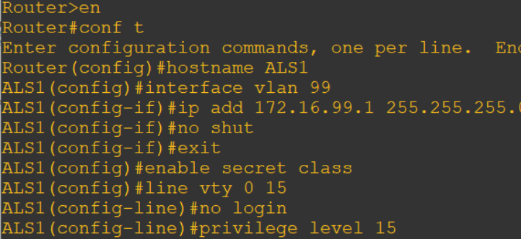

**ALS2**

ALS2# conf t

Enter configuration commands, one per line. End with CNTL/Z.

ALS2(config)# interface vlan 99

ALS2(config-if)# ip address 172.16.99.1 255.255.255.0

ALS2(config-if)# no shutdown

ALS2(config-if)# exit

ALS2# conf t

ALS2(config)# enable secret class

ALS2(config)# line vty 0 15

ALS2(config-line)# no login

ALS2(config-line)# privilege level 15

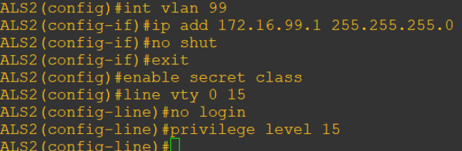

ALS1(config)# ip default-gateway 172.16.99.1

ALS2(config)# ip default-gateway 172.16.99.1

Step 2: Configure host PCs.

host A > ip 172.16.100.101/24 172.16.100.1

host B > ip 172.16.200.101/24 172.16.200.1

**Step 3: Configure trunks and Ether Channels between switches. Configure the trunks and Ether Channel from DLS1 to ALS1**

DLS1(config-line)# exit

DLS1(config)# int ran fastethernet 1/7 - 8

DLS1(config-if-range)# switchport trunk encapsulation

dot1q

DLS1(config-if-range)# switchport mode trunk

DLS1(config-if-range)# channel-group 1 mode on

DLS1(config-if-range)# no shut

DLS1(config-if-range)# exit

**Configure the trunks and EtherChannel from DLS1 to ALS2**

DLS1(config)# int ran fastethernet 1/9 - 10

DLS1(config-if-range)# switchport trunk encapsulation dot1q

DLS1(config-if-range)# switchport mode trunk

DLS1(config-if-range)# channel-group 2 mode on

DLS1(config-if-range)# no shut

**Configure the trunks and EtherChannel from ALS1 and DLS1**

ALS1# conf t

ALS1(config)# int ran fastethernet 1/11 - 12

ALS1(config-if-range)# switchport mode trunk

ALS1(config-if-range)# channel-group 3 mode on

ALS1(config-if-range)# no shut

**Configure the trunks and EtherChannel and ALS1 and ALS2**

ALS1(config-if-range)# exit

ALS1(config)# interface range fastethernet 1/7 – 8

ALS1(config-if-range)# switchport mode trunk

ALS1(config-if-range)# channel-group 2 mode on

ALS1(config-if-range)# no shut

**Configure the trunks and EtherChannel from ALS2 and DLS1**

ALS2# conf t

ALS2(config)# int ran fastethernet 1/11 – 12

ALS2(config-if-range)# switchport mode trunk

ALS2(config-if-range)# channel-group 3 mode on

ALS2(config-if-range)# no shut

**Configure the trunks and EtherChannel and ALS2 and ALS1**

ALS2(config-if-range)# exit

ALS2(config)# int ran fastethernet 1/9 – 10

ALS2(config-if-range)# switchport mode trunk

ALS2(config-if-range)# channel-group 2 mode on

ALS2(config-if-range)# no shut

**Step 4: Configure VTP on ALS1 and ALS2**

ALS1(config)# vtp mode client

ALS2(config)# vtp mode client

**Step 5: Configure VTP on DLS1**

DLS1(config)# vtp domain SWPOD

DLS1(config)# vtp version 2

DLS1(config)# vlan 99

DLS1(config-vlan)# name Management

DLS1(config-vlan)# vlan 100

DLS1(config-vlan)# name Finance

DLS1(config-vlan)# vlan 200

DLS1(config-vlan)# name Engineering

DLS1(config-vlan)# exit

**Step 6: Configure access ports.**

ALS1(config)# interface fastEthernet 1/6

ALS1(config-if)# switchport mode access

ALS1(config-if)# switchport access vlan 100

ALS1(config-if)# no shut

ALS2(config)# interface fastEthernet 1/6

ALS2(config-if)# switchport mode access

ALS2(config-if)# switchport access vlan 200

ALS1(config-if)# no shut

**Step 7: Configure VLAN interfaces and enable routing**

DLS1(config)# interface vlan 100

DLS1(config-if)# ip address 172.16.100.1 255.255.255.0

DLS1(config-if)# interface vlan 200

DLS1(config-if)# ip address 172.16.200.1 255.255.255.0

DLS1(config-if)# exit

DLS1(config)# ip routing

DLS1(config)# exit

DLS1# show ip route

DLS1# tclsh

foreach address {

172.16.99.1

172.16.99.101

172.16.99.102

172.16.100.1

172.16.200.1

172.16.100.101

172.16.200.101

} {

ping $address }

**Part 2: Configure Cisco IOS IP SLA**

**Step 1: Configure Cisco IOS IP SLA responders**

ALS1

ALS1(config)# exit

ALS1(config)# ip sla responder

ALS1(config)# ip sla responder udp-echo ipaddress

172.16.99.1 port 5000

ALS2

ALS2(config)# exit

ALS2(config)# ip sla responder

ALS2(config)# ip sla responder udp-echo ipaddress

172.16.99.1 port 5000

**Step 2: Configure the Cisco IOS IP SLA source to measure network performance**

DLS1

DLS1(config)# ip sla 1

DLS1(config-ip-sla)# icmp-echo 172.16.100.101

DLS1(config-ip-sla-echo)# exit

DLS1(config)# ip sla 2

DLS1(config-ip-sla)# icmp-echo 172.16.200.101

DLS1(config-ip-sla-echo)# exit

DLS1(config)# ip sla 3

DLS1(config-ip-sla)# udp-jitter 172.16.99.101 5000

DLS1(config-ip-sla-jitter)# exit

DLS1(config)# ip sla 4

DLS1(config-ip-sla)# udp-jitter 172.16.99.102 5000

DLS1(config-ip-sla-jitter)# exit

DLS1(config)# ip sla schedule 1 life forever start-time now

DLS1(config)# ip sla schedule 2 life forever start-time now

DLS1(config)# ip sla schedule 3 life forever start-time now

DLS1(config)# ip sla schedule 4 life forever start-time now

DLS1(config)# exit

**Step 3: Monitor IP SLAs operations**

DLS1

DLS1# show ip sla configuration 1

DLS1# show ip sla configuration 3

DLS1# show ip sla application

ALS1

ALS1# show ip sla responder

DLS1

DLS1# show ip sla statistics 1

DLS1# show ip sla statistics 3

ALS1

ALS1(config)# interface vlan 99

ALS1(config-if)# shutdown

DLS1

DLS1# show ip sla statistics 3

**Part 3: Switch Port Analyzer (SPAN) Feature**

**Step 1: Configure Remote SPAN (RSPAN)**

DLS1

DLS1(config)# vlan 300

DLS1(config-vlan)# name REMOTE_SPAN

DLS1(config-vlan)# remote-span

DLS1# show vlan brief | include active

ALS1

ALS1# show vlan brief | include active

ALS1(config)# monitor session 1 source interface Fa0/6

ALS1(config)# monitor session 1 destination remote vlan300

ALS1# show monitor

ALS2

ALS2(config)# monitor session 10 source remote vlan 300

ALS2(config)# monitor session 10 destination interface Fa0/6

ALS2# show monitor

ALS2# show interface f0/6

**Step 2: Test RSPAN operation**

**Step 3: End of Lab**

DLS1 :

DLS1# show run brief | exclude !

hostname DLS1

boot-start-marker

boot-end-marker

enable secret 5 $1$394h$4u5EACpRNVCKAFz1Ntit6/

no aaa new-model

clock timezone CST -6 0

clock summer-time CDT recurring

system mtu routing 1500

ip routing

no ip domain-lookup

ip domain-name CCNP.NET

spanning-tree mode pvst

spanning-tree extend system-id

vlan internal allocation policy ascending

interface Port-channel1

switchport trunk encapsulation dot1q

switchport trunk native vlan 666

switchport mode trunk

interface Port-channel2

switchport trunk encapsulation dot1q

switchport trunk native vlan 666

switchport mode trunk

interface FastEthernet0/1

shutdown

interface FastEthernet0/2

shutdown

interface FastEthernet0/3

shutdown

interface FastEthernet0/4

shutdown

interface FastEthernet0/5

shutdown

interface FastEthernet0/6

shutdown

interface FastEthernet0/7

description EtherChannel to ALS1

switchport trunk encapsulation dot1q

switchport trunk native vlan 666

switchport mode trunk

channel-group 1 mode active

interface FastEthernet0/8

description EtherChannel to ALS1

switchport trunk encapsulation dot1q

switchport trunk native vlan 666

switchport mode trunk

channel

-group 1 mode active

interface FastEthernet0/9

description EtherChannel to ALS2

switchport trunk encapsulation dot1

q

switchport trunk native vlan 666

switchport mode trunk

channel

-group 2 mode active

interface FastEthernet0/10

description EtherChannel to ALS2

switchport trunk encapsulation dot1q

switchport trunk native vlan 666

switchport mode trunk

channel

-group 2 mode active

interface FastEthernet0/11

shutdown

interface FastEthernet0/12

shutdown

interface FastEthernet0/13

shutdown

interface FastEthernet0/14

shutdown

interface FastEthernet0/15

shutdown

interface FastEthernet0/16

shutdown

interface FastEthernet0/17

shutdown

interface FastEthernet0/18

shutdown

interface FastEthernet0/19

shutdown

interface FastEthernet0/20

shutdown

interface FastEthernet0/21

shutdown

interface FastEthernet0/22

shutdown

interface FastEthernet0/23

shutdown

interface FastEthernet0/24

shutdown

interface GigabitEthernet0/1

shutdown

interface GigabitEthernet0/2

shutdown

interface Vlan1

no ip address

interface Vlan99

ip address 172.16.99.1 255.255.255.0

interface Vlan100

ip address 172.16.100.1 255.255.255.0

interface Vlan200

Modern Networking Practical 53004220003

43 | P a g e

ip address 172.16.200.1 255.255.255.0

ip http server

ip http secure

-server

ip sla 1

icmp

-echo 172.16.100.101

ip sla schedule 1 life forever start

-time now

ip sla 2

icmp

-echo 172.16.200.101

ip sla schedule 2 life forever start

-time now

ip sla 3

udp

-jitter 172.16.99.101 5000

ip sla schedule 3 life forever start

-time now

ip sla 4

udp

-jitter 172.16.99.102 5000

ip sla schedule 4 life forever start

-time now

line con 0

exec

-timeout 0 0

logging synchronous

line vty 0 4

password cisco

login

line vty 5 15

password cisco

login

end

DLS1#

ALS1:

ALS1# show run brief | exclude !

Building configuration.

Current configuration : 2692 bytes

version 15.0

no service pad

service timestamps debug datetime msec

service timestamps log datetime msec

no service password

-encryption

hostname ALS1

boot

-start

-marker

boot

-end

-marker

enable secret 5 $1$eOw5$elPah.syL1h.EPTDwlpnG0

no aaa new

-model

clock timezone CST

-6 0

clock summer

-time CDT recurring

system mtu routing 1500

no ip domain

-lookup

ip domain

-name CCNP.NET

spanning

-tree mode pvst

spanning

-tree extend system

-id

vlan internal allocation policy ascending

interface Port

-channel1

switchport trunk native vlan 666

Modern Networking Practical 53004220003

44 | P a g e

switchport mode trunk

interface Port

-channel3

switchport trunk native vlan 666

switchport mode trunk

interface FastEthernet0/1

shutdown

interface FastEthernet0/2

shutdown

interface FastEthernet0/3

shutdown

interface FastEthernet0/4

shutdown

interface FastEthernet0/5

shutdown

interface FastEthernet0/6

switchport access vlan 100

switchport mode access

interface FastEthernet0/7

description EtherChannel to DLS1

switchport trunk native vlan 666

switchport mode trunk

channel

-group 1 mode active

interface FastEthernet0/8

description EtherChannel to DLS1

switchport trunk native vlan 666

switchport mode trunk

channel

-group 1 mode active

interface FastEthernet0/9

shutdown

interface FastEthernet0/10

shutdown

interface FastEthernet0/11

description EtherChannel to ALS2

switchport trunk native vlan 666

switchport mode trunk

channel

-group 3 mode active

interface FastEthernet0/12

description EtherChannel to ALS2

switchport trunk native vlan 666

switchport mode trunk

channel

-group 3 mode active

interface FastEthernet0/13

shutdown

interface FastEthernet0/14

shutdown

interface FastEthernet0/15

shutdown

interface FastEthernet0/16

shutdown

interface FastEthernet0/17

shutdown

interface FastEthernet0/18

shutdown

interface FastEthernet0/19

shutdown

interface FastEthernet0/20

shutdown

interface FastEthernet0/21

shutdown

interface FastEthernet0/22

shutdown

interface FastEthernet0/23

shutdown

interface FastEthernet0/24

shutdown

interface GigabitEthernet0/1

shutdown

interface GigabitEthernet0/2

shutdown

interface Vlan1

no ip address

interface Vlan99

ip address 172.16.99.101 255.255.255.0

ip default-gateway 172.16.99.1

ip http server

ip http secure-server

ip sla responder

ip sla responder udp-echo ipaddress 172.16.99.1 port 5000

line con 0

exec-timeout 0 0

logging synchronous

line vty 0 4

password cisco

login

line vty 5 15

password cisco

login

monitor session 1 source interface Fa0/6

monitor session 1 destination remote vlan 300

end

ALS1#

ALS2:

ALS2# show run brief | exclude !

hostname ALS2

boot-start-marker

boot-end-marker

enable secret 5 $1$QTDK$sDfAMuL5FIHWCO5U4q9F50

no aaa new-model

clock timezone CST -6 0

clock summer-time CDT recurring

system mtu routing 1500

no ip domain-lookup

ip domain-name CCNP.NET

spanning

-tree mode pvst

spanning

-tree extend system

-id

vlan internal allocation policy ascending

interface Port

-channel2

switchport trunk native vlan 666

switchport mode trunk

interface Port

-channel3

switchport trunk native vlan 666

switchport mode trunk

interface FastEthernet0/1

shutdown

interface FastEthernet0/2

shutdown

interface FastEthernet0/3

shutdown

interface FastEthernet0/4

shutdown

interface FastEthernet0/5

shutdown

interface FastEthernet0/6

switchport access vlan 200

switchport mode access

interface FastEthernet0/7

shutdown

interface FastEthernet0/8

shutdown

interface FastEthernet0/9

description EtherChannel to DLS1

switchport trunk native vlan 666

switchport mode trunk

channel

-group 2 mode active

interface FastEthernet0/10

description EtherChannel to DLS1

switchport trunk native vlan 666

switchport mode trunk

channel

-group 2 mode active

interface FastEthernet0/11

description EtherChannel to ALS1

switchport trunk native vlan 666

switchport mode trunk

channel

-group 3 mode active

interface FastEthernet0/12

description EtherChannel to ALS1

switchport trunk native vlan 666

switchport mode trunk

channel

-group 3 mode active

interface FastEthernet0/13

shutdown

interface FastEthernet0/14

shutdown

interface FastEthernet0/15

shutdown

interface FastEthernet0/16

shutdown

interface FastEthernet0/17

shutdown

interface FastEthernet0/18

shutdown

interface FastEthernet0/19

shutdown

interface FastEthernet0/20

shutdown

interface FastEthernet0/21

shutdown

interface FastEthernet0/22

shutdown

interface FastEthernet0/23

shutdown

interface FastEthernet0/24

shutdown

interface GigabitEthernet0/1

shutdown

interface GigabitEthernet0/2

shutdown

interface Vlan1

no ip address

interface Vlan99

ip address 172.16.99.102 255.255.255.0

ip default-gateway 172.16.99.1

ip http server

ip http secure-server

ip sla responder

ip sla responder udp-echo ipaddress 172.16.99.1 port 5000

line con 0

exec-timeout 0 0

logging synchronous

line vty 0 4

password cisco

login

line vty 5 15

password cisco

login

monitor session 10 destination interface Fa0/6

monitor session 10 source remote vlan 300

end

ALS2#

# **Practical 7**

**Aim: Inter-VLAN Routing.**

**Topology:**

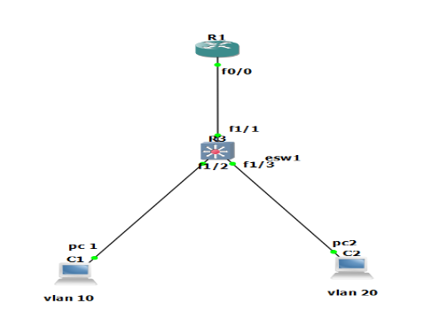

**Configuration for Router R1:**

R1#conf t

R1(config)#int f 0/0

R1(config-if)#no ip address

R1(config-if)#no shut

R1(config-if)#int f 0/0.1

R1(config-subif)#encapsulation dot1Q 10

R1(config-subif)#ip address 10.0.0.1 255.255.255.0

R1(config-subif)#exit

R1(config)#int f 0/0.2

R1(config-subif)#encapsulation dot1Q 20

R1(config-subif)#ip address 20.0.0.1 255.255.255.0

R1(config-subif)#exit

**Configuration for Switch:**

ESW1#

ESW1#vlan database

ESW1(vlan)#vlan 10 name IT

ESW1(vlan)#vlan 20 name HR

ESW1(vlan)#exit

ESW1#conf t

ESW1(config)#int f 1/2

ESW1(config-if)#switchport mode access

ESW1(config-if)#switchport access vlan 10

ESW1(config-if)#exit

ESW1(config)#int f 1/3

ESW1(config-if)#switchport mode access

ESW1(config-if)#switchport access vlan 20

ESW1(config-if)#exit

ESW1(config)#int f 1/1

ESW1(config-if)#switch port mode trunk

ESW1(config-if)#switchport trunk encapsulation dot1Q

ESW1(config-if)#exit

ESW1(config)#

Configuration for PC1

PC1>

PC1>ip 10.0.0.2 /24 10.0.01

PC1>save

PC1>ping 10.0.0.1

PC1>

Configuration for PC2

PC2>

PC2>ip 20.0.0.2 /24 20.0.01

PC2>save

PC2>ping 20.0.0.1

PC2>

RESULT:

ESW1#show vlan-switch

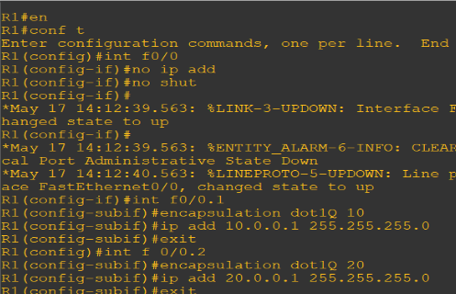

# **Practical 8**

**Aim:** **Simulating MPLS environment**

**Topology:**

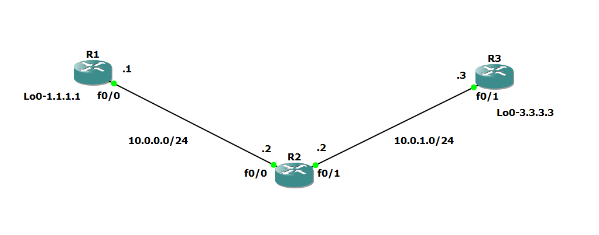

**Step 1 :** IP addressing of MPLS Core and OSPF

First bring 3 routers into topology R1, R2, R3. We are going to address the routers and configure ospf to ensure loopback to loopback connectivity between R1 and R3.

**R1 Console**

hostname R1

int lo0

ip add 1.1.1.1 255.255.255.255

ip ospf 1 area 0

int f0/0

ip add 10.0.0.1 255.255.255.0

no shut

ip ospf 1 area 0

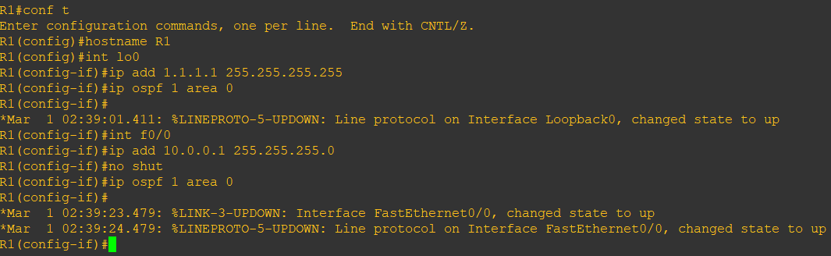

**R2 Console**

hostname R2

int lo0

ip add 2.2.2.2 255.255.255.255

ip ospf 1 area 0

int f0/0

ip add 10.0.0.2 255.255.255.0

no shut

ip ospf 1 area 0

int f0/1

ip add 10.0.1.2 255.255.255.0

no shut

ip ospf 1 area 0

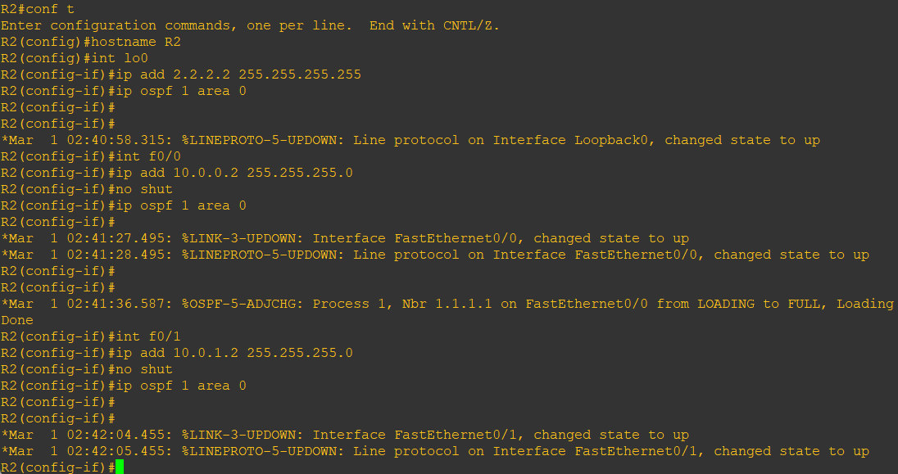

**R3 Console**

hostname R3

int lo0

ip add 3.3.3.3 255.255.255.255

ip ospf 1 area 0

int f0/1

ip add 10.0.1.3 255.255.255.0

no shut

ip ospf 1 area 0

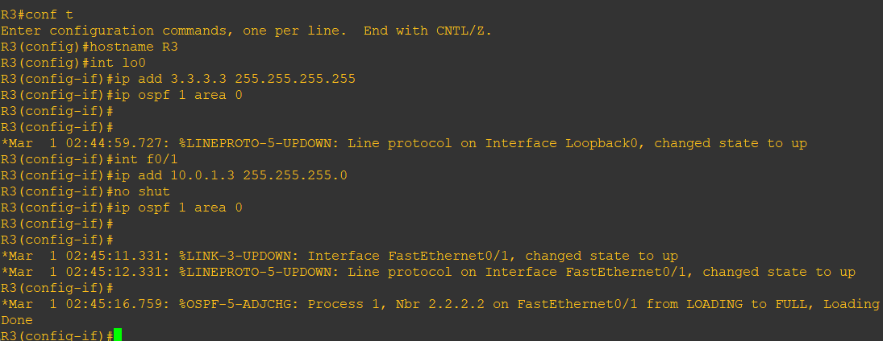

We should now have full ip connectivity between R1, R2, R3 to verify this we need to see if we can ping between the loopbacks of R1 and R3

**R1 Console**

ping 3.3.3.3 source lo0

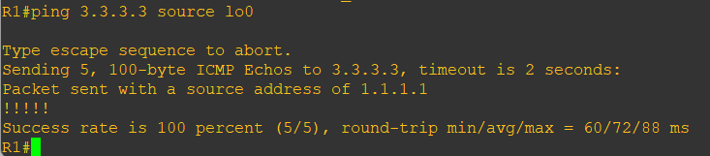

**Step 2 :** Configure LDP on all the interfaces in the MPLS Core

In order to run MPLS you need to enable it:

Under the ospf process use the mpls ldp autoconfig command

**R1 Console**

router ospf 1

mpls ldp autoconfig

**R2 Console**

router ospf 1

mpls ldp autoconfig

**R3 Console**

router ospf 1

mpls ldp autoconfig

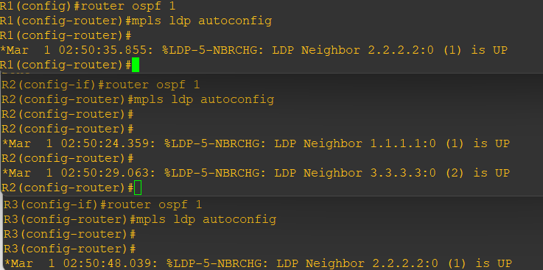

To verify the mpls interfaces the command is very simple – sh mpls interface

This is done on R2 and you can see that both interfaces are running mpls and using LDP

**R2 Console**

show mpls interface

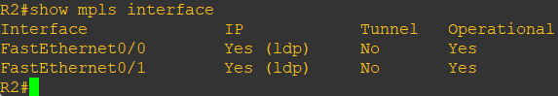

show mpls ldp neighbor

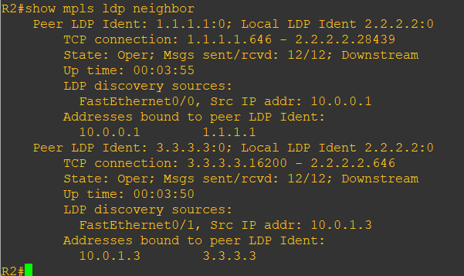

One more verification to confirm LDP is running ok is to do a trace between R1 and R3 and verify if you get MPLS Labels show up in the trace.

**R1 Console**

trace 3.3.3.3

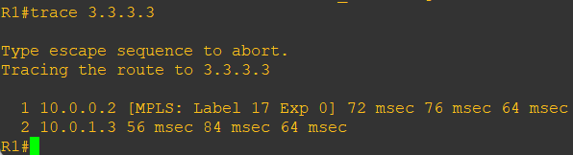

As you can see the trace to R2 used an MPLS Label in the path, as this is a very small MPLS core only one label was used as R3 was the final hop.

So to review we have now configured IP addresses on the MPLS core, enabled OSPF and full IP connectivity between all routers and finally enabled mpls on all the interfaces in the core and have established ldp neighbors between all routers.

**Step 3 :** MPLS BGP Configuration between R1 and R3

We need to establish a Multi Protocol BGP session between R1 and R3 this is done by configuring the vpnv4 address family as below

**R1 Console**

router bgp 1

neighbor 3.3.3.3 remote-as 1

neighbor 3.3.3.3 update-source Loopback0

no auto-summary

!

address-family vpnv4

neighbor 3.3.3.3 activate

**R3 Console**

router bgp 1

neighbor 1.1.1.1 remote-as 1

neighbor 1.1.1.1 update-source Loopback0

no auto-summary

!

address-family vpnv4

neighbor 1.1.1.1 activate

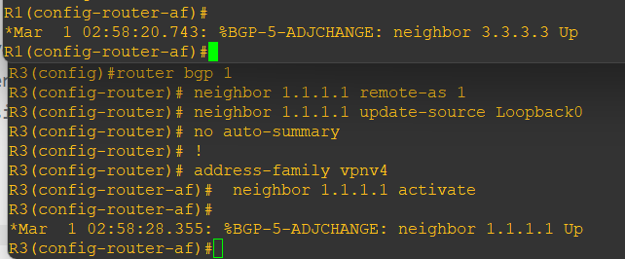

To verify the BGP session between R1 and R3 issue the command sh bgp vpnv4 unicast all summary

**R1 Console**

show bgp vpnv4 unicast all summary

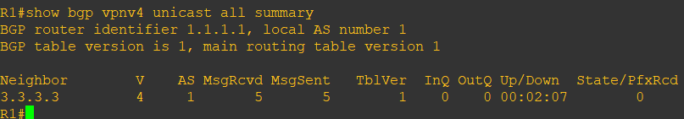

You can see here that we do have a bgp vpnv4 peering to R3 – looking at the PfxRcd you can see it says 0 this is because we have not got any routes in BGP. We are now going to add two more routers to the topology. These will be the customer sites connected to R1 and R3. We will then create a VRF on each router and put the interfaces connected to each site router into that VRF.

**Step 4:** Add two more routers, create VRFs

We will add two more routers into the topology so it now looks like the final topology

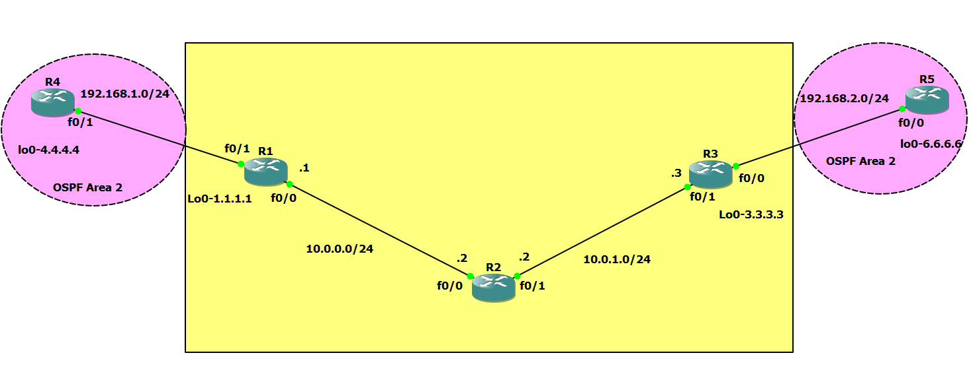

Router 4 will peer OSPF using process number 2 to a VRF configured on R1. It will use the local site addressing of 192.168.1.0/24.

**R4 Console**

int lo0

ip add 4.4.4.4 255.255.255.255

ip ospf 2 area 2

int f0/1

ip add 192.168.1.4 255.255.255.0

ip ospf 2 area 2

no shut

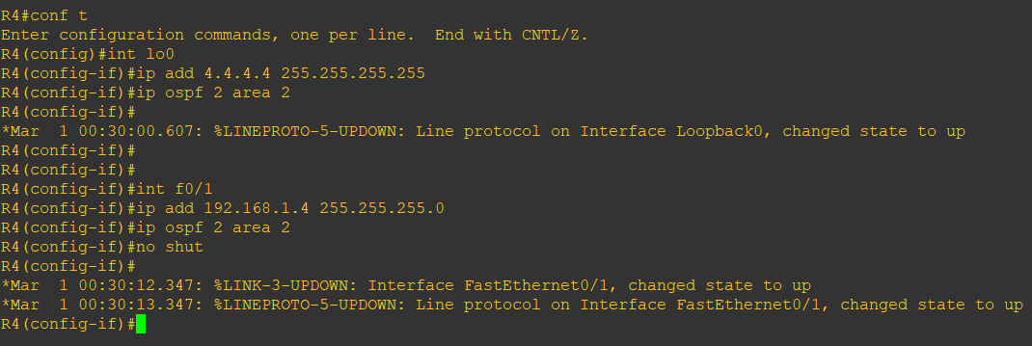

**R1 Console**

int f0/1

no shut

ip add 192.168.1.1 255.255.255.0

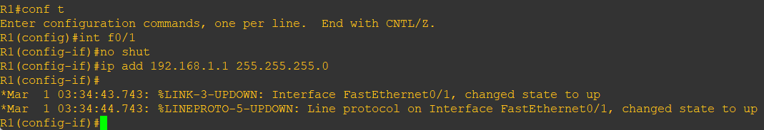

Now at this point we have R4 peering to R1 but in the global routing table of R1 which is not what we want. We are now going to start using VRF’s.

We now need to create a VRF on R1

For this mpls practical, we will be using VRF RED

**R1 Console**

ip vrf RED

rd 4:4

route-target both 4:4

int f0/1

ip vrf forwarding RED

Now notice what happens when you do that – the IP address is removed

We need to re-apply it

int f0/1

ip address 192.168.1.1 255.255.255.0

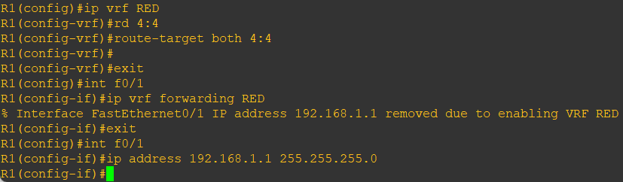

show run int f0/1

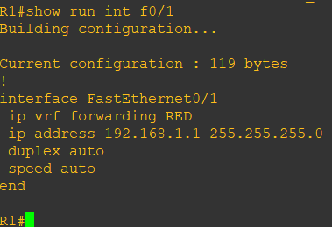

Now there are 2 routing tables within R1:

The Global Routing Table

The Routing Table for VRF RED

If we issue the command sh ip route this shows the routes in the global table and we do not see 192.168.1.0/24

show ip route

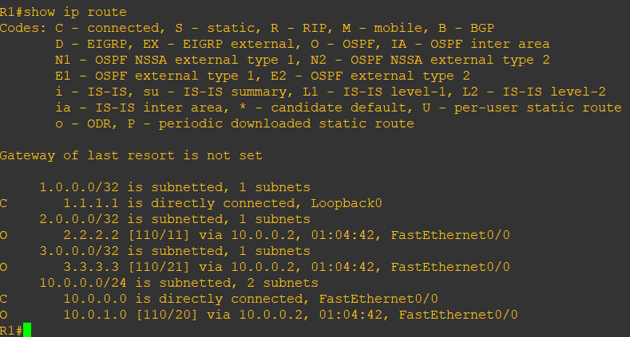

If we now issue the command sh ip route vrf red – this will show the routes in the routing table for VRF RED

**R1 Console**

show ip route vrf RED

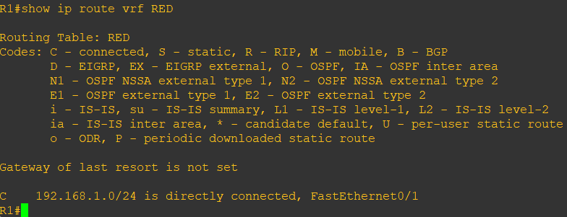

We just need to enable OSPF on this interface and get the loopback address for R4 in the VRF RED routing table before proceeding.

**R1 Console**

int f0/1

ip ospf 2 area 2

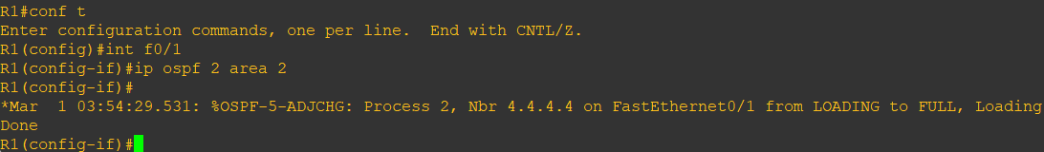

If we now check the routes in the VRF RED routing table you should see 4.4.4.4 in there as well.

**R1 Console**

show ip route vrf RED

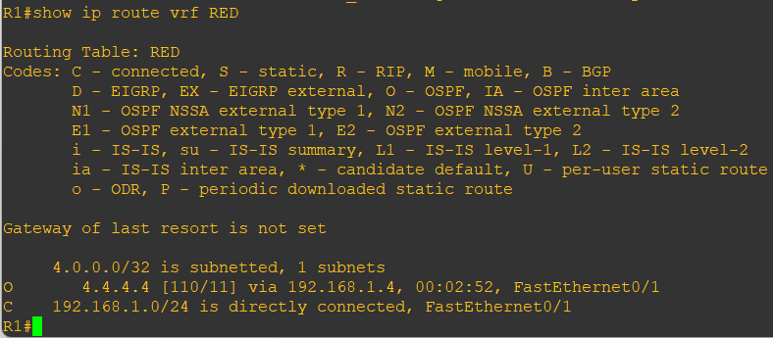

We now need to repeat this process for R3 & R5

Router 5 will peer OSPF using process number 2 to a VRF configured on R3. It will use the local site addressing of 192.168.2.0/24.

**R5 Console**

int lo0

ip add 6.6.6.6 255.255.255.255

ip ospf 2 area 2

int f0/0

ip add 192.168.2.6 255.255.255.0

ip ospf 2 area 2

no shut

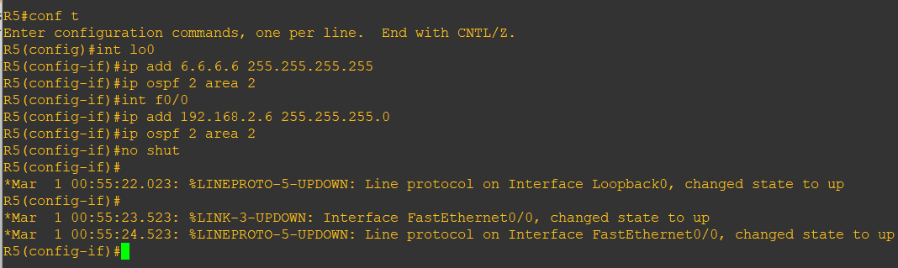

**R3 Console**

int f0/0

no shut

ip add 192.168.2.3 255.255.255.0

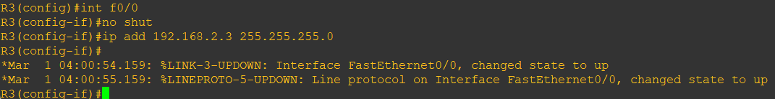

We also need to configure a VRF onto R3 as well.

**R3 Console**

ip vrf RED

rd 4:4

route-target both 4:4

int f0/0

ip vrf forwarding RED

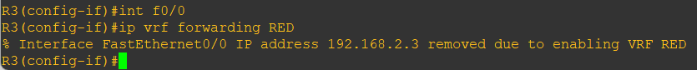

int f0/0

ip address 192.168.2.1 255.255.255.0

show run int f0/0

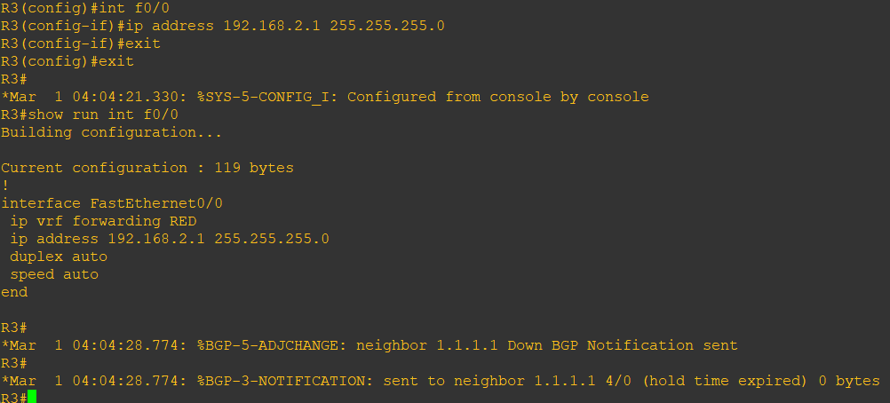

Finally, we just need to enable OSPF on that interface and verify the routes are in the RED routing table.

**R3 Console**

int f0/0

ip ospf 2 area 2

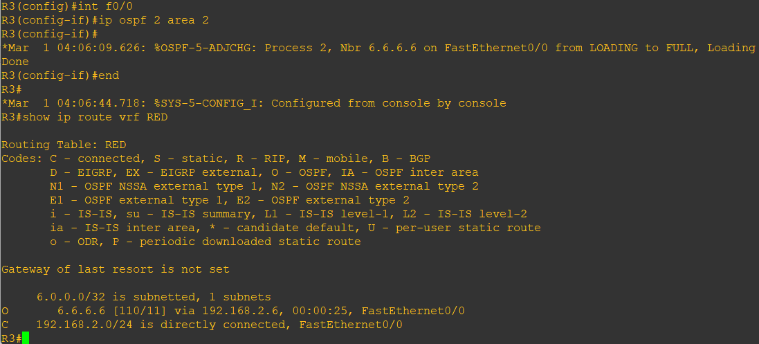

show ip route vrf RED



Check the routes on R4

**R4 Console**

show ip route

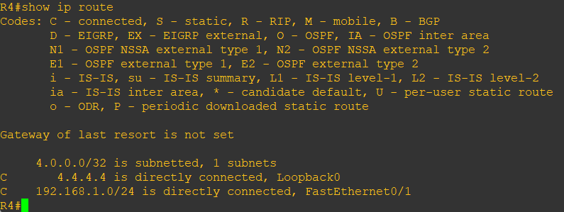

As expected, we have the local interface and the loopback address.

When we are done, we want to see 6.6.6.6 in there so we can ping across the MPLS

Check the routes on R1

**R1 Console**

show ip route

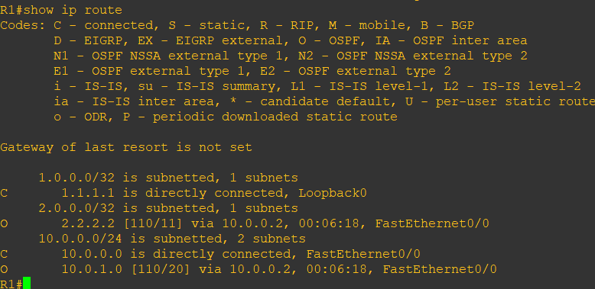

show ip route vrf RED

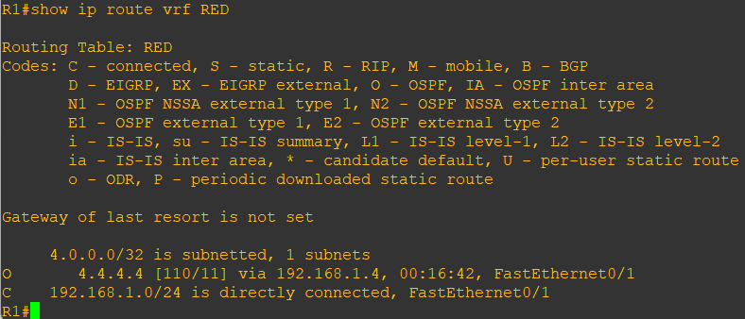

Redistribute OSPF into MP-BGP on R1

**R1 Console**

router bgp 1

address-family ipv4 vrf RED

redistribute ospf 2

Redistribute OSPF into MP-BGP on R3

**R3 Console**

router bgp 1

address-family ipv4 vrf RED

redistribute ospf 2

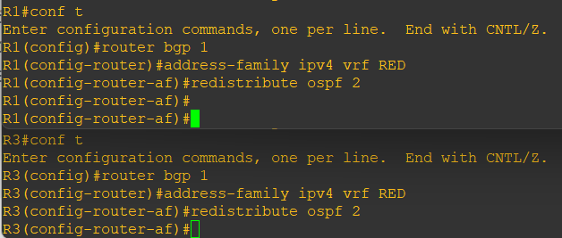

This has enabled redistribution of the OSPF routes into BGP. We can check the routes from R4 and R5 are now showing in the BGP table for their VRF with this command

**R1 Console**

show ip bgp vpnv4 vrf RED

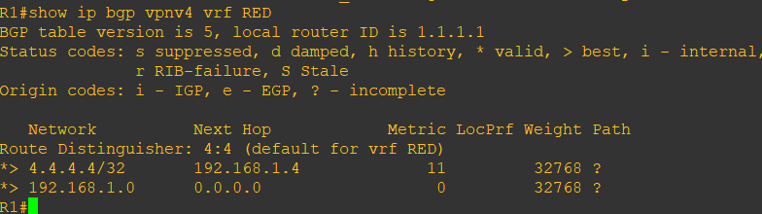

Here we can see that 4.4.4.4 is now in the BGP table in VRF RED on R1 with a next hop of 192.168.1.4 (R4) also, 6.6.6.6 is in there as well with a next hop of 3.3.3.3 (which is the loopback of R3 – showing that it is going over the MPLS and R1 is not in the picture)

The same should be true on R3

**R3 Console**

show ip bgp vpnv4 vrf RED

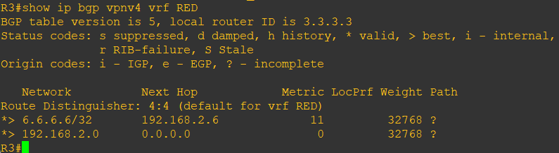

6.6.6.6 is now in the BGP table in VRF RED on R3 with a next hop of 192.168.2.6 (R5) also 4.4.4.4 is in there as well with a next hop of 1.1.1.1 (which is the loopback of R1 – showing that it is going over the MPLS and R2 is not in the picture)

The final step is to get the routes that have come across the MPLS back into OSPF and then we can get end to end connectivity

**R1 Console**

router ospf 2

redistribute bgp 1 subnets

**R3 Console**

router ospf 2

redistribute bgp 1 subnets

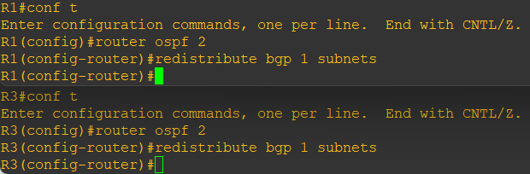

**R4 Console**

show ip route

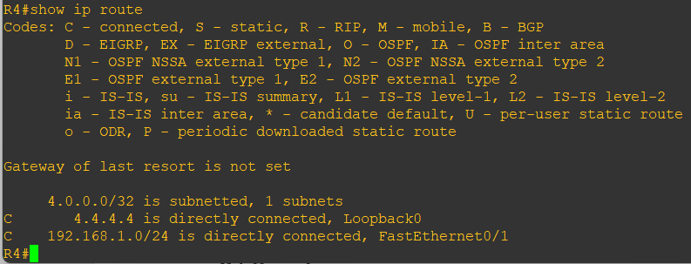

**R5 Console**

show ip route

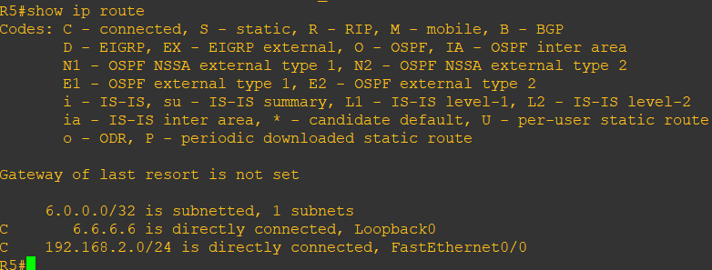

Now we should be able to ping across the MPLS

**R4 Console**

ping 6.6.6.6

trace 6.6.6.6

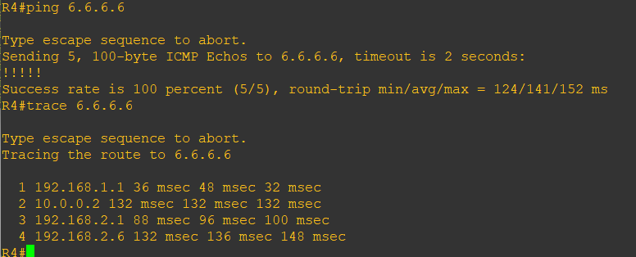

# **Practical 9**

**Aim: Simulating VRF**

What is a VRF in networking?

Virtual routing and forwarding (VRF) is a technology included in IP (Internet Protocol) that allows multiple instances of a routing table to co-exist in a router and work together but not interfere with each other. This increases functionality by allowing network paths to be segmented without using multiple devices. If two companies are both addressed locally with the same address space it could accommodate both their routing tables in different VRFs – it distinguishes between the two of them using a Route Distinguisher.

Here, there are 2 different companies namely company A (Blue) and company B (Pink). These 2 companies wouldn’t want their information to be shared with any other company.

We make use of VRF (Virtual Routing and Forwarding) as the companies require isolation.

**Topology:**

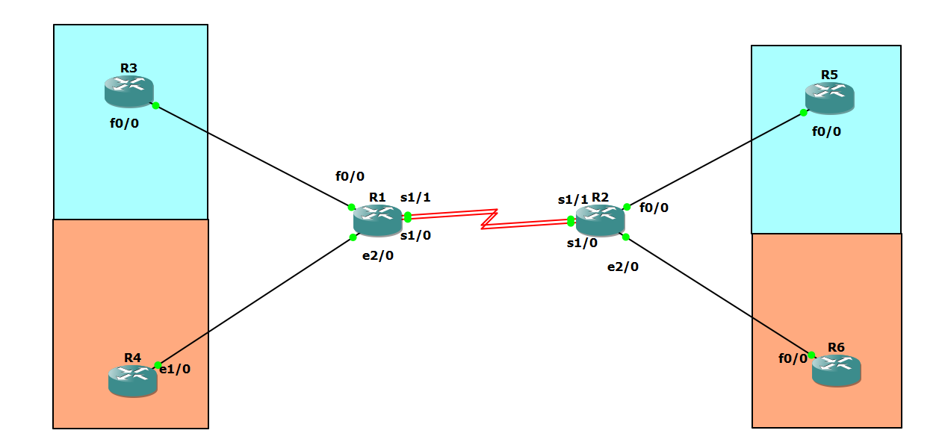

VRF helps to divide and split a router into multiple virtual routers

The VRF routers are split into 2, where 1 part is completely isolated from the other

Here in this case, R3 and R5 belong to company A, R4 and R6 belong to company B

Since we are using VRF, we are keeping identical IP addresses

**Step 1: Configure the routers assign addresses.**

a) Cable the network as shown in the topology diagram. Erase the startup configuration, and reload each router to clear previous configurations.

b) Using the addressing scheme in the diagram, create the loopback interfaces and apply IP addresses to these and the serial interfaces on R1, R2, R3, R4, R5 and R6. On the serial interfaces connect R1 and R2, and connect the other routers through fast ethernet.

**Router R1 Console**

conf t

ip vrf custA

exit

no shut

ip vrf custB

exit

no shut

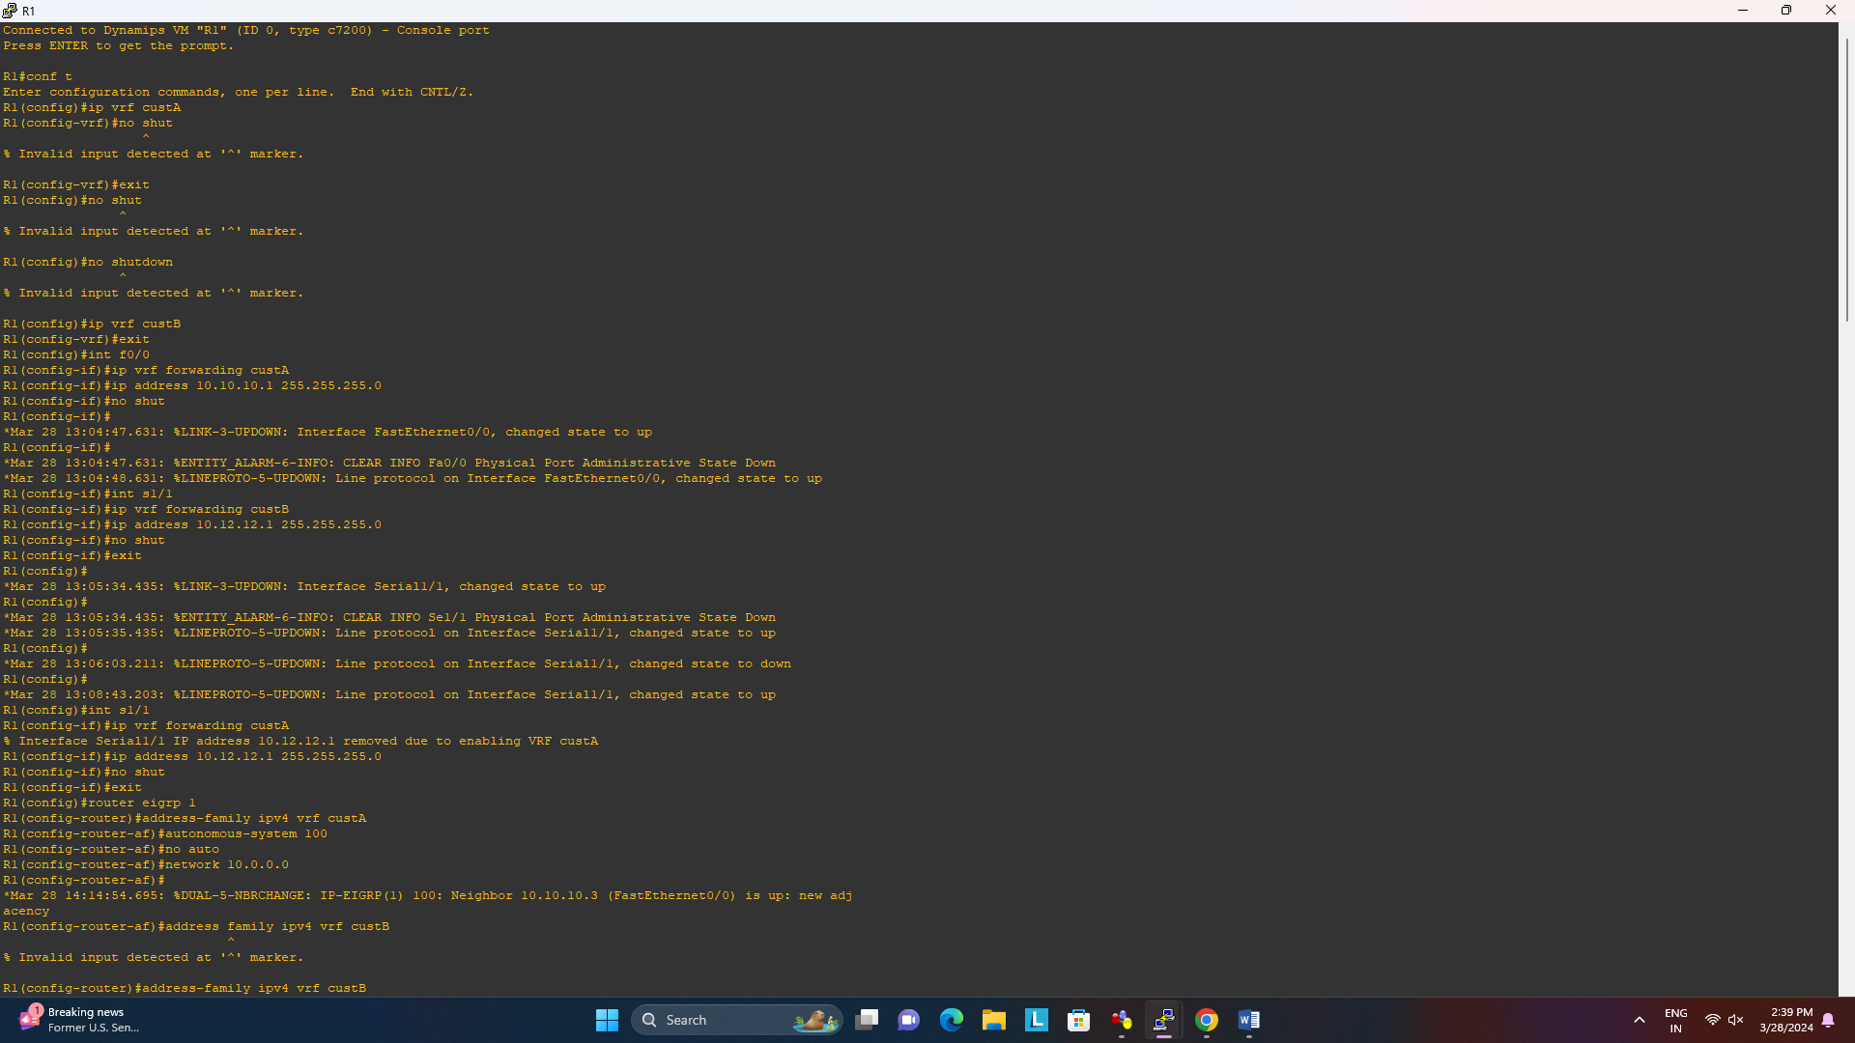

**Assign IP addresses**

int f0/0

ip vrf forwarding custA

ip address 10.10.10.1 255.255.255.0

no shut



int s1/1

ip vrf forwarding custA

ip address 10.12.12.1 255.255.255.0

no shut

exit



int e2/0

ip vrf forwarding custB

ip address 10.12.12.2 255.255.255.0

no shut

exit

int e2/0

ip vrf forwarding custB

ip address 10.10.10.2 255.255.255.0

no shut

exit

int s1/0

ip vrf forwarding custB

ip address 10.12.12.2 255.255.255.0

no shut

exit

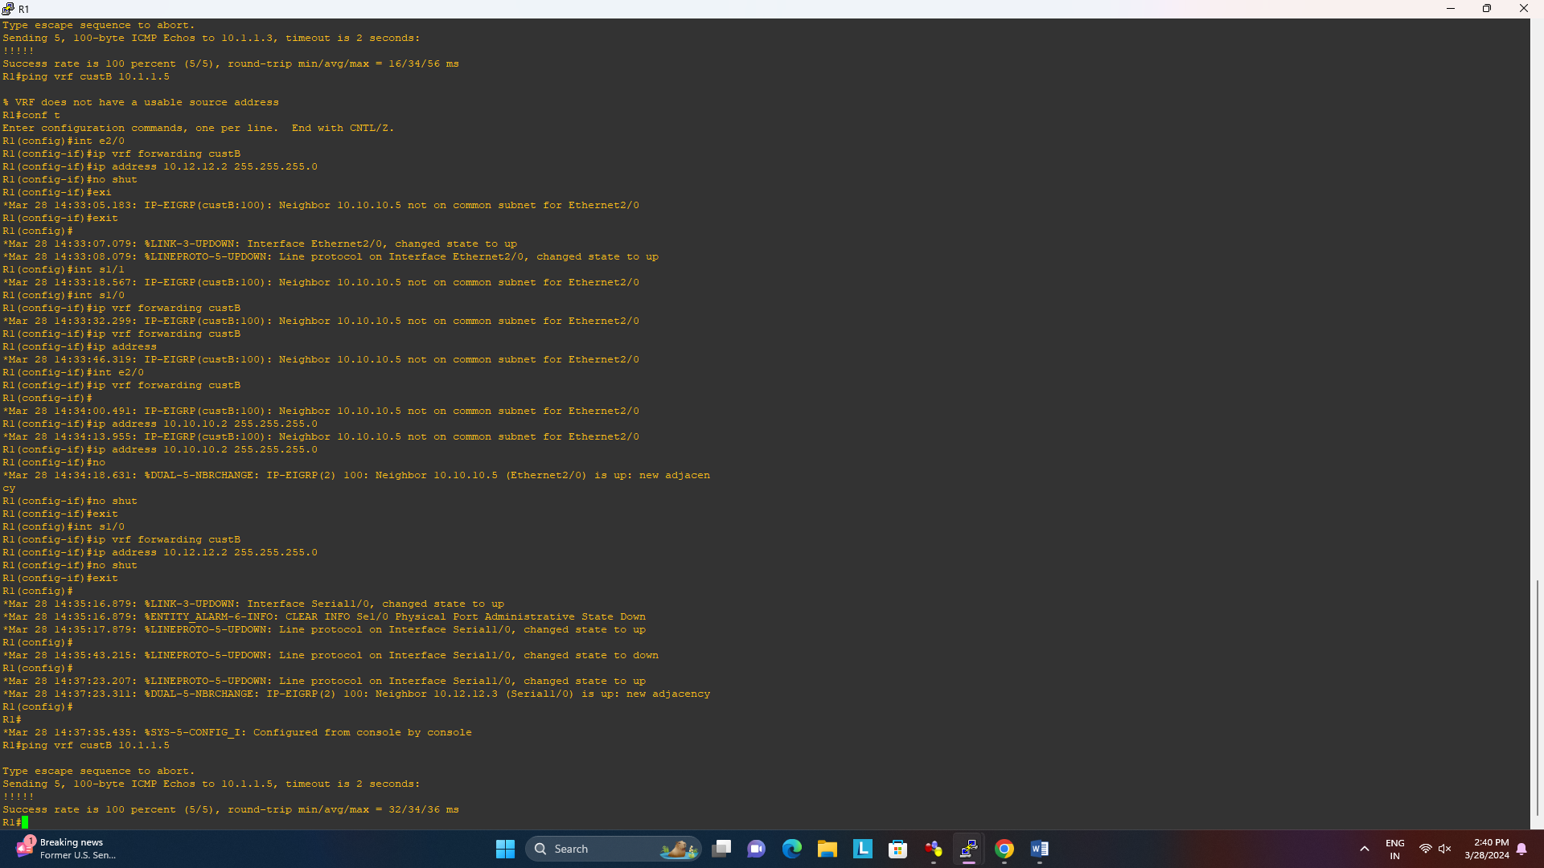

**R2 Console**

conf t

ip vrf custA

exit

ip vrf custB

exit

no shut

int f0/0

ip vrf forwarding custA

ip address 10.20.20.2 255.255.255.0

no shut

exit

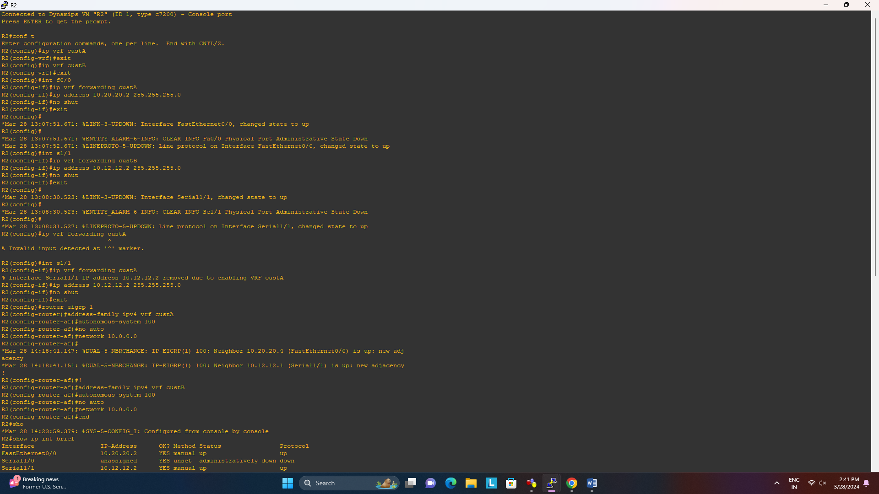

int s1/1

ip vrf forwarding custA

ip address 10.12.12.2 255.255.255.0

no shut

exit



int e2/0

ip vrf forwarding custB

ip address 10.20.20.3 255.255.255.0

no shut

exit

int s1/0

ip vrf forwarding custB

ip address 10.12.12.3 255.255.255.0

no shut

exit

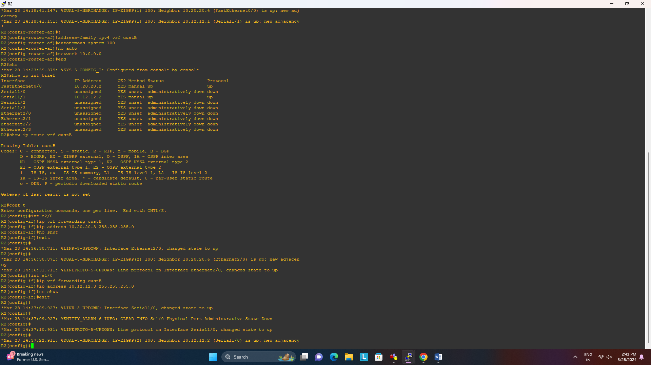

**R3 Console**

int f0/0

ip add 10.10.10.3 255.255.255.0

no shut

int lo0

ip add 10.1.1.3 255.255.255.0

no shut

exit

end

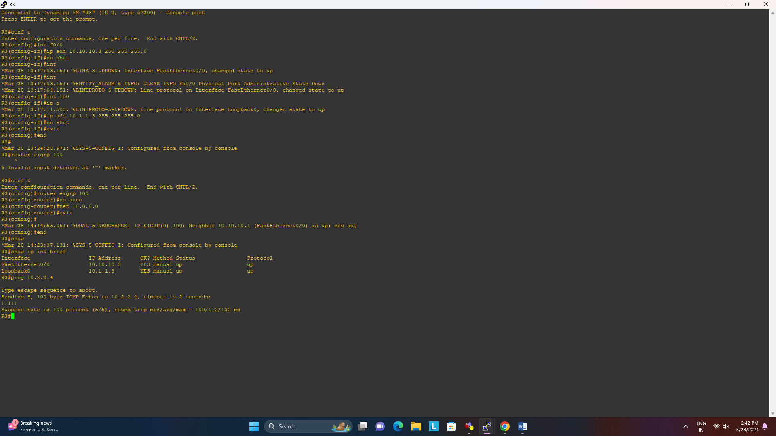

**R4 Console**

int e1/0

ip add 10.10.10.5 255.255.255.0

no shut

int lo0

ip add 10.1.1.5 255.255.255.0

no shut

exit

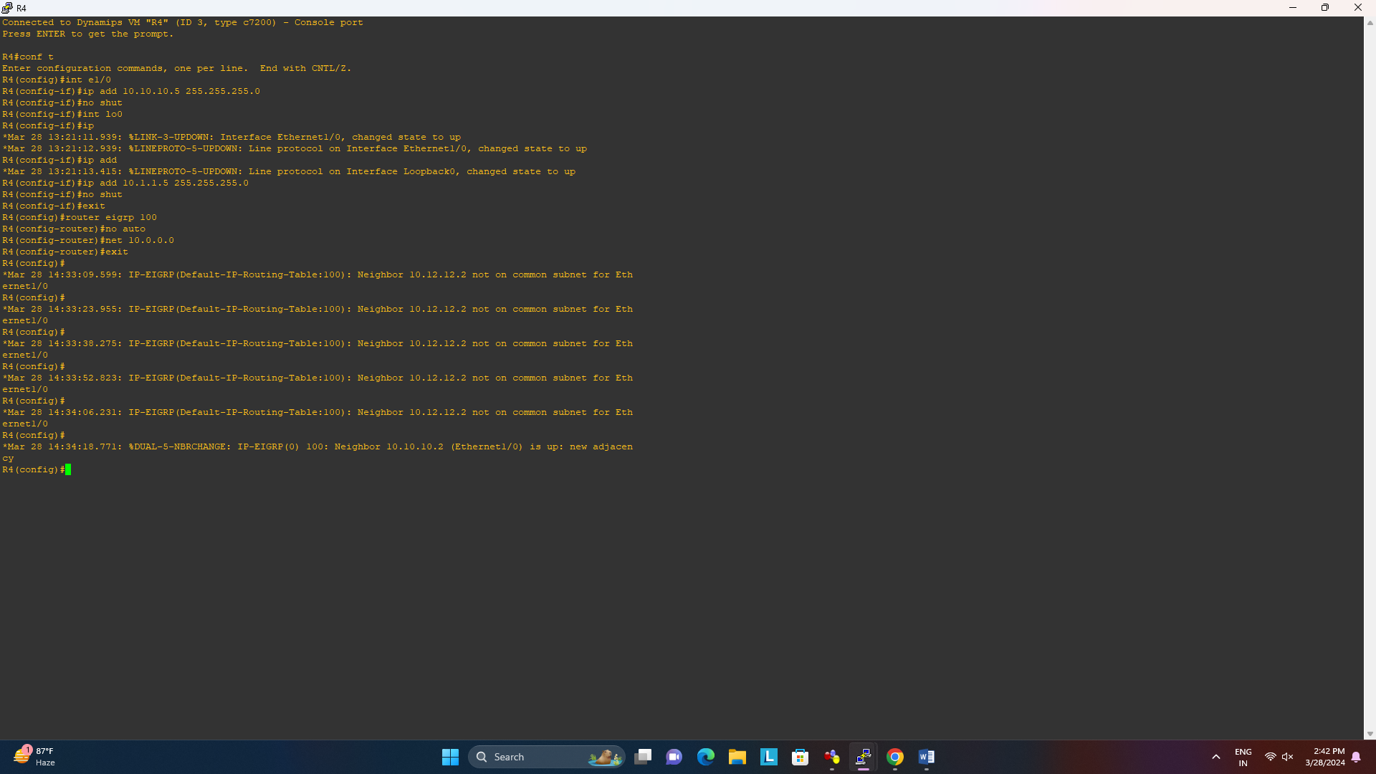

**R5 Console**

int f0/0

ip add 10.20.20.4 255.255.255.0

no shut

int lo0

ip add 10.2.2.4 255.255.255.0

no shut

exit

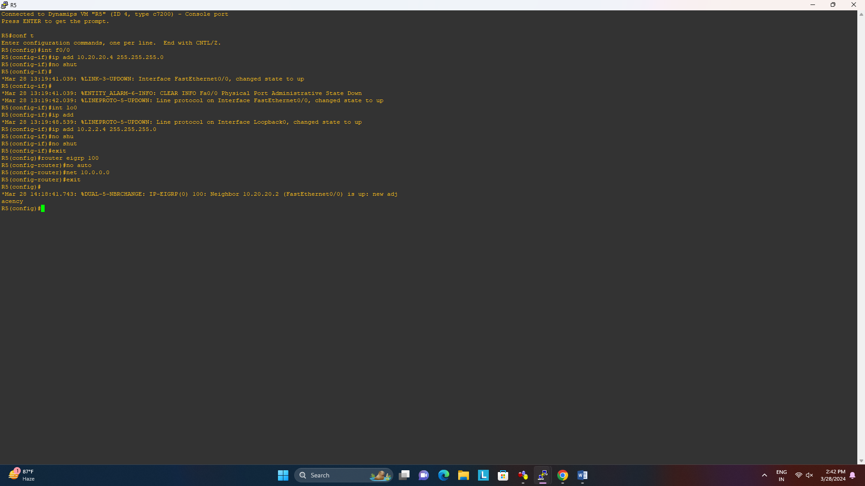

**R6 Console**

int f0/0

ip add 10.20.20.6 255.255.255.0

no shut

int lo0

ip add 10.2.2.6 255.255.255.0

no shut

exit

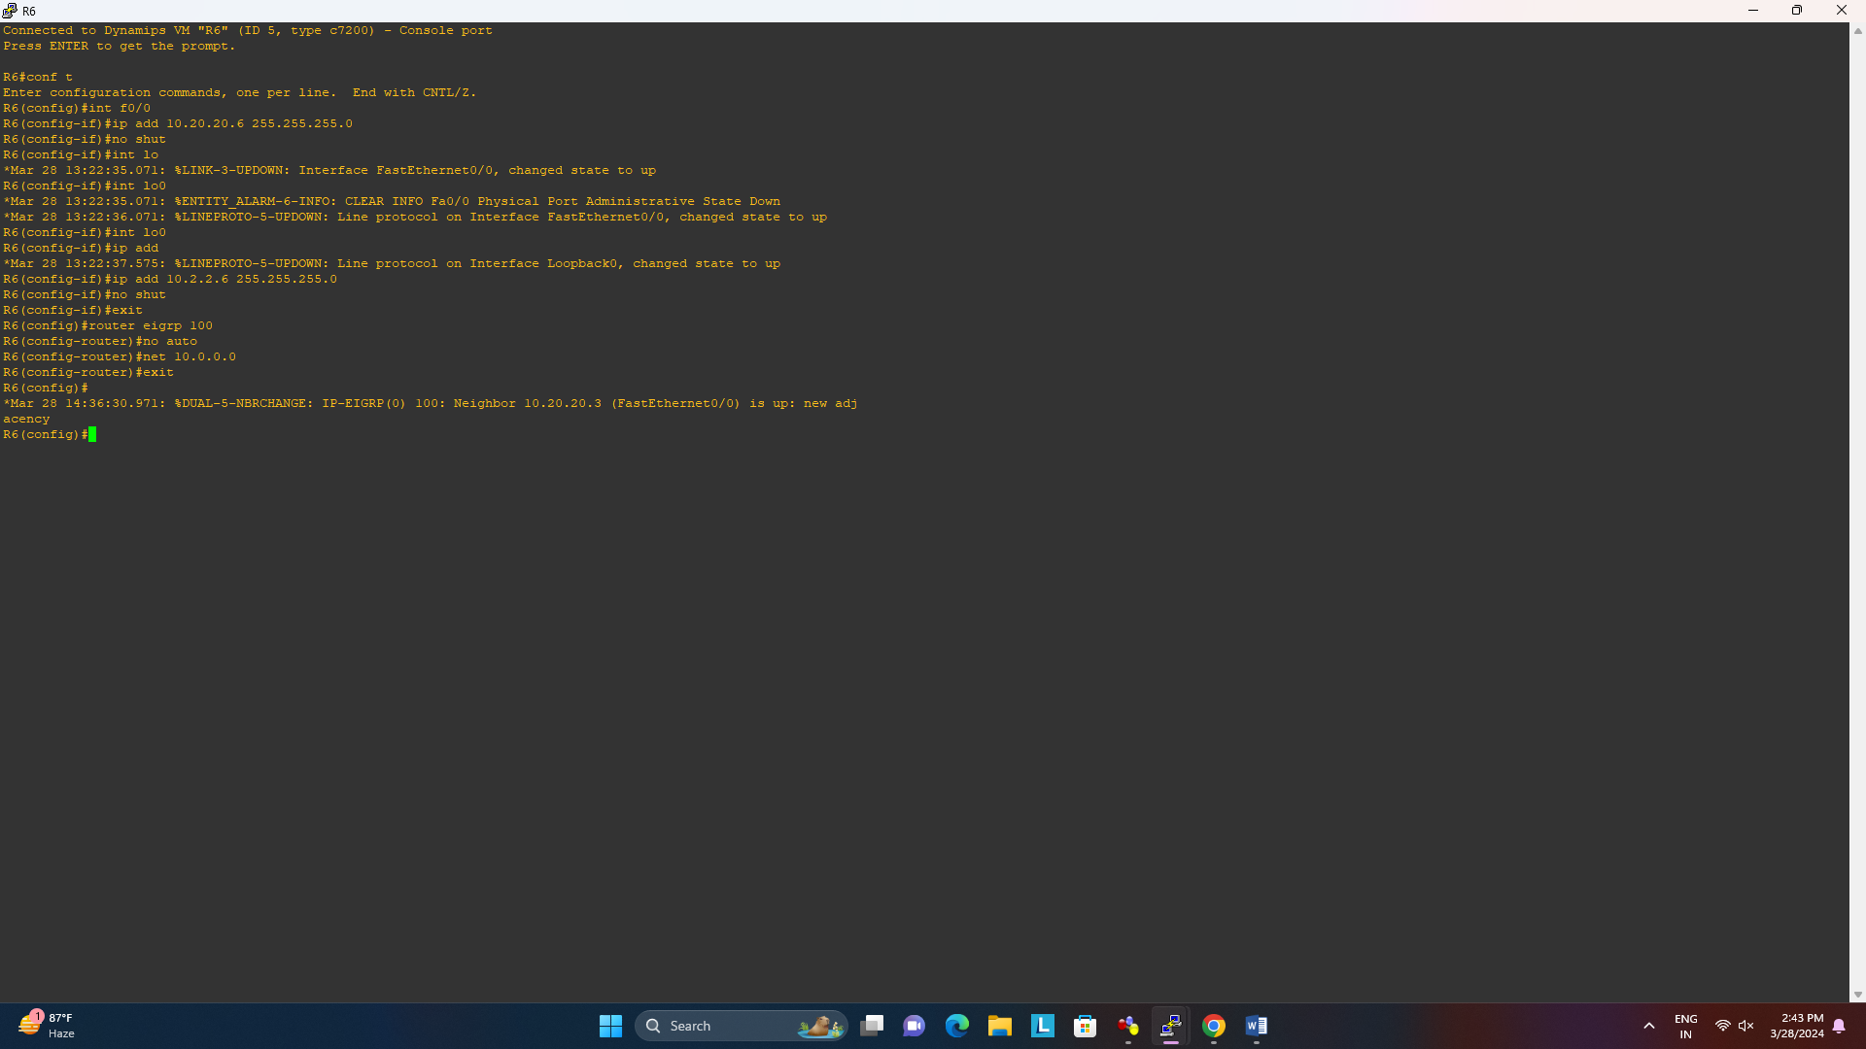

**R3 Console**

router eigrp 100

no auto

net 10.0.0.0

exit



**R4 Console**

router eigrp 100

no auto

net 10.0.0.0

exit



**R5 Console**

router eigrp 100

no auto

net 10.0.0.0

exit



**R6 Console**

router eigrp 100

no auto

net 10.0.0.0

exit



**R1 Console**

router eigrp 1

address-family ipv4 vrf custA

autonomous-system 100

no auto

network 10.0.0.0



address-family ipv4 vrf custB

autonomous-system 100

no auto

network 10.0.0.0

exit

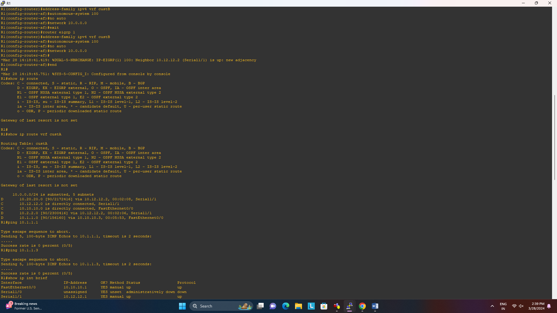

**R2 Console**

router eigrp 1

address-family ipv4 vrf custA

autonomous-system 100

no auto

network 10.0.0.0

address-family ipv4 vrf custB

autonomous-system 100

no auto network 10.0.0.0

end



**R1 Console**

show ip route

show ip route vrf custA



show ip int brief

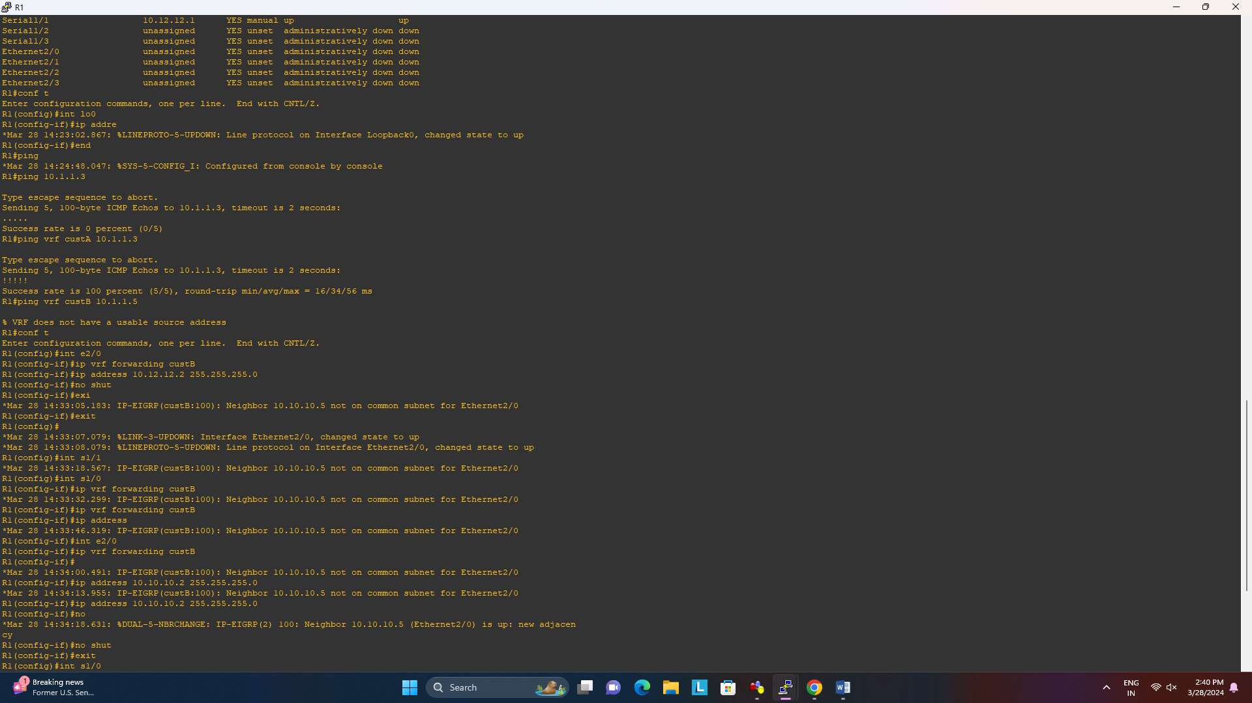

**R3 Console**

show ip int brief

ping 10.2.2.4



**R1 Console**

ping 10.1.1.3 (Doesn’t work because we haven’t specified vrf)

ping vrf custA 10.1.1.3



ping vrf custB 10.1.1.5



**R3 Console**

show ip int brief

ping 10.2.2.4



**R2 Console**

show ip route vrf custB

